Map for Training on 13th June 2021 & The working test 7th August 2021
Address: Earl of Malmesbury, Greywell Hill House, Greywell Hill, Greywell, Hook RG29 1DG. For those of you who have downloaded and use the Waht3words app: What3words for Greywell House driveway is ///loads.decimal.yummy for the carpark is ///trackers.flame.marker
Exit Junction 5 from the M3, take the A287 signposted Odiham/North Warnborough, as you exit the roundabout move into the right hand lane as you will need to turn right about 150 yards across the dual carriageway (Signposted for Greywell). This is Hook Road, stay on this road for 1.3miles, whilst on Hook Road you will pass the Fox and Goose Pub on your right and then a row of houses on your right and grass field on your left, Hook Road has now become The street.
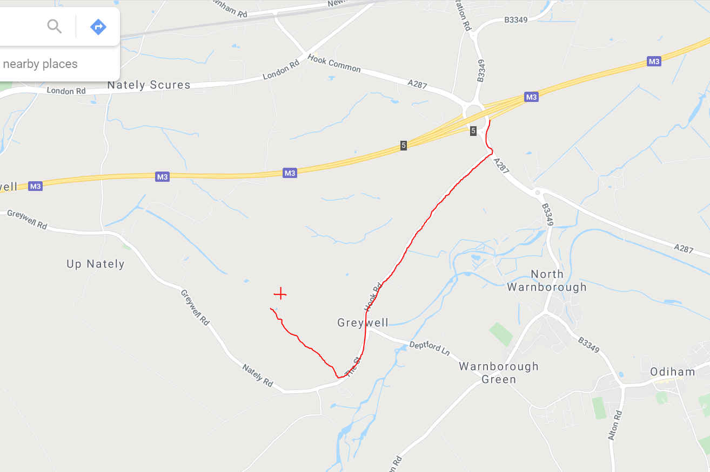

Once past the grass field, slow down and look out for the Working Minority Training Day signs at the bottom of the driveway on your right.
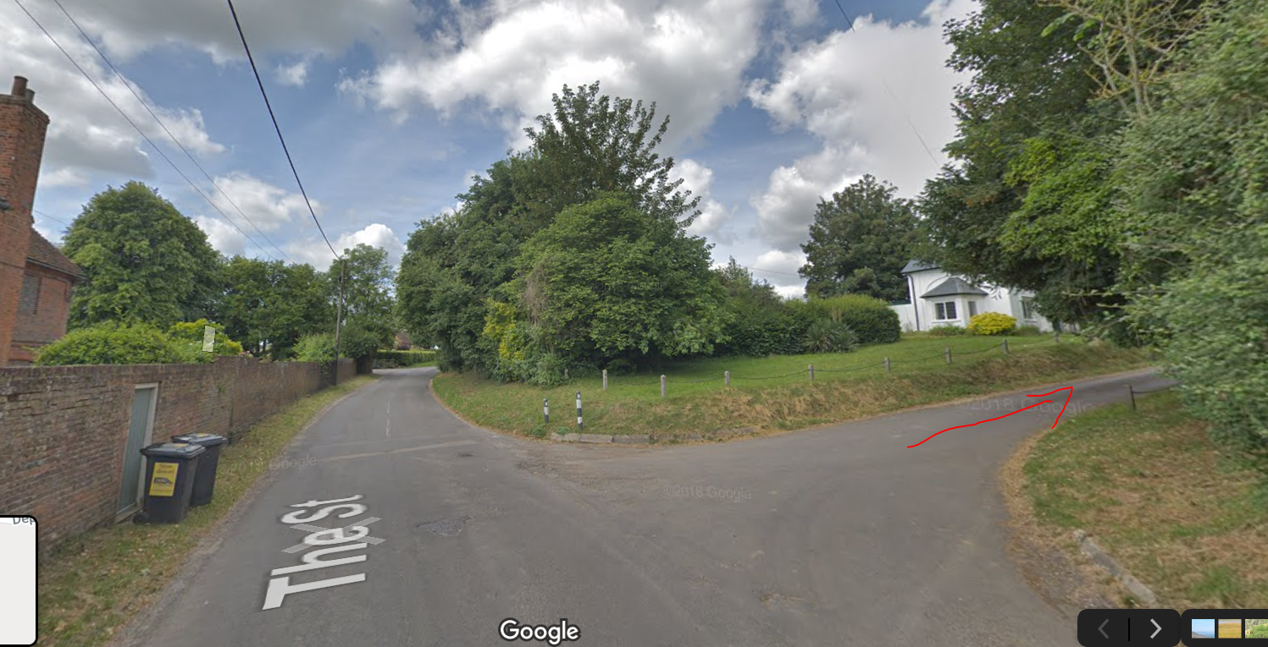
Turn up the driveway with the white gatehouse on your left. Follow the driveway and when in splits into two take the left hand fork and follow the track around the back for the house to the labelled Car Park.
Please respect the speed restrictions on the driveway, lots of deer, birds etc may be running around.
