Dummies and Shot will be used

Running in line with KC Regulations

3 Classes

Puppy 6 – 18 Months

Novice

Open

9:30am for a Prompt 10am start

Please bring lunch

Raffle prizes and home bakes would be appreciated

Tea, Coffee and Cake during awards will be on offer

£10.00 per dog & Handler

Please download the entry form from our website [Workingminorityretrieverclub@gmail.com](mailto:Workingminorityretrieverclub@gmail.com)

or email [workingminorityretrieverclub@gmail.com](mailto:workingminorityretrieverclub@gmail.com)

to request an entry form and complete & return it to the email or address provided on the entry form

Payment details on entry form by bank transfer to club account or email for alternative payment method

Contact Debbie 07776195105

Run by The Working Minority Retriever Club

EST 2019

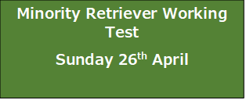

Judges:

Chris Marshall

Neil Varney



By Kind permission of

The Earl of Malmesbury

Greywill Hill House,

Greywell, Hook,

Hants, RG29 1DG