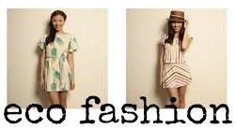
Cotton
- Made from natural fibers
- Biodegradable
- Wicks away sweat
- Breathable
- Soft

Environmental Impacts:
- Requires a lot of water (3% of global water use)
- Requires a lot of pesticides (7% of all chemicals used for agriculture in the U.S.)
- Requires arable land (2% globally)
- Organic cotton can improve the chemical effect of cotton, but it tends to require more land use because crop yields decrease

Hemp
- Natural fiber
- No chemical processing required
- Requires less water than cotton (medium amount)
- Requires little to no pesticides
- Biodegradable
- Machine washable

Environmental Impacts:
- Must be imported from areas where it is legal to grow
- Can be more expensive

Linen (Flax)
- Uses basically no water, and emits ¼ of the carbon as cotton per pound of fiber
- Look for linen made in mills that are Oeko-Tex 100 certified
- Flax can be grown on rough terrain unsuitable for food production
- Flax can be cultivated and processed without chemicals, though it is uncommon
- Natural fibers
- No pesticides or chemicals required
- Biodegradable
- Lightweight
- Breathable

Environmental Impacts:
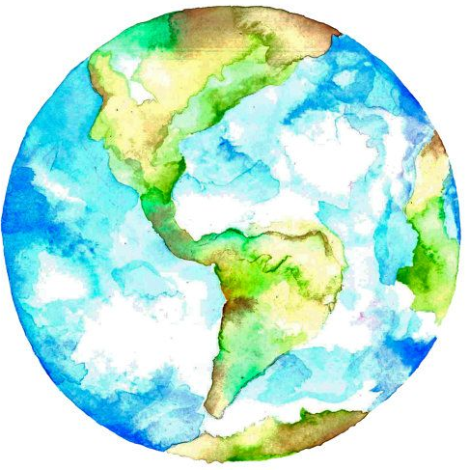
- Conventional flax growing uses fertilizers and pesticides, although less than crops like cotton
- Linens need to be dyed and treated to reduce wrinkling.
- Conventional linen is processed into fiber from the raw flax crop through a process of water-retting, which soaks the flax crop in rivers or waterways and results in a high amount of pollutants making their way into waterways. These include residual agro-chemicals as well as natural waste.
*More eco-friendly processing methods are dew-retting and enzyme-retting. These processes turn the raw crop into fiber while avoiding the water pollution associated with the water-retting process

- Not widely recycled
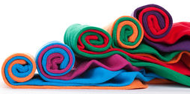
- Wrinkles easily
- May need to hand wash

Silk
- Natural fibers
- Requires less water than cotton
- Biodegradable
- Luxurious and smooth feel

Environmental Impacts:
- Can be expensive
- Requires dry cleaning
- Silk worms are killed, unless it's vegan silk

Rayon/Viscose
- Man-made fiber made from wood pulp, usually bamboo
- Biodegradable, but the chemicals required to transform it into fabric, including carbon disulfide, are unsafe
- Affordable
- Uses much less water than cotton

Environmental Impacts:
- Chronic exposure to carbon disulfide can cause serious health problems for rayon workers, including Parkinson’s disease, premature heart attack and stroke
- The source of cellulose can be questionable and lead to deforestation of rainforests
- If the fabric is processed mechanically, rather than chemically, it has a much smaller impact. This is called ‘bamboo linen’ but it is harder to find and more expensive
- It is processed with chemicals that can be released into the environment, but the fabric mill can also processes and dispose of the chemicals properly.
- Since this fabric comes from wood pulp, is best if the wood is sourced sustainably (such as Lenzing Viscose, which ensures certain sustainable requirements are met)
- If brands are careful about the source and processing of the viscose it can be a good eco-friendly fabric to use.

Tencel/Lyocell
- Semi-synthetic fiber with properties almost identical to cotton
- Manufactured from Eucalyptus trees, which grow fast and thick on low-grade land
- Eucalyptus trees don’t need irrigation, water is still used to process the pulp and turn it into TENCEL™ fiber
- Lenzing estimates its water use at 155 gallons per pound of fiber (80% less waster than cotton)
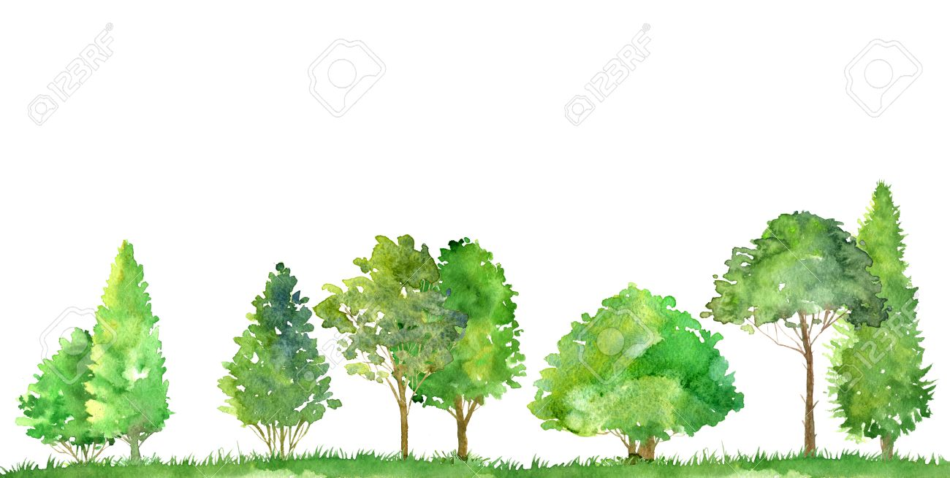
- It takes just half an acre to grow enough trees for one ton of TENCEL™ fiber (Cotton needs at least five times as much land)
- Production is done without the use of pesticides or insecticides (unlike cotton)
- Part of the Rayon family
- Closed loop production process, meaning over 99% of the non-toxic solvent is recycled and pushed back into the system instead of being flushed out as wastewater
- TENCEL™ fibers are certified by the European eco-label Oeko Tex 100 as containing low levels of manufacturing chemicals and byproducts
- Biodegradable
- Anti-bacterial

Environmental Impacts:
- Chemical processing is required to turn fiber into fabric, which is toxic. However, harm is mitigated by the use of closed loop processing, which recycles the chemicals rather than releasing them into the environment.

Polyester
- Requires less water
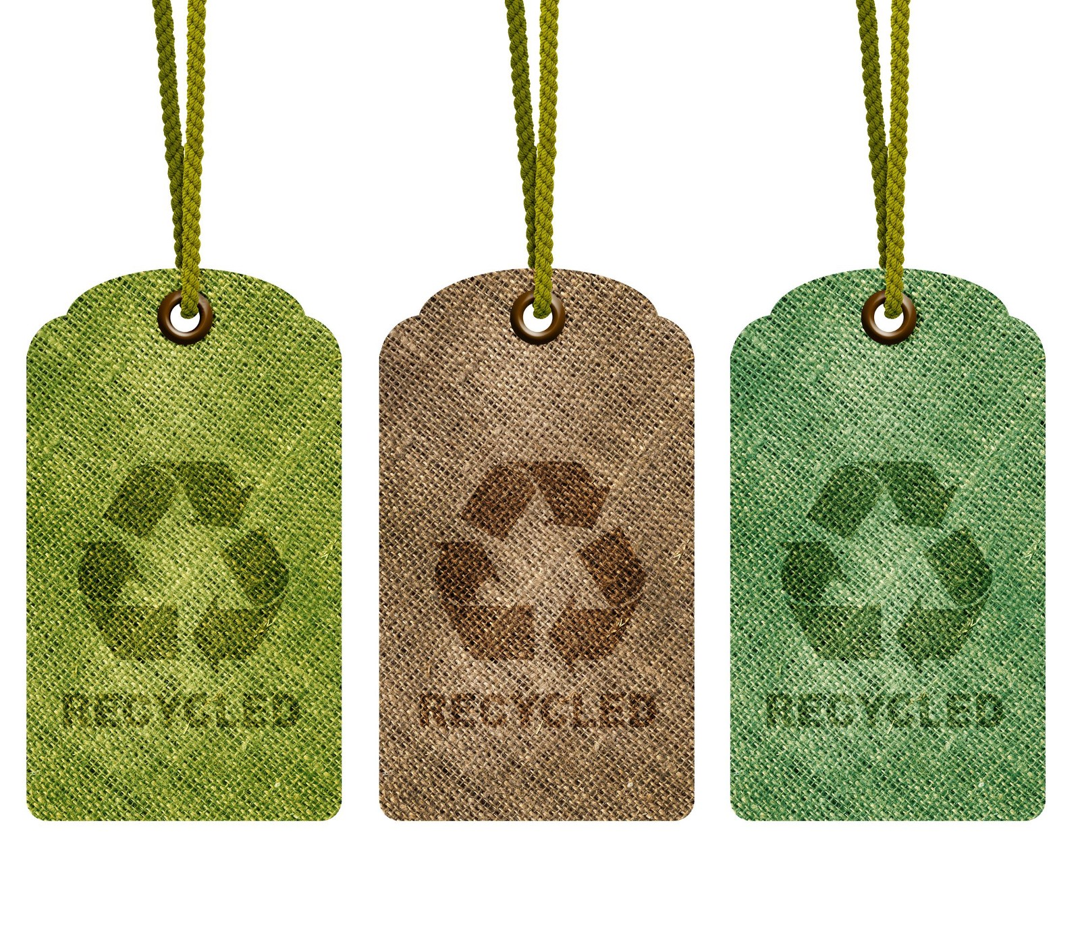
- Easy to care for
- Affordable

Environmental Impacts:
- Every wash releases plastic microfibers into waterways and these persist indefinitely, contaminating lakes and oceans and getting ingested by animals and, indirectly, by humans.
- Produced from toxic chemicals that are extremely harmful to humans and the environment
- Sourced from non-renewable resources (oil)
- High energy consumption during production
- Produces carbon dioxide
- Non-biodegradable
*Recycled polyester has much less of an impact but still releases microfibers into waterways

Nylon
- Requires less water
- Affordable

Environmental Impacts:
- Sourced from non-renewable resources (oil)
- Processed with chemicals that are harmful to the environment and humans
- Non-biodegradable
- Typically requires acid dying
- Creates nitrous oxide (a potent greenhouse gas)
*Look for ECONYL® regenerated nylon made out of 100% regenerated nylon - which means no waste and no new resources were harmed in the production, and keeps waste from oceans and landfills like fishing nets, carpet fluff, and fabric scraps. ECONYL® is Oeko-Tex certified which ensures that there are no hazardous chemicals used in dyeing the fabric.

Five main aspects to determine is a fiber is sustainable:
1 - The source of the fiber (natural or man-made/synthetic)
2 - The resources required to create the fiber (water, pesticides, land, energy, carbon dioxide, fossil fuels, etc.) and whether they are renewable
3 - The process of turning the fiber into yarn (does it use harmful chemicals? how are they disposed of? does it use large amounts of energy?)
4 - The longevity of the fabric (does it last)?
5 - The end-life of the fabric (is it biodegradable)?
Generally, natural fabrics like organic cotton and linen (made from plants) and Tencel (made from sustainable wood pulp) are more sustainable than man-made fabrics like Polyester and Nylon (which are petroleum-based and take thousands of years to biodegrade). Choose organic fabrics whenever possible. A better option is to buy used items, but the best option is to refrain from buying any items at all.
