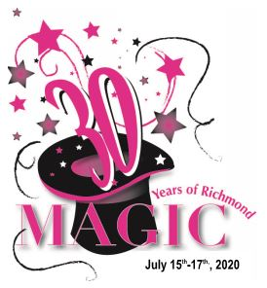
2021 RICHMOND RIVER LAKE DAYS PARADE ENTRY FORM
“30 Years of Magic“
Date: Saturday July 17th 2021 Registration Deadline: June 21st 2021
Parade Start time: 7:00 pm Parade Line-up: 6:00 pm
Parade line-up order is determined primarily by the date we receive this registration form.
A confirmation letter with line-up #, map & instructions will be emailed/mailed to you prior to the parade. In the unlikely event of weather forcing cancellation of the parade, there will be NO refund of the parade entry fees. (Income is used to offset parade expenses)

Fill out this form & mail it with applicable fee to the address below. Please keep a copy of this form for your records.
Name of business or parade entry/float: ______________________________________________________________________________
Describe your parade entry: ______________________________________________________________________________
(Please Describe your parade entry/float (tractor, musical, animals, etc.), as we try to keep similar entries separated. We also like to be sensitive to where animals and bands are placed in the line-up)

Number of Unit(s): ______ Length of Unit #1: _____ Length of Unit #2: ________ Themed Float: Yes or No
Contact Person: _______________________________Phone Number: ________________________
Address: ______________________________ City: __________________ State: ____ Zip: _______
Email Address: ___________________________________ Sponsors Name: ____________________
Entrant Category (check one):
___Richmond Civic & Commerce Member-enclose $15.00 per unit
___NON- Richmond Civic & Commerce Member-enclose $25.00 per unit
___Politician/Political Party-enclose $50.00 per unit
___Non-Profit group status-NO CHARGE
Music or Sound Category (check only if applicable):
___ I cannot have my unit next to loud music or sounds (we will try to accommodate)
___ My unit does produce music or sound

Prize Category 1st place $250.00 2nd Place $150.00 3rd Place $50.00
(must be THEME to be judged, please indicate above if you have a themed float)
(The judges need to be able to see your parade entry/float number during the parade)
Make Check payable to: Richmond River Lake Days Mail to: Richmond River Lake Days PO Box 586 Richmond MN 56368
Questions, Please reach out to: Brianna Larison blarison@steilins.com.

