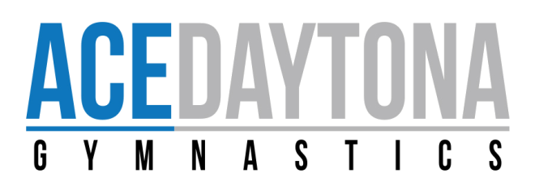
Dear After-School Families,
We would like to inform you of some changes that will take place in our program beginning, Monday, September 24,2020. DCFS has brought some things to our attention that need to be addressed with our families. Ace Daytona Gymnastics is not a licensed daycare facility, therefore, there are policies and procedures, that for the time being, we will need to change in our program.
At this time we fall under the “Instructional/Tutorial Programs” that would exempt us from being considered a daycare. This is what the policy states:
(B) Instructional/Tutorial Programs. The program is not designated as a Gold Seal Quality Care provider and has a single insutrstional/tutorial purpose and that purpose is the only service that the program provides. Some examples of these programs include, but are not limited to, tutoring; a computer class; a ballet class; a karate class; baseball instruction or other sport; the program cannot provide any service beyond the instructional and tutorial/academic activity; and:
- Does not cater, serve or prepare meals. The program may choose to provide drinks and ready-to-eat snacks that are individually pre-packaged and do not require refrigeration.
- Does not advertise or otherwise represent that the program has attributes of child care, as defined in Section 402.302(1), F.S.
- Enrollment information shall clearly define the duration of the instructional sessions. Session time may not exceed two hours. If tutoring is provided in multiple academic areas, the total combined session times cannot exceed three hours per day.
- Does not contract to deliver a school readiness program pursuant to Section 1002.88, F.S.
Due to Ace Daytona Gymnastics falling into this category of offering an instructional program, gymnastics, to our children, we must fall into these parameters at this time. Please note the changes to our program below. This will all take place starting Monday, September 24, 2020
- Free pick-up provided to all children in our pick-up program
- Every child will be enrolled into a 2-hour class session; this session will be from 3:30-5:30pm
- Pick-up for your child will be 5:30pm
- We will no longer have any homework time for the children
Please note that Ace Daytona Gymnastics still maintains a level of safety and excellence for your children. We will continue to provide the best supervision while your child is on our campus.
Unfortunately, due to changes that are being made, these changes will now have to be made in all after-school programs across the state of Florida. We understand that as parents, we all want to make sure our children are in a safe and encouraging environment while we are working.
Thank you for your understanding, and if you have any questions please don’t hesitate to ask.
Ace Daytona Gymnastics Staff

