Sponsorship Donation Form
Please complete and submit this donation form to:
Ace Daytona Gymnastics, 4431 Eastport Parkway, Port Orange, FL 32127
Donors will be recognized at the following levels for their total support of our programs:
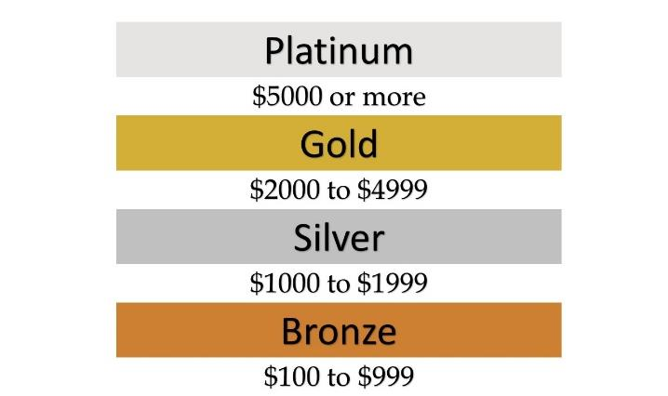
$75- $149
$150- $299
$300- $499
$500+

All of our Sponsors advertised with the following:
Platinum- Logo and Business name on Cups, Website, Program Ad, T-shirt & Banner
Gold- Logo and Business name on Cups, Website, Program Ad & T-shirt
Silver- Logo and Business name on Cups, Website & Program Ad
Bronze- Logo and Business name on Cups & Website
CONTRIBUTOR INFORMATION:
Name: ________________________________________________________________________
Address: _______________________________________________________________________
City: ____________ State: _________ Zip: ________ Phone: _____________________________
E-Mail: ___________________________________________
Make checks payable to: Ace Daytona Gymnastics
Credit Card:
Visa MasterCard Discover Account:
Billing Zip: _____________ Expiration: ____________ Security Code: __________
Signature: _____________________________________________________________________

