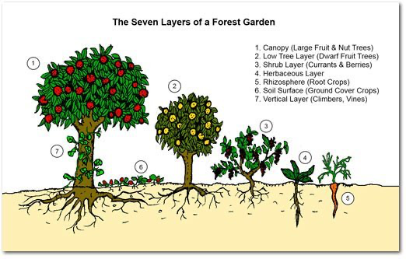

The seven layers of a Food Forest :

1. Canopy – large fruit and nut trees
2. Low Tree Layer – smaller fruit trees
3. Shrubs – currants and berries
4. Herbaceous – herbs
5. Rhizosphere (Root) – root vegetables
6. Soil surface – ground cover
7. Vertical (or Vine) layer – vines and climbers

www.fruitmommy.com

