[YOUR NAME]
[YOUR ADDRESS]
[SUBURB AND POSTCODE]

[TODAY’S DATE}

To: Springfield City Group
PO Box 4167, Springfield QLD 4300

Dear Minister for the Environment and Water,

REF: EPBC 2020/8651 “Scenic Precinct” – Controlled Action
Lot 51 SP242316 and Lot 50 SP242316 and Lot 1 RP863336
Springfield College Drive, Springfield, Ipswich, Queensland
I refer to a proposal to clear 24 Ha of Koala habitat by Springfield City Group on Lot 51 SP242316. This was deemed to be a “controlled action” in 2020, with Assessment by Preliminary Documentation.
This referral ought to be rejected due to the unacceptable impact to the “endangered” Koala and other MNES.

Context
This block has significant vegetation for Koalas especially in the context of Greater Springfield. It is zoned as “community residential” and “creek line open space” under the Ipswich Planning Scheme, and under a master plan called the Springfield Structure Plan (SSP). It was originally gazetted as a Development Control Plan (DCP) in 1997 under an old planning act. Koalas in SEQ have been declared “endangered” under State and Federal Legislation. Sadly, the State has given the developers of Springfield an exemption from recent Koala-specific initiatives designed to stop Koalas going extinct in SEQ. However, Federal legislation still applies.
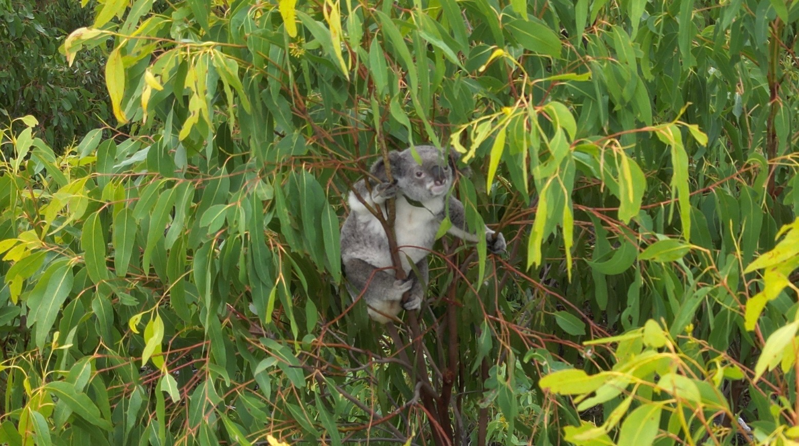
Young Koala in Thick Canopy

OBJECTIVE Environmental Advice
The Department wants objective advice on impacts to MNES (see Additional Information Request). The report tendered for this proposal is certainly not objective. It is biassed heavily towards development and even promotes development that doesn’t meet any codes. No objective biologist would make statements in support of 0% Avoidance and 0% Mitigation. An objective biologist would report on the rich biodiversity found along this ridgeline, and the ages of some of the Broad-leaved Ironbarks and Gum-topped Box (up to 500 years old). An objective biologist would emphasise the connection of this forest to the larger forested area in Brookwater, Bellbird Park, Camira, Springfield, Goodna, Redbank Plains and Redbank. An objective biologist would not use the SAT methodology for estimating koala populations as it is largely out of date and discredited.

I would suggest that the Department gets their own independent and objective advice. This ought to be a standard practice, as all developer reports are biassed, by definition.

I also wish to congratulate the Minister for changing the focus to “avoiding and mitigating” impacts on MNES, especially endangered species. Offsets have proven to be totally ineffective in halting declines in Koalas. They were always meant to be a “last resort”, yet somehow became a “first choice”. A recent audit found that most offsets had not been realised anyway. I wonder what an audit of offset offerings would show here in SEQ? 0% Avoidance and 0% Mitigation is totally unacceptable for MNES.

I also suggest that the wrong assessment process was decided for this development.

Nature of this Development
The developers propose to totally remove all the vegetation in the area subject of this assessment (i.e. 24.2Ha). There is No consideration for wildlife, and especially Koalas. This proposal is certainly NOT an example of “Urban Best Practice” as suggested by McAlpine, et al, 2007 or Koala-sensitive Design Guidelines, Code 25 or SPP (Biodiversity). Nothing to hint at being “Nature Positive”. Sadly, there is only nature negative.

There is insufficient detail of the actual design behind this proposal, so one can only assume that there are no mitigation strategies and total tree clearing is intended.

The proponents claim to subscribe to “best practice”, yet there are no features that incorporate Koalas or other wildlife. Queensland QDesign Manual or State Code 24 or National Urban Policy have not been incorporated into this design - just whole-sale ‘cut and fill’ and total tree clearing. They claim to go “above and beyond mandatory ICC standards”. Yet the development footprint is totally cleared of vegetation, well below the most basic of standards.

There is nothing “sustainable” or “best practice” or “professional” at all about this proposal.

Past Clearing of Koala Habitat
There have been a number of blocks cleared for development in Springfield that have been referred to Federal Government under EPBC Act. All had high impact on Koalas. Nevertheless, all were approved. All were offset for 100% of the impact. There was absolutely NO AVOIDANCE and NO MITIGATION anywhere. Many avenues for avoidance could have been taken but were not, for purely economic reasons. Many avenues for mitigation should have been taken, but were not. So, Koalas are now absent from these areas. 341Ha of Koala habitat was cleared and not one Koala was saved.
2013/7057 – Spring Mountain 255Ha cleared No Avoidance No Mitigation 100% OFFSET
2014/7306 – Village 1 40Ha cleared No Avoidance No Mitigation 100% OFFSET
2016/7676 – First Nine 46Ha cleared No Avoidance No Mitigation 100% OFFSET
2017/7875 – Woogaroo Hts 55Ha cleared No Avoidance No Mitigation 100% OFFSET
All these applications, however, especially mentioned a large nearby area (i.e. Lot 9999 and Lot 51) as being intact bushland and a place where Koalas would live, and thus it would supposedly be OK to cut down all the Koala trees on the relevant block and do no mitigation.
A block to the north of this application in Bellbird Park also pointed to this large area of Koala habitat across the creek, with the inference that this made it OK to cut down Koala trees. EPBC 2013/7074 Brentwood.
So, Lot 51 has been used as a defacto reserve for the past decade – a decade that saw the population of Koalas plummet. Thus, any clearing in Lot 51 will cast doubt over past approvals that were based on ZERO AVOIDANCE and MITIGATION. As these other blocks have all now been cleared, this block, Lot 51, must remain fully vegetated as a reserve.
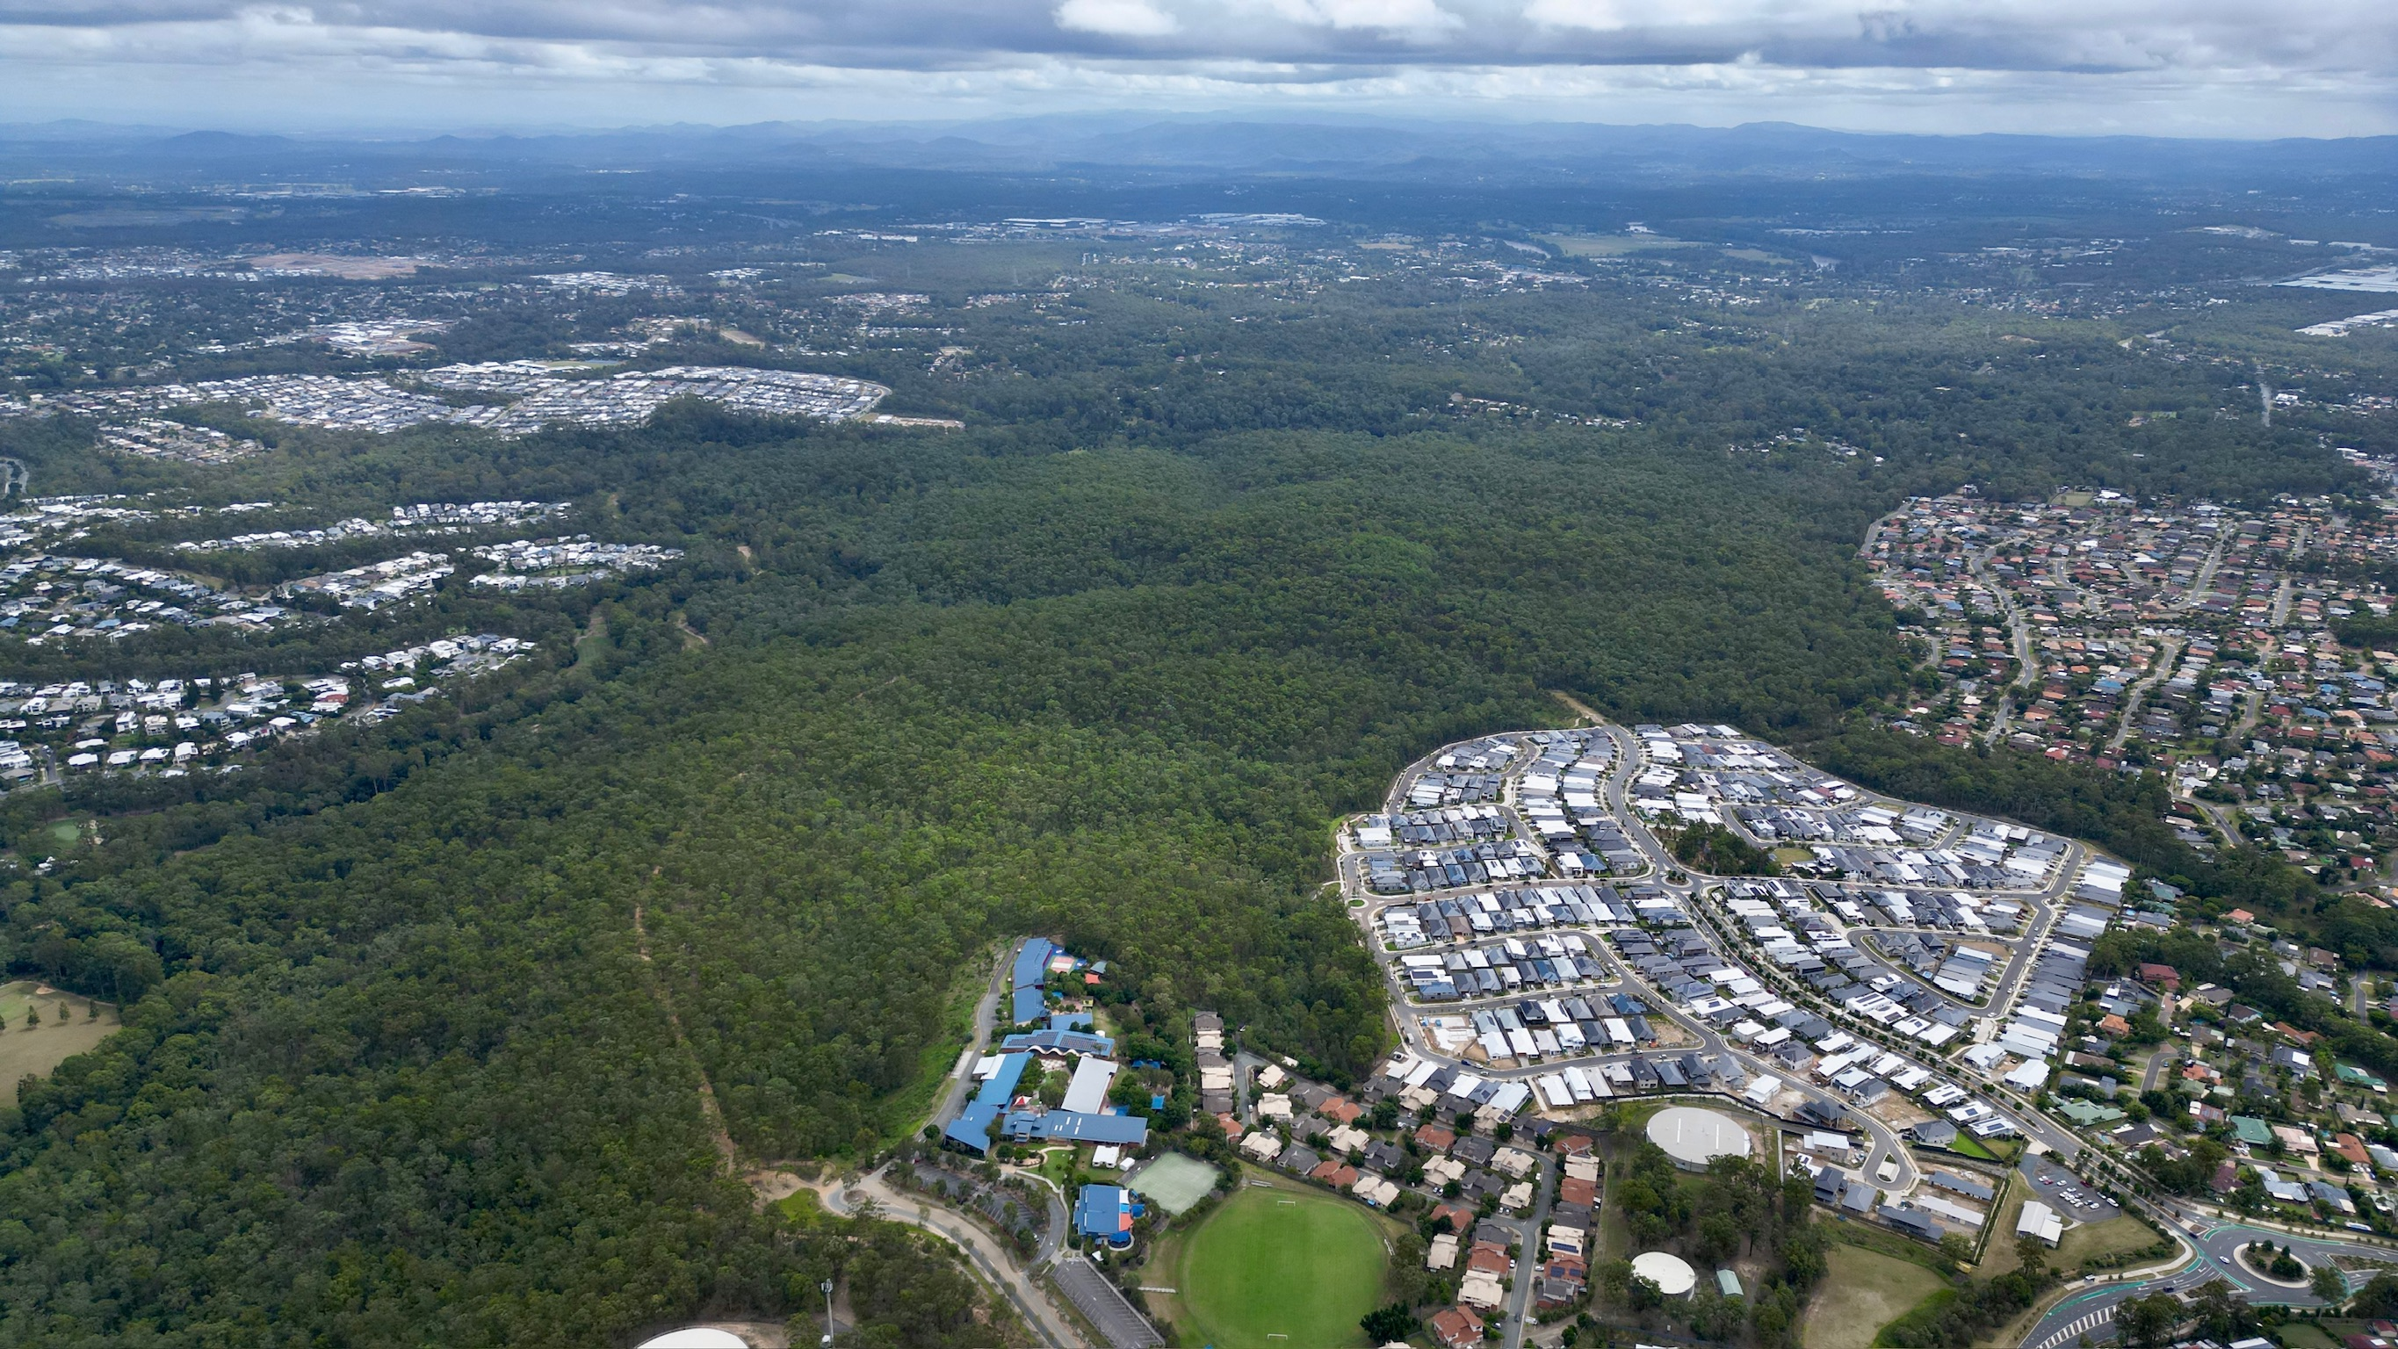
Wider view looking north with Springfield College (Primary) in foreground.

Woogaroo Forest
The eucalypt forest remnants scattered across Bellbird Park, Goodna, Camira, Brookwater, Redbank Plains and even Collingwood Park have been locally labelled as the “Woogaroo Forest”. Woogaroo Creek forms a central spine and perhaps supports a refuge for Koalas during drier times. This forested area supports a district colony of Koalas that move around to cope with seasonal fluctuations. Extensive clearing of 24Ha on Lot 51 would seriously affect the viability of the Woogaroo Forest and the district colony of Koalas.

Ecological Report
The Ecological Report for this application notes that it was mapped by the State as Koala Habitat; that Koalas use the site; and that this was part of a district colony of Koalas. The clearing would have a large impact on Koalas, and by inference the district Koala colony. Grey-headed Flying Foxes likewise would be heavily impacted. The report also rated the chance of finding Greater Gliders as “unlikely”, in spite of their historical occurrence here and recent sightings in the close vicinity at Spring Mountain. It therefore ought to be highly likely that Greater Gliders would be found here.
The constant whine from all reports emanating from Springfield regarding clearing of MNES habitat is that this is a special area for housing and Koalas have no right to be here. They have this magical DCP and Structure Plan that somehow entitles them to make all wildlife extinct in the area, according to them. The notion of “sustainability” and a professional approach to urban development have gone missing. It is, after all, just plain old urban development that we are talking about here and this should be “sustainable” and to a suitable standard wherever it occurs. And the concept of sustainable development should be “front and centre”. There is nothing special about the type of development proposed here, needing extraordinary exemptions from State requirements. It is just a fantasy that Springfield would not need to be a “sustainable” community, just like every other community. Sustainable communities accommodate wildlife and conserve koalas.
Scenic Precinct Design
There is no proposed design to show how the proponent has avoided and mitigated impacts on MNES on the 24 Ha of cleared land. As all trees within the footprint are proposed to be cleared, there appears to be NO attempt to AVOID impacts on MNES or MITIGATE impacts on MNES either.
The landscape offers many opportunities to AVOID and MITIGATE impacts. The zoning under the Ipswich Planning Scheme (and SSP) shows much more “creek line open space”. The clearing footprint goes into this open space zone, so the proponent has actually gone out of their way to totally clear more land than they are entitled to. They are actively passing up an opportunity to show some AVOIDANCE (actively increasing impacts on MNES). Thus, the footprint for development is in doubt and highly likely to change. The current referral ought to be rejected.
Not clearing “undevelopable” land along Possum Creek due to creek buffering and steepness is NOT mitigation. It is what happens in the 24Ha clearing footprint that counts!
There seems to be the admission in this report, that there will be a lot of cut and fill. The proposed design for the immediate neighbour to the north – Lot 9999 – includes cutting 15m off the ridgeline at the lot boundary and filling part of a gully there too. This development here would no doubt follow that line along the top of the ridge, up towards the water reservoir. Such a cut is truly excessive (of mining scale) and certainly not best practice and doesn’t exceed any Council codes. The gully between the ridgetop and the school looks like being filled. The gully at the eastern end near the main road looks like being filled as well. That whole hillside will no doubt be extensively modified, even though it was considered too steep for housing and roads in the SSP.
Ipswich City Council has a constraints layer on steepness and a code for retention of natural drainage features. It has a Guideline for vegetation retention and a Code for Vegetation Management. Ipswich also has a code for limited Earthmoving and excessive use of retaining walls. The proposed extent of clearing and earthmoving would generally not be acceptable.
Other parts of Springfield, such as Springfield Lakes and Brookwater, have successfully retained gullies and vegetation and ridgelines. So, it can readily be done. This is basically the intention of the Springfield Structure Plan, as can be seen in the Aims in Section 1.3. This has proven adequate for some MNES, as Swift Parrots and Regent Honeyeaters have been seen there before.
Please note that the Springfield Structure Plan and original Development Control Plan are irrelevant to this assessment. The proponent does not follow them anyway as substantial areas zoned as “creek line open space” are simply changed to “community residential” without any impact assessment or semblance of a process. A normal expectation would be that open space would progressively grow larger as site constraints at precinct level remove areas from consideration as housing. Instead, here the open space is stolen.
Wild Block
This block is steep and rugged. It has been left to the last to develop because it is so wild and therefore of low yield. However, the economic argument is put that development somehow needs to be very dense to cover costs and there are just no avenues to do any mitigation. This is a never-ending spiral – the steeper the block, the more the costs, the denser the development. This is a spurious argument. The block should not be developed due to serious site constraints.
It is also prone to land slippage. Much of the soil is sodic and therefore unstable. A recent major slippage occurred at the on/off ramp near Bunnings, where the whole hillside slumped and blocked the road for months. The slope slumped again this week (December). This proposal is in similar geology and any slope modifications will no doubt increase the risks of slippage quite substantially. The soil is also quite unsuitable for fill.
A key aim of the Springfield Structure Plan is to create communities in “sympathy with the natural landform taking into account the protection, and where possible, enhancement of the natural environment” (Section 1.3 (h)). So, this particular proposal does not even meet the aims of the Master Plan. So much for so-called “master planning”. This referral ought to be rejected.
National Initiatives to Conserve Koalas
It should be noted that the Federal Government is actively involved in the conservation of Koalas. There is a National Koala Recovery Plan along with a special team. This Plan involves coordination with the States. It aims to “recover” koala numbers.
The National Koala Monitoring Program is actively monitoring Koalas all around eastern Australia. Data from the Woogaroo Forest and other Ipswich locations are being collated on a national basis to assist in the recovery of Koalas.
The Great Eastern Ranges initiative includes outcomes to conserve Koalas by creating climate-change corridors. The Koalas of Woogaroo Forest may well benefit from these corridors.
This development proposal, with total clearing of 24Ha and NO MITIGATION, makes it harder to achieve any form of “recovery”. Koala numbers will need to start to increase before actual recovery can begin. The loss of 24 Ha here would represent the loss of perhaps 4 individuals from the district koala population. High developer profits here look likely to cause a substantial increase in federal outlays to get back to nature neutral, let alone nature positive. This is a net economic loss.

Thoughts of Local Experts
Dr Daryl Jones recently suggested that no Koala habitat in SEQ should be cleared at all, as the Koala is in such a parlous state.
Dr Frank Carrick, in 2013, over 10 years ago, suggested in his peer review associated with EPBC 2013/7057 that clearing there would have a significant impact on the local Koala colony.
Ipswich Koala Protection Society (IKPS) believes that Koalas are in real danger here of going extinct in the district. Taking out a large piece of viable habitat will move the district Koala colony closer to an extinction threshold. I believe QUT have done some modelling on the remaining vegetated blocks in Springfield, that shows the very real extinction risk of continued clearing.
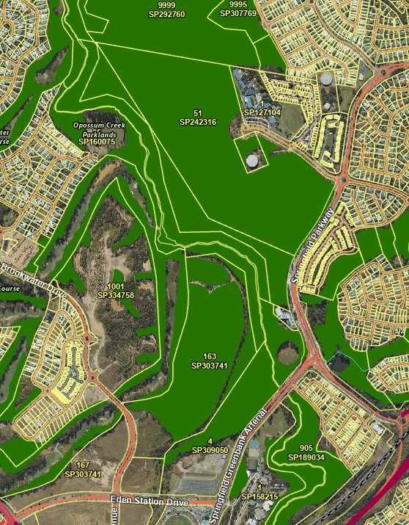
Lot 51 – Koala Habitat
Koala is “endangered”
Now that the Koala is “endangered” there would be high expectations of much more “Avoidance” and “Mitigation” and less reliance on “Offset”. State Code 25 and associated Guidelines would be a bare minimum standard for development in all Koala habitat areas in SEQ. Guidelines by McAlpine, et al in 2007 would also be appropriate. Every professional applies the appropriate codes and standards to their work. Professional urban designers apply the appropriate codes to their work. This area is no different. It is just urban development, regardless of any Structure Plan and ought to be designed with MNES in mind (and MSES/MLES for that matter). Note that the report was done in 2025, so the status of the Koala is “endangered”. This status should apply in this case. Nothing has happened since 2020 regarding this development, so the status that applies at the time of final assessment ought to be the status for the assessment. Anything less is just nonsense.
Note that “Land Clearing” is a listed Key Threatening Process, and especially for Koala. Approving the clearing of koala habitat is basically a Key Threatening Process and cannot lead to koala recovery.

Mature Canopy as a Habitat Feature
A very important aspect of this forest is that it features a mature canopy of mixed eucalyptus trees. It therefore has resources and niches for many species and ecosystems. This aspect was not covered by the applicant. This mature canopy provides for MNES species such as Koala, Grey-headed Flying Fox, Greater Glider, Swift Parrot and Regent Honeyeater. This mature canopy comes from trees that are of mature height. The block has been logged in parts in the past and used for timber resources by a company called Burnie Board. It was selectively logged, with natural regrowth and coppicing occurring. This forest is now considered to be remnant and therefore of high ecological value. Old trees were left as a seed source. Older trees were left in the gullies. Regrowth trees have matured in the last 40 years since logging stopped. Retained trees then have since developed more habitat features and would certainly be considered as “old growth”.
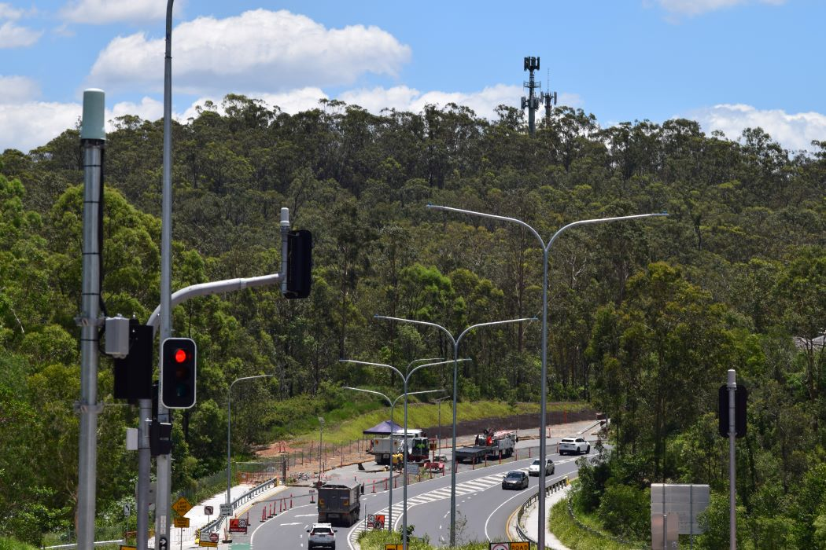
Mature Canopy below Tower
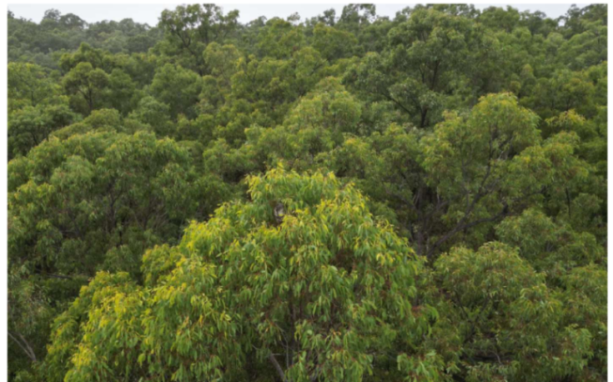
Mature Canopy with Abundant Resources

Greater Glider (endangered)
Greater Gliders used to be common and found around here. Incessant clearing in Springfield and nearby areas could easily push Greater Gliders into this area. A recent find west of Esk in Deongwar State Forest shows that GG can exist in logged, sub-optimal forests. They are found fairly close by in Spring Mountain and Greenbank Army land. It is “highly likely” that they are here too.

Grey-Headed Flying Fox
There is a Flying Fox camp nearby in Camira, along Sandy Creek, perhaps 2kms from this block. Grey-Headed Flying Fox (GHFF) use this camp regularly and Bat Rescue monitor this site. Regular heavy flowering of Gum-topped Box (Eucalyptus moluccana) across the district, noted in April 2024 and April/May 2025, provides excellent resources for GHFF. Broad-leaved Ironbark flowered in July/August 2024 and in July 2025 and no doubt provides substantial nectar resources for GHFF. Blue Gums and Spotted Gums and Grey Gums also flower here at different times. There is a sequential burst of canopy flowering that covers most of the year.
Any mature canopy of mixed species near this camp, such as Lot 51, would provide an extended nectar resource essential for GHFF. The loss of 24Ha would impact this camp, and GHFF, severely. There can be no recovery outcomes with this proposal; only “nature negative”.
Swift Parrot and Regent Honeyeater
Swift Parrots have been observed in the district from time to time. They are a nectar specialist that flies here to SEQ every winter from Tasmania. The loss of a mature canopy here must impact the ability of Swift Parrots to overwinter in this district, and therefore reduces the value of South East Queensland.
Regent Honeyeaters have also been seen at Springfield Lakes, travelling with Little Friarbirds, also a nectar specialist. Fewer flowering trees in the area would impact them.
Coleus habrophyllus (previously known as Plectranthus habrophyllus) – endangered.
This aromatic herbaceous plant is found scattered up the Woogaroo Creek catchment, on or near sandstone outcrops and ridges. It is found on nearby properties. It occurs on my property, directly across Woogaroo Creek to the north of this block. It would certainly occur along the higher points of this development area. Lloyd Bird found it here in 1996 (see Herbarium records). It seems to move around a bit depending on the prevailing weather pattern. The severe reshaping of this block would certainly destroy some occurrences of this plant and reduce the overall population.
Rufous Fantail (migratory)
Rufous Fantail is a species of creek-lines and wet gullies. It is found up and down Woogaroo Creek and Possum Creek and adjoining forests. There seems to be a rough pattern of migration through SEQ at certain times. Clearing Lot 51 will have an impact on the district/regional population. It will limit their ability to move through the landscape, as they regularly do.
Black-faced Monarch and Spectacled Monarch (migratory)
These two species are associated with Vine Scrubs and wetter Riparian Forests. They are regularly present all along Woogaroo and Possum Creeks. They are usually resident in the warmer months but can often be seen here at all times of the year. (Reference – records held by myself of birds over 20 years on a rainforest block on Woogaroo Creek, near the block in question). Forests in gullies would certainly help them move through the area.

White-throated Needletail (or Swift) – “vulnerable”
Flocks of this species move across the Woogaroo Creek valley on a reasonably common timetable. Generally, every Spring and Summer, flocks use the insect resources of the Woogaroo Forest and may hang around for up to a day at a time. They fly low to the canopy over every portion of the forest. Taking out 24 Ha of forest canopy will decrease their available food resources.
Other Species
Collared Delmas have been found in nearby areas of similar geology and floristics. It would be expected that these cryptic species could be here. MNES species.
Yellow-bellied Gliders have been found on adjacent Lot 9999 and also nearby in Augusta Heights. So, it is highly probable that Yellow-bellied Gliders are resident on Lot 51. MNES species.
Lloyd’s Native Olive has been found in the district and is highly likely to be here. MNES species.
Frillneck Lizard (Chlamydosaurus kingii) is expected to be found here as it was found on adjacent Lot 9999. This would be the southern-most occurrence of this iconic species in Australia and therefore of high local significance and possible national significance. Clearing of most of Lot 51 would certainly threaten the persistence of this special population.
Rainbow Bee-eater (previously listed migratory species). The Rainbow Bee-eater is a common element of this area. It is somewhat migratory but a few individuals seem to stay over Winter, more so in recent years. It is insectivorous and requires intact forest canopies to provide their food. The Woogaroo Forest provides that mature canopy, and the loss of 24 Ha would limit their ability to remain in this area.

The forests of Lot 51 are of very high environmental values. A number of MSES species are found here or highly likely to be found here. Powerful Owls use the area for hunting. Slender Milkvine has been found on Lot 9999 and likely to be found here too.
Offsets
There should be no offsets for koalas. Offsets simply enable the extinction of koalas in the eastern suburbs of Ipswich. And the offset offering at Aratula will not be koala habitat for at least 20 years and nothing like the area lost for at least 40 years. There is nothing “nature positive” in this arrangement. A large area of 350Ha has already been cleared in Springfield with offsets local and elsewhere. Yet koala numbers continue to fall in SEQ. There are offsets everywhere but no recovery anywhere. Clearly offsets are of no benefit at all. More needs to be done to design urban communities that actually recover koalas. If koalas can’t be recovered then the designs are not appropriate and development should not occur.
This particular offset (ROA4 off Moorang Lane) is in the Upper Bremer catchment, over 50kms away. There is no survey of the local koala population to see if any recovery can be detected in 20 years. The Offset Proposal is the barest of minimums (at 51Ha) and surely not big enough. The proponent is certainly not achieving any best practice standards here. The offset for Grey-headed Flying Fox is 14 kms away from the nearest likely roost and nothing like the 2 kms here. The offset for Regent Honeyeater seems highly unlikely. There aren’t any flowering Mugga Ironbarks or an equivalent, as the area is mainly old river terraces and basalt sediment fans that don’t favour ironbarks. There are more sightings around Brisbane and Ipswich than there are out at Moorang.
This offset is too far away from Ipswich to be of any benefit. Offsets should be a tool of last resort for small residual impacts on MNES.
This proposal does not follow any of the Offset Principles, such as, improving the situation for Koalas in Ipswich; proportional to the status of “endangered”; additional to conservation requirements of Planning Codes, such as Vegetation Management; and basically being an effective and reasonable response.
Cultural Heritage (Section 7)
The offered Cultural Heritage Plan was done in 1999 and just a one-page map. This is an insult to reconciliation initiatives. Nothing has been done on Lot 51 regarding cultural heritage for 25 years. There has been no attempt to understand more about indigenous land use and the role of country in the lives of First Nations owners. There has been no further advancement of the preservation of cultural heritage.
Reject This Referral
When are we going to start being “sustainable”? When are we going to live with our wildlife? Why do we make it an “either/or” as far as Koalas (and much of our endemic wildlife) are concerned? Why do we allow short-term profit motives to dictate long-term sustainability outcomes? We certainly need to be “nature positive”.
There is no attempt to follow “best practice” guidelines on Lot 51. Let’s keep it fully vegetated. This referral ought to be rejected.
[Any final words you may have]

Yours sincerely,
[YOUR NAME]

