[YOUR NAME]
[YOUR ADDRESS]
[SUBURB AND POSTCODE]

[TODAY’S DATE]
To: Springfield City Group
PO Box 4167, Springfield QLD 4300

Dear Minister for the Environment and Water,

REF: EPBC 2020/8629 “Peninsula” (Town Centre) – Controlled Action
Lot 163 SP303741 Brookwater, Ipswich, Queensland
I refer to a proposal to clear 18 Ha of Koala habitat by Springfield City Group on Lot 163 SP303741. This was deemed to be a “controlled action” in 2020, and the lot has since changed cadastre (it was Lot 63).
This referral ought to be rejected due to the unacceptable impact on koalas and other MNES.
Past Clearing of Koala Habitat
There have been several blocks cleared for development in Springfield that have been referred to Federal Government under EPBC Act. All had high impact on Koalas. Nevertheless, all were approved. All were offset for 100% of the impact. There was absolutely NO AVOIDANCE and NO MITIGATION anywhere. Many avenues for avoidance could have been taken but were not, for purely economic reasons. Many avenues for mitigation should have been taken but were not. So, Koalas are now absent from these areas. 341Ha of Koala habitat was cleared and not one Koala was saved.
2013/7057 – Spring Mountain 255Ha cleared No Avoidance No Mitigation 100% OFFSET
2014/7306 – Village 1 40Ha cleared No Avoidance No Mitigation 100% OFFSET
2016/7676 – First Nine 46Ha cleared No Avoidance No Mitigation 100% OFFSET
2017/7875 – Woogaroo Hts 55Ha cleared No Avoidance No Mitigation 100% OFFSET
Woogaroo Forest
The eucalypt forest remnants scattered across Bellbird Park, Goodna, Redbank, Camira, Brookwater, Redbank Plains and even Collingwood Park have been locally labelled as the “Woogaroo Forest”. Woogaroo Creek forms a central spine and perhaps supports a refuge for Koalas during drier times. This forested area supports a district colony of Koalas that move around to cope with seasonal fluctuations. Clearing 18Ha at the southern end of the Woogaroo Forest will impact the viability of the district colony of Koalas.
Koala is “endangered”
Now that the Koala is “endangered” there would be high expectations of much more “Avoidance” and “Mitigation” and less reliance on “Offset”. State Code 25 and associated Guidelines would be a bare minimum standard for development in all Koala habitat areas in SEQ. Guidelines by McAlpine, et al in 2007 would also be appropriate. Every professional applies the appropriate codes and standards to their work. Professional urban designers ought to apply the appropriate codes to their work. This area is no different. It is just urban development, regardless of any Structure Plan and ought to be designed with MNES in mind (and MSES for that matter).
Ecological Report
The Ecological Report for this application notes that it was mapped by the State as Koala Habitat; that Koalas used the site; and that this was part of a district colony of Koalas. The clearing would have a large impact on Koalas, and by inference the district Koala colony. Grey-headed Flying Foxes likewise would be heavily impacted. The report also rated the chance of finding Greater Gliders as “unlikely”, despite their historical occurrence here and recent sightings in the close vicinity at Spring Mountain. It therefore ought to be highly likely that Greater Gliders would be found here.
The constant whine from all ecological reports emanating from Springfield regarding clearing of MNES habitat is that this is a special area for housing and Koalas have no right to be here. They have this magical DCP or Structure Plan that somehow entitles them to make all wildlife extinct in the area, according to them. The notion of “sustainability” and a professional approach to urban development have gone missing. It is, after all, just plain old urban development that we are talking about here and this should be “sustainable” and to a suitable standard wherever it occurs. And the concept of sustainable development should be “front and centre”. There is nothing special about the type of development proposed here, needing extraordinary exemptions from State requirements. It is just a fantasy that Springfield would not need to be a “sustainable” community, just like every other community.
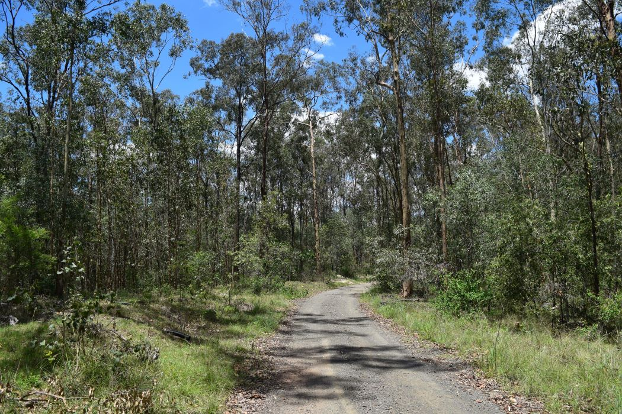
Forest on Lot 163.
Nature of this Development
This block has significant vegetation for Koalas in the context of Greater Springfield. It is zoned as “town centre” under the Ipswich Planning Scheme, and under a master plan called the Springfield Structure Plan (SSP). It was originally gazetted as a Development Control Plan (DCP) in 1997 under an old planning act. Koalas in SEQ have been declared “endangered” under State and Federal Legislation. However, Federal legislation still applies.
The developers propose to destroy all the vegetation on this block. No consideration for wildlife, and especially Koalas. No intention of meeting any codes of the Ipswich Planning Scheme – nothing “sustainable” or “best practice” or “professional” at all. This proposal is certainly NOT an example of “Urban Best Practice” as suggested by McAlpine, et al, 2007. Nothing to hint at being “Nature Positive”. Sadly, there is only nature negative.

Peninsula Design
This proposal for Peninsula admits to making NO attempt to AVOID impacts on MNES at all. The landscape offers some opportunities to AVOID impacts. But 18Ha will be totally cleared.
There has been NO attempt to MITIGATE impacts on MNES either. Once again, the terrain offers many opportunities to MITIGATE certain impacts.
Ipswich has codes for limited Earthmoving and excessive use of retaining walls and Vegetation Retention. As no details are provided one can only assume that major landscape reshaping will be proposed and thus the proposed extent of clearing and earthmoving would not be acceptable under these codes.
Other parts of Springfield, such as Springfield Lakes and Brookwater, have successfully retained gullies and vegetation and ridgelines. So, it can readily be done. This is basically the intention of the Springfield Structure Plan, as can be seen in the Aims in Section 1.3. This has proven adequate for MNES, as Swift Parrots and Regent Honeyeaters have been seen here before.
An internal road near the creek goes underwater in Flood. It will no doubt be handed back to Council should more detailed analysis be done. The road plus buffer would reduce the area needed to be cleared. Setbacks from Mountain and Possum Creeks would also reduce the development footprint – the boundary is on the creek in a few places. The Ipswich Infrastructure Plan shows much more Open Space than that proposed here. Thus, the proposal for the area wanting to be cleared is confused and certainly cannot be accepted as is.
Possum Creek Corridor
A corridor along Possum Creek has been touted as a koala corridor. A recent Trunk Sewer installation has sliced a 50m wide gash up the whole corridor. Half of the clearing was of Koala habitat trees such as Blue Gum and Grey Ironbark. There are no plans to rectify any of the damage, apparently. This corridor has been compromised for Koalas making this block even more critical for the survival of the species. This referral ought to be rejected.
National Initiatives to Conserve Koalas
It should be noted that the Federal Government is actively involved in the conservation of Koalas. There is a National Koala Recovery Plan along with a special team. This Plan involves coordination with the States. The National Koala Monitoring Program is actively monitoring Koalas all around eastern Australia. Data from the Woogaroo Forest and other Ipswich locations are being collated on a national basis to assist in the recovery of Koalas.
This development proposal, with total clearing of 18Ha and NO MITIGATION, makes it harder to achieve any form of “recovery”. Koala numbers will need to increase before recovery can begin. High developer profits here look likely to cause a substantial increase in federal outlays to get back to nature neutral, let alone nature positive. This is a net economic loss.
Of course, the Queensland State Government has a number of initiatives to conserve Koalas. Sadly, they don’t care about the likely extinction of Koalas in the Eastern Suburbs of Ipswich. This shows up a fundamental problem of intent. It seems that the Federal Government is the only body serious about recovering Koalas here.
Thoughts of Local Experts
Dr Daryl Jones recently suggested that no Koala habitat in SEQ should be cleared at all, as the Koala is in such a parlous state.
Dr Frank Carrick, in 2013, over 10 years ago, suggested in his peer review associated with EPBC 2013/7057 that clearing there would have a significant impact on the local Koala colony.
Ipswich Koala Protection Society (IKPS) believes that Koalas are in real danger here of going extinct in the district. Taking out a piece of viable habitat will push the district Koala colony further towards an extinction threshold.
Mature Canopy as a Habitat Feature
A very important aspect of this forest is that it features a mature canopy of mixed eucalyptus trees. It therefore has resources and niches for many species and ecosystems. This aspect was not covered by the applicant. This mature canopy provides for MNES species such as Koala, Grey-headed Flying Fox, Greater Glider, Swift Parrot and Regent Honeyeater. This mature canopy comes from trees that are of mature height. The block has been logged in the past and used for timber resources by a company called Burnie Board. It was selectively logged, with natural regrowth and coppicing occurring. This forest is remnant and therefore of high ecological value. Old trees were left as seed sources. Regrowth trees have matured in the last 40 years since logging stopped. Retained trees have continued to develop more habitat features.
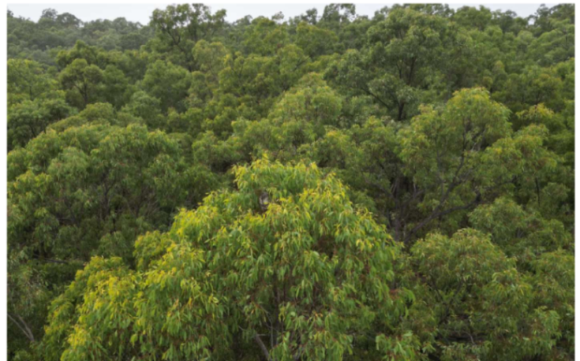
Mature Canopy with Abundant Resources
Note that twenty large stumps from old ironbark trees were observed recently on this block – probably cut down within the last 5 years. These would have been habitat trees of substantial age (perhaps exceeding 300 years). This clearing was probably not approved by the federal government and therefore illegal.
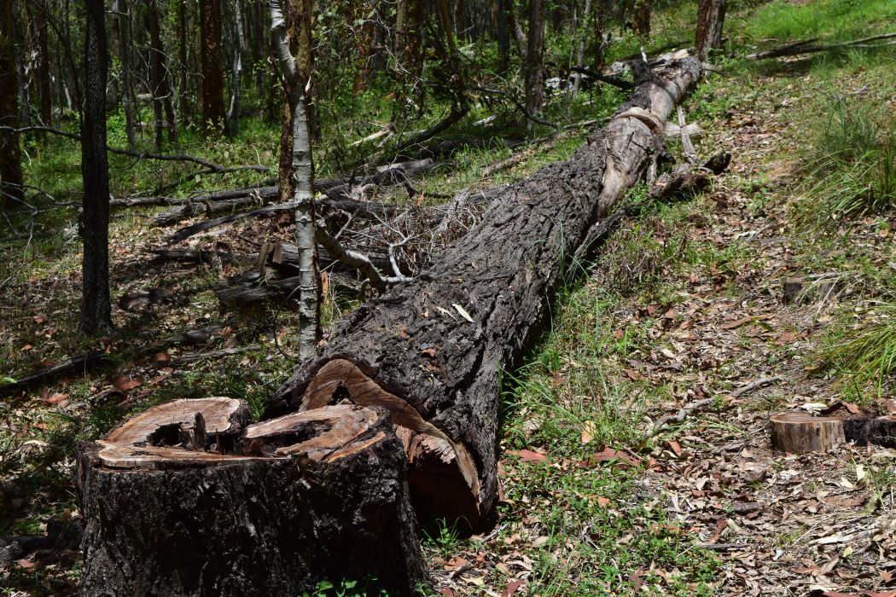
Old Ironbark tree dropped and left.
Greater Glider (endangered)
Greater Gliders used to be common and found around here. Incessant clearing in Springfield and nearby areas could easily push Greater Gliders into this area. A recent find west of Esk in Deongwar State Forest shows that GG can exist in logged, sub-optimal forests. They are found fairly close by in Spring Mountain and Greenbank Army land. It is “highly likely” that they are here too, especially since there are large Flooded Gums along Mountain Creek.
Grey-Headed Flying Fox
There is a Flying Fox camp nearby in Camira, along Sandy Creek, perhaps 2kms from this block. Grey-Headed FF use this camp regularly and Bat Rescue monitor this site. Regular heavy flowering of Gum-topped Box (Eucalyptus moluccana) across the district, in April 2024 and April/May 2025, provides excellent resources for GHFF. Broad-leaved Ironbark flowered in July/August 2024 and in July 2025 and no doubt provides substantial nectar resources for GHFF. There is a sequential burst of canopy flowering that covers most of the year.
Any mature canopy of mixed species near this camp, such as Lot 163, would provide an extended nectar resource essential for GHFF. The loss of 18Ha of canopy would certainly impact GHFF.
Swift Parrot and Regent Honeyeater
Swift Parrots have been observed in the district from time to time. They are a nectar specialist that flies here to SEQ every winter from Tasmania. The loss of a mature canopy here must impact the ability of Swift Parrots to overwinter in this district and therefore reduces the value of Southeast Queensland.
Regent Honeyeaters have also been seen at Springfield Lakes, travelling with Little Friarbirds, also a nectar specialist. Fewer flowering trees in the area would impact them.
Coleus habrophyllus (previously known as Plectranthus habrophyllus) – endangered.
This aromatic herbaceous plant is found scattered up the Woogaroo Creek catchment, on or near sandstone outcrops. It is found in nearby properties. It occurs on my property on Woogaroo Creek. It would certainly occur along the higher points of this development area. The total reshaping of this block would certainly destroy some occurrences of this plant and reduce the overall population. No sandstone outcrops are planned to be left.
Rufous Fantail (migratory)
Rufous Fantail is a species of creek-lines and wet gullies. It is found up and down Woogaroo Creek and Possum Creek. There seems to be a rough pattern of migration through SEQ at certain times. Leaving absolutely no habitat will have an impact on the district/regional population. It will limit their ability to move through the landscape, as they regularly do.
Black-faced Monarch and Spectacled Monarch (migratory)
These two species are associated with Vine Scrubs and wetter Riparian Forests. They are regularly present all along Woogaroo and Possum Creeks. They are usually resident in the warmer months but can often be seen here at all times of the year. (Reference – records held by myself of birds over 20 years on a rainforest block on Woogaroo Creek).
White-throated Needletail (or Swift) – “vulnerable”
Flocks of this species move across the Woogaroo Creek valley on a reasonably common timetable. Generally, every Spring and Summer, flocks use the insect resources of the Woogaroo Forest for up to a day at a time. They fly low to the canopy over every portion of the forest. Taking out 18 Ha of forest canopy will decrease their available food resources. Thus, there is a possibility that they may not come this way in the future.
Reject This Referral
There is no attempt to follow “best practice” guidelines, despite claims to be “best practice”.
Let’s keep this block fully vegetated. This referral ought to be rejected.
Yours sincerely,
[YOUR NAME]

