NOVAH Desk Range ( 10 Year Warranty) Single & Double Sided Office Desks , Workstations , Meeting Tables
THE SUPPLIER HAS GIVEN US A PRICE DECREASE SO YOU WIN !
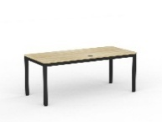From $359.00 + gst NOVAH Straight Desk - 2 Top/Frame colour options , 3 sizes from 1200/1500/1600/1800 x 600/700/800 x 730 (h) with 25mm Melamine Top with PVC Scallop Edge, Modern & Sturdy Triangular Steel Leg Construction . 1200mm gets cable port hole
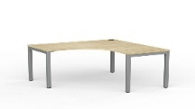From $549.00 + gst NOVAH Corner/Workstation Desk - 2 sizes - 1500mm & 1800mm with Cable Port hole , 2 Top Colours , 2 Frame Colours 90° workstation with 25mm melamine top with PVC Edge Modern & Sturdy Triangular Steel Leg Construction ,. Choose your size, frame colour and worktop finish.
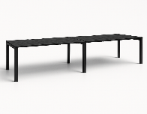From $649.00 + gst NOVAH Single Side Shared Desk – 2 Colour choices , 2 Desktop x 3000 x 800 x 725mm , 3200 x 800 x 725mm , 2600mm x 800 x 725mm with 25mm melamine top with PVC Edge Modern & Sturdy Triangular Steel Leg Construction . Scallop Edge
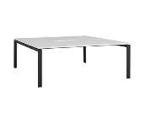 From $1439.00 + gst NOVAH Double Side Shared Desk – 2 Colour choices , from 2 -6 Users1500 x 1625 x 725 yp to 5400 x 1625 x 725mm with 25mm melamine top with PVC Edge Modern & Sturdy Triangular Steel Leg Construction . Scallop Edge
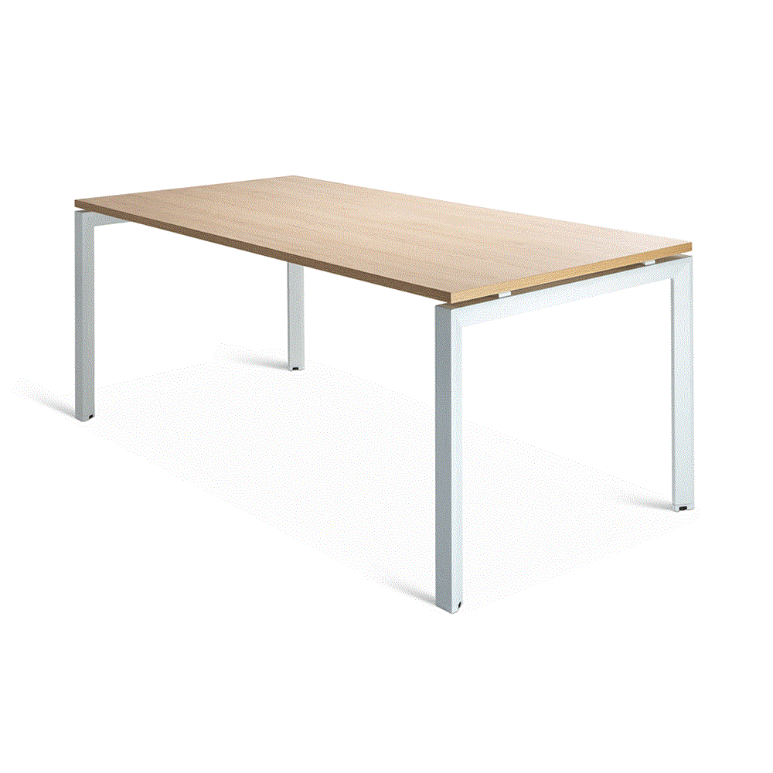 From $449.00 + gst NOVAH Meeting Table 2 Top/Frame colour options , 2 sizes from 1600 x 800 x 730 (h) and 1800 x 900 x 730(h) with 25mm Melamine Top with PVC Scallop Edge, Modern & Sturdy Triangular Steel Leg Construction . Telescopic Beams allow table to be set from 1200 up to 1800mm . Cable tray and snake optional extras .

All Lines Available 1st July 2026 to 30th September 2026.
Talk to us about other furniture options and feel free to call or email us
Prices : Deliver Flat Pack to Commercial Metro ground level premises Freight Inclusive

Canterbury Cartridge & Rolls
Locals Looking after Local Businesses
207 Earlys Road , West Eyreton 7475 . Call me , John Sutton , anytime on 03 310 2409
Mob 027 4840275 , email at qbusimaging@xtra.co.nz with any queries or orders .
Visit us online at www.qualitybusinessimaging.co.nz

