**1st June 2025 Price List**

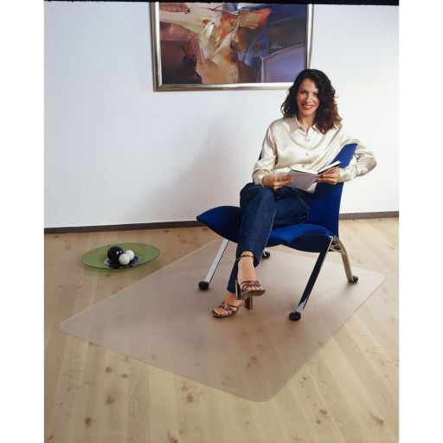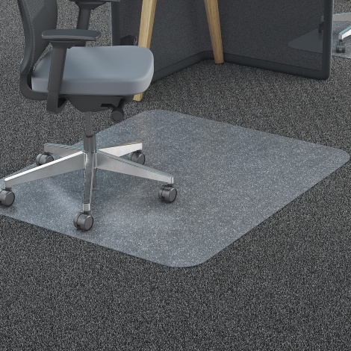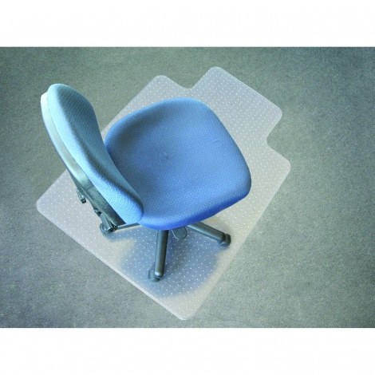

The Full Chair Mat Range from **MARBIG .**  A great range of products to compliment our **BURO Seating and KNIGHT GROUP DESK** range or just to make life better for your Office , Work Space or factory area .

Available in Super Strong Poly Carbonate or PVC for Carpeted and Hard Floor Areas .

Listed is the Basic Info , for Full detail call me for a brochure or visit our Website www.qualitybusinessimaging.co.nz and get all the Specifications , Features and Benefits .

They will give great protection and increase life span for your Carpets and Hard Surface areas , stop chair “ wheel rutting” , legs “spiking “and give your space a cleaner healthier look , are easy clean , while allowing easier access in and out of your chair at the desk :

**87105 MARBIG Chairmat Carpet DELUXE Key Hole shape 115 x 134cm $291.90 , 2 year warranty, carpet up to 12mm**

**87101 MARBIG Chairmat Carpet DELUXE Key Hole shape 90 x 120cm $234.85 , as above**

**87220 MARBIG Chairmat Carpet DURAMAT Key Hole Shape 90 x 120cm $239.90 , 2 year warranty , up to 6mm**

**87191 MARBIG Chairmat Carpet Poly Carbonate Rectangle 120 x 150cm $369.90 , 5 year warranty , up to 12mm**

**87190 MARBIG Chairmat Carpet Poly Carbonate Rectangle 90 x 120cm $249.90 , 5 year warranty , up to 12mm**

**87201 MARBIG Chairmat Hard Floor ECONOMAT PVE Key Hole shape 91 x 121cm $199.90 , 1 year warranty**

**87207 MARBIG Chairmat Hard Floor ECONOMAT Key Hole shape 115 x 134cm $259.90 , 3 year warrant**

**0275710 JASTEK Chairmat PLUSH PILE CARPET , 113 X 133CM key hole $289.00 , 1 year warranty**

**All prices plus GST .**

**Free delivery to metro areas**