Available from 1st May 2026 to 30th June 2026 ( or while stock lasts )
OKI Range Office Desks , Workstations , Desks , Cupboards & Credenza – DEALS!!
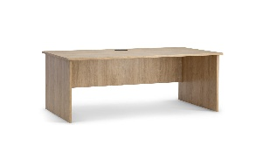As low as $289 + gst OKI Straight Desk - 3 sizes from 1200/1500/1800 x 600 x 730 (h) with 25mm Melteca Top/Sides. Durable/scratch resistant . 16mm Modesty Panel. 80mm Cable Port . 10 Year Manufacturer Warranty
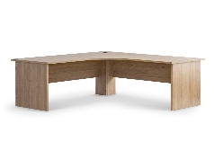As low as $449.00 + gst
OKI Corner/Workstation Desk - 4 sizes from 1500/1800 x 600 x 730 (h) or 1700LH x 1200RH x 600 x730 (h) and visa versa with 25mm Melteca Top/Sides. Durable/scratch resistant . 16mm Modesty Panel. 80mm Cable Port . 10 Year Manufacturer Warranty
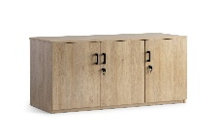As low as $469.00 + gst
OKI Credenza Lockable – 2 sizes from 1200 x 450 x 900 (h) or 1800 x 450 x 900 (h)
25mm Melteca Top , 18mm side & doors , 16mm back. Durable/scratch resistant One adjustable shelf and Lockable unit . 10 Year Manufacturer Warranty
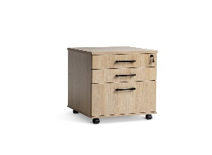As low as $299.90 + gst
OKI Mobiles – Lockable – 2 sizes - 2 Draw & File 478 x 470 x 640 (h) , 4 Draw 478 x 470 x 640 (h) . 25mm Melteca Top , 18mm side & draws , 16mm back. Durable/scratch resistant . Smooth slide ball bearing runners. Lockable unit . 10 Year Manufacturer Warranty
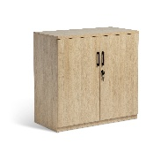 As low as $399.00 + gst
OKI Cupboard – Lockable – 2 sizes 900 x 450 x 900 (h) or 900 x 450 x 1800 (h) 25mm Melteca Top , 18mm side & doors for strength , 1 Fixed mid shelf 3 adjustable shelf can take 20kg each . Lockable Double Doors , 10 Year Manufacturer Warranty .

Talk to us about all the other furniture options and deals available .
Prices include Delivery of Flat Pack & assembled Mobiles to commercial metro address
All furniture comes in AUTUMN OAK for Uniform colour in the Workplace
Canterbury Cartridge & Rolls
Locals Looking after Local Businesses
207 Earlys Road , West Eyreton 7475 . Call me , John Sutton , anytime on 0800 782 528
Mob 027 4840275 , ( 03 ) 310 2409 , email at qbusimaging@xtra.co.nz with any queries or orders . Visit us online at www.qualitybusinessimaging.co.nz

