**1st August 2025**

**NEW ADDITIONS to the BURO Seating MONDO range**  for the Astute Budget minded client

**REMEMBER , With every Mondo purchased , Buro Seating donates to Trees That Count.**

**MOLTI Visitor / Office Chair - Priced from $229.00 + gst , assembled & delivered**

* Breathable mesh back to keep you cool and comfortable
* Powder coated steel 4 leg frame
* Glides and 40mm castors included in box
* PP armrests or replace with arm caps included in box
* High-density cut foam upholstered seat
* Stackable , Weight rated to 100KG , 6 Year warranty .

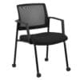

**MONDO Riley Office Chair - Priced from $279.00 + gst , assembled & delivered**

Breathable mesh back chair

Gas lift seat height adjustment **( ADD Arms for just another $49.00 + GST )**

Synchronised adjustable seat and backrest angle

Body weight tension adjustment – Chair rated to carry up to 120kg user weight

Strong nylon 5 star base with 60mm nylon castors , **6 Year Warranty**

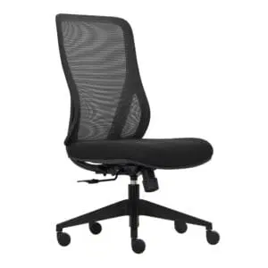

**MONDO Colt Office Chair – Priced from $359.00 + gst , assembled & delivered**

Breathable mesh high back with lumbar support

Comfortable moulded foam upholstered seat

Gas lift seat height adjustment , 1 lever simple mechanism

Tilt tension adjustment , Chair rated to carry up to 120kg user weight

Strong nylon 5 star base with 60mm nylon castors , **6 Year Warranty**

Adjustable flip up armrests

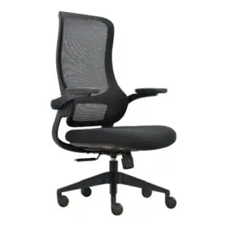

**CHECK OUT THE full BURO Seating range INCLUDING the PLATO Bonded Leather Chair , the 8+ Hour ROMA & METRO range plus much more , all viewable at our website or** [**www.buroseating.co.nz**](http://www.buroseating.co.nz)

**Canterbury Cartridge & Rolls**

**Locals Looking after Local Businesses**

207 Earlys Road , West Eyreton 7475 . Call me , **John Sutton** , anytime on 0800 782 528

Mob 027 4840275 , ( 03 ) 310 2409 , email at [**qbusimaging@xtra.co.nz**](mailto:qbusimaging@xtra.co.nz)with any queries or orders **. Visit us online at** [**www.qualitybusinessimaging.co.nz**](http://www.qualitybusinessimaging.co.nz)