Available from 1st August 2025

**KNIGHT Group Deals - Only While Stocks last**

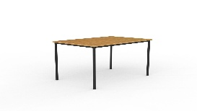

As low as  **$249.00 + gst**

**ERGOPLAN Canteen Table** 4 sizes from1200mm x 600mm x 730mm (h) with a 18mm Tawa or White top. 20mm steel legs finished in black powdercoat . 5 Year Manufacturer Warranty

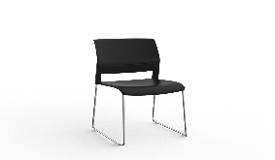

As low as  **$179.00 + gst**

**The Game** skid chair features a strong and rigid frame, with large seat and back moulded for 3+ hour comfort. 160kg rating , 5 Year Warranty . 3 Base Colours , 6 Shell Colours

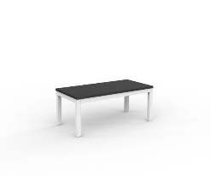

As low as  **$329.00 + gst**

**CUBIT Coffee** Table with 25mm top & powdercoat frame - 450mm high. 15 Year warranty

600mmx 600mm and 1200mm x 600m . 3 Frame Colours & 5 top Colours .

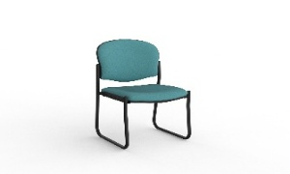

As low as **$269.00 + gst ( add arms for only $59.00 + gst extra )**

**RAZ Chair range** Fully welded **skid or stacker frame**, and Italian styled backrest , 6+ hour comfort . Upholstered in your choice of Crown, Breathe or Splice fabrics, or black PU. Stackable 4 high. 140kg rating , 5 Year Warranty . 2 Base Colours , 30+ Fabric Colours

**Talk to us about all the other furniture options and deals available .**

**Visit www.knightgroup.co.nz**

**Canterbury Cartridge & Rolls**

**Locals Looking after Local Businesses**

207 Earlys Road , West Eyreton 7475 . Call me , **John Sutton** , anytime on 0800 782 528

Mob 027 4840275 , ( 03 ) 310 2409 , email at [**qbusimaging@xtra.co.nz**](mailto:qbusimaging@xtra.co.nz)with any queries or orders **. Visit us online at** [**www.qualitybusinessimaging.co.nz**](http://www.qualitybusinessimaging.co.nz)