Available February 1st 2026 to 31st March 2026 ( All prices plus gst )
NEW DEALS for selected BURO Seating for the Astute Budget minded client
MOLTI Visitor / Office Chair - NORMALLY $249.00 . Now from $239.00 delivered
Breathable mesh back to keep you cool and comfortable
Glides and 40mm castors , PP armrests or replace with arm caps included in box
High-density cut foam upholstered seat . Stackable , Weight rated to 100KG , 6 Year warranty .
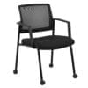 Powder coated steel 4 leg frame BUY 3+ PAY ONLY $229 each incl. ass & del

MONDO Riley Office Chair - Normally $279.00 . Now $263.00 delivered
Gas lift seat height adjustment , Synchronised adjustable seat and backrest angle
Body weight tension adjustment – Chair rated to carry up to 120kg user weight
Strong nylon 5 star base with 60mm nylon castors , 6 Year Warranty
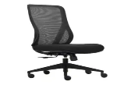 Breathable mesh back BUY 3+ PAY ONLY Chair & Arms $309.00 ea delivered

MONDO Colt Office Chair – Normally $359.00 . Now $339.00 Delivered
Breathable mesh high back with lumbar support , Adjustable flip up armrests
Comfortable moulded foam upholstered seat Gas lift height adjustment , 1 lever mechanism
Tilt tension adjustment , Chair rated to carry up to 120kg user weight
Strong nylon 5 star base with 60mm nylon castors , 6 Year Warranty
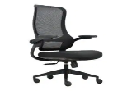 Strong nylon 5 star base with 60mm nylon castors , 6 Year Warranty

ROMA 3 Lever Office Chair – Normally $399.00.Now $369.90 Delivered assembled
10 Year Warranty : HIGH BACK BLACK ONLY, Ratchet height adjustable back/lumbar • Independently adjustable seat angle – free floating or lockable • Independently adjustable back rest angle – free floating & lockable • gas lift • Polyurethane moulded foam • Nylon base • 60mm wheels
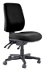
METRO Mesh Back Office Chair – Normally $519.00 . Now $474.00 Delivered assembled
10 Year Warranty ; Adjustable seat height • Ratchet height adjustable back • Independently adjustable seat tilt - free floating or lockable • Independently adjustable back tilt - free floating or lockable • High density polyurethane moulded foam seat • Black nylon base* 60mm wheels
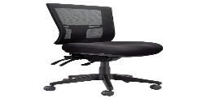
CHECK OUT THE NEW BURO ODYSSEY from $449 ( 4 colours PU and Fabric ) plus much more

Canterbury Cartridge & Rolls
Locals Looking after Local Businesses
207 Earlys Road , West Eyreton 7475 . Call me , John Sutton , anytime on 0800 782 528
Mob 027 4840275 , ( 03 ) 310 2409 , email at qbusimaging@xtra.co.nz with any queries or orders . Visit us online at www.qualitybusinessimaging.co.nz

