ROYALBREEWORLD Non-Refundable* Puppy Deposit Agreement Puppy Preferences
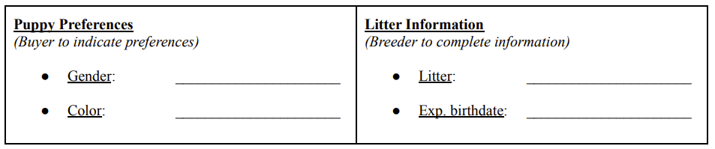
This agreement (“Agreement”), dated as of __________________, 20__ (the “Effective Date”), is between ROYALBREEDWORLD(“Breeder”), and __________________________(“Buyer name”).
Cell:_______________________________ Email_______________________________________(Buyer)
Buyer agrees to place a $500 deposit (“Deposit”) on a Goldendoodle puppy from Breeder.
1. Non-Refundable Deposit*. Buyer acknowledges that the Deposit is non-refundable in all circumstances, including but not limited to if Buyer decides s/he does not want or is no longer able to take the puppy. Upon receipt of the Deposit, Breeder agrees to hold the puppy for Buyer until it has been weaned and is ready for pick up. (Estimated 8 weeks of age) The Deposit shall be made in US Dollars and paid to Breeder via cash, or PayPal, Venmo or Zelle.
2. Buyer Acknowledgements: Buyer further acknowledges and agrees that (a) Breeder cannot control litter sizes and that the wait time for puppies can be longer than expected; (b) the Deposit gives Buyer a “pick” place, but does not guarantee a puppy or that Buyer’s preferences will be available when it is Buyer’s turn to pick; (c) pick places are given on a first-come first served basis and Buyer’s place in line is not negotiable; and (d) Breeder cannot and does not guarantee any specific qualities of the puppy when it becomes an adult.
3. Buyer’s Right to Transfer/Refund. Notwithstanding the foregoing, if a puppy that meets Buyer’s identified preferences is not available when it becomes Buyer’s turn to pick a puppy from the selected litter, Buyer may elect (a) to have the Deposit transferred to the next litter or (b) have the Deposit refunded.
4. Refund at Breeder’s Discretion. If Buyer pays the Deposit, then later decides s/he does not want the puppy for any reason, Breeder is not required to refund the Deposit. If, however, Breeder is able to sell the puppy to another buyer within a reasonable amount of time after Buyer notifies Breeder of his/her decision, Breeder may (in its sole discretion) refund the Deposit to Buyer.* If you selection is not available when you select your puppy your deposit can be refunded.
5. Final Purchase Price. Breeder and Buyer agree that (a) the Deposit shall be applied to the final purchase price of the puppy and (b) the remaining balance will become due before the puppy ownership is transferred from Breeder to Buyer. The total purchase price for the puppy is $_________. The foregoing purchase price does not include any delivery charges.
6. Governing Law. This Agreement, and all matters arising out of or relating to this Agreement, shall be governed by and construed in accordance with the laws of the State of Florida without regard to the conflicts of laws provisions thereof.
Email to: royalbreedworld@gmail.com We will send PayPal, Venmo or Zelle link to you for Deposit.
BREEDER: __________________________________
Print Name:______________________________
BUYER: ____________________________________
Print Name:______________________________

