Community Rewards
Benefitting Union Elementary PTSO
Supporting Union’s PTSO just got even easier! By signing up for these community rewards programs, you can support our school while you shop!
Kroger: Link your Kroger Plus card to Union Elementary School PTSO. Union has been assigned a NPO number 37510. Please refer to this number in all future correspondence.
PLEASE NOTE: If you were already enrolled, we no longer need to reenroll every May.
TO USE THE KROGER COMMUNITY REWARDS PROGRAM: Register online at krogercommunityrewards.com. Be sure to have your Kroger Plus card handy and register your card with your organization after you sign up.
Amazon Smile: Be sure to use this link when shopping on Amazon. The prices and Amazon prime remains the same, but a portion of your purchases can come back to Union Elementary. Set Union Elementary School PTSO as your charitable organization:
http://smile.amazon.com/ch/30-0275605
You use the same account on Amazon.com and AmazonSmile. Your shopping cart, Wish List, wedding or baby registry, and other account settings are also the same.
On your first visit to AmazonSmile (smile.amazon.com), you need to select a charitable organization to receive donations from eligible purchases before you begin shopping. Amazon will remember your selection, and then every eligible purchase you make at smile.amazon.com will result in a donation.
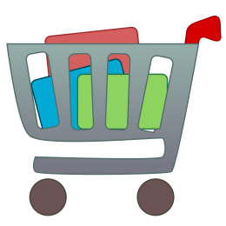
If you use a smartphone app to shop on Amazon, you cannot shop on Amazon Smile through the app. You must use an internet browser. Smartphone users can create a shortcut to the link on their screen to be used just like the app! It’s a great way to remember to support Union while shopping!

Any questions, please reach out to Julie Horton at julieannhorton@hotmail.com

