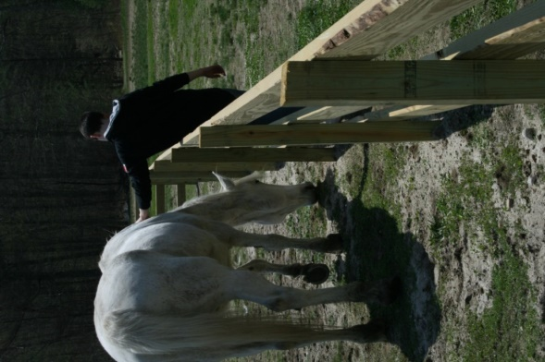****

***Hope and Healing in Harmony***

**Information Sheet**

EAGALA Model Equine-Assisted Psychotherapy and Personal   
Development is experiencing rapid growth around the globe.

Why? In two words:**STRONG OUTCOMES.**Equine-assisted work often helps clients change and grow more effectively and quickly than traditional clinical and psycho-educational approaches.

That's because people typically learn best by doing. Life lessons take deeper root when individuals both understand them in their heads and experience them in their bodies. Working with horses is engaging, real time and hands-on. The experience is immediate and fully felt.

**So why horses and not other animals?**

Horses are large and powerful. This creates a natural opportunity for some to overcome fear and develop confidence. Working alongside a horse, in spite of those fears, creates confidence and provides wonderful insight when dealing with other intimidating and challenging situations in life.

Horses are social animals, with defined roles within their herds. They would rather be with their peers. They have distinct personalities, attitudes and moods; an approach that works with one horse won’t necessarily work with another. At times, they seem stubborn and defiant. They like to have fun. In other words, horses are a lot like us socially - when we work on our relationships with them, we in turn are learning how to improve our relationships with others.

Horses respond with unique insight into exactly who we are in the moment. They are profoundly gifted reflectors of our true selves because their very survival depends on reading us right.

Because they can read and respond to the nonverbal messages we are always sending, they begin to act in ways that feel familiar to other relationships or dynamics in our lives. They become our spouse, partner, colleague, children, dreams, fears, addictions, etc. and begin to act out these very dynamics in our lives. This gives us a chance to work through those relationships and issues in a safe and nonjudgmental environment.

A client may say, "This horse is stubborn. That horse doesn't like me," etc. The lesson is that by changing ourselves, the horses respond differently. They provide this immediate feedback to real changes that we make - not what we just talk about.

For some reason, even when we feel stuck or hopeless, the horses move and make changes in the space, which in turn helps us become "unstuck." Clients repeatedly report that the horses seem to act and be exactly what is needed in the moment.

**It's all on the ground**

EAGALA sessions involve no horseback riding. Why? In this work, the horses are able to be themselves and not have to act a certain way, just like our clients can do. This is a space to explore, be ourselves, and build relationships on equal footing.

**Solution-oriented for all ages**

EAGALA sessions are facilitated by a certified team of mental health professional and equine specialist who hold the space for clients and horses to interact. Life stories begin unfolding symbolically in a safe and supportive setting. We believe that clients of all ages and needs truly have their own best solutions. As the horses play out scenarios, clients gain insights and begin to see and feel shifts in themselves as well.

**Vision Statement**

Every person around the world has access to EAGALA Model services.

**Mission Statement**

EAGALA provides education, standards, innovation, and support to professionals providing services in Equine Assisted Psychotherapy and Learning around the world.

**Values**

* **POSITIVE IMPACT:** Serve society through making a positive impact in the lives of people and horses
* **QUALITY:** Focus on standards of quality, professionalism and excellence in all programs and at all levels of the organization
* **INTEGRITY:** Ensure that principles, ethical standards and a clear identity guide our decisions and actions
* **COLLABORATION:** Maintain a culture of collaboration through supporting one another and sharing information, experience, and ideas
* **CONTINUOUS IMPROVEMENT:** Nurture a commitment to learning, innovation and improvement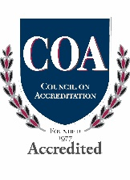  
    
    
  ***For more information regarding Harmony Hill School’s EAGALA Program please contact our Clinical Director, Heather Quercia at 401-949-0690 Ext: 3363 or at HQuercia@hhs.org***