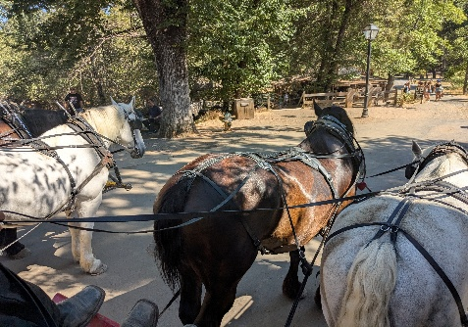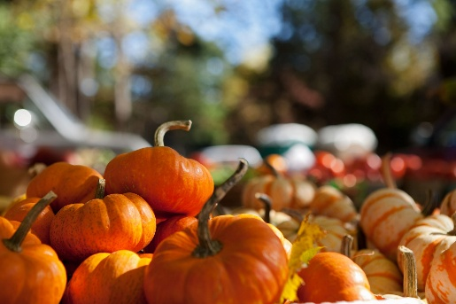
COLUMBIA HARVEST FESTIFALL 2026
October 10 and 11, 2026 from 10 am to 5 pm

The Columbia Harvest Festifall 2026 is a weekend event in Columbia State Historic Park that is sponsored by the Columbia Chamber of Commerce.
Vendors line the streets to showcase their items that are historically reminiscent of the Gold Rush period.
Some examples of acceptable items include the following: handmade signs, wood carvings, artwork, tinware, silver items, copper work, birdhouses, clothing, embroidered items, books, instruments, ceramics, pottery, edible items, stationary, toys, dolls, quilts, jewelry, and more! Focus should be on handmade items. Ask the event coordinator if there are any questions about acceptable products. Imported or mass-produced items should be avoided.
Participation Guidelines
- The standard booth space is 10’ x 10’. Vendors can purchase multiple booths if desired.
- Shade canopies are highly recommended and should be white or neutral in color.
- Booth décor and displays should be as “old-timey” as possible. Try to use canvas or cotton draperies for tables and chairs and avoid plastic and tarps.
- Booth décor cannot use highly flammable items such as cornstalks, straw, etc.
- Historical costumes are encouraged but not necessary. Vendors should avoid shorts, t-shirts, and revealing clothing.
- Booth Fee is $150 (per 10x10) for the entire event.
- Applications must be received by September 30, 2026.
Event Coordinators: Beth Smith (209) 599-0923 or
Rene Pisciotta (209) 588-6968
bethsandrenep@gmail.com

HARVEST FESTIFALL APPLICATION 2026

EVENT DATES: October 10 and 11, 2026

Complete this form and email to bethsandrenep@gmail.com

Applications can also be mailed to:
How many people will be in the booth:________
How Many Vehicles will you be bringing: _________
Do you have a trailer:_________ If so, how long:____
Columbia Chamber of Commerce
Attn: Harvest Festifall
PO Box 1824, Columbia, CA 95310

Name(s): _________________________________Phone:_________________________

Business Name: __________________________________________________________

Mailing Address: _________________________________________________________

Email Address:____________________________________________________________

Description of merchandise for sale: _______________________________________________________________________________________________________________________________________________________________________________________________________________________________________
Does your booth have a backdrop? ________________ Side Panels? ___________________

How long do you need to set up? ___________ How many booth spaces?_____________

Preferred Location: __________________________________________________________

What does the coordinator need to know?
__________________________________________________________________________________________________________________________________________________________
Harvest Festifall Information
CHANGES THIS YEAR: The process involves submitting your application to the event coordinators. The event coordinators will let you know if you are approved and an invoice will be sent for payment. Booth spaces are not reserved until payment has been received. Each day, one lunch meal will be provided by our local restaurants. Additional meals can be purchased for $15 each and options will be provided with your approval notice.

Parking will be assigned by space number, please let us know if you have special considerations or need disabled parking.

While Myia Davila has immensely enjoyed coordinating this event in the past, she has passed the torch to Beth Smith and Rene Pisciotta to coordinate this year. Beth and Rene have a wealth of experience and there is no doubt that they will do an amazing job!

PLEASE NOTE: Columbia is a working town. The town has live animals that could be frightened with certain sounds, displays, or items that you may use to decorate or sell at your booth. Please understand that if your booth contains any of these items, you may be asked to move or take the items to your vehicle. Please contact the event coordinator if you have any questions. The goal is to have a safe, fun, and profitable event for everyone!
APPROVED ITEMS: only approved items can be displayed for sale. The event coordinators can ask you to leave the event if unapproved items are displayed.
BOOTH SPACES: are subject to change. The event coordinator tries to accommodate individual requests but having the same space year after year is not guaranteed.
SET UP TIMES: Saturday begins at 7:00 am and Sunday begins at 8:00 am

FIRST CHECK IN: prior to setting up. The staff will assist you in finding your booth location. Staff present will be able to assist you.

SET UP INSTRUCTIONS: Please be considerate of other vendors trying to set up. Please do not bring anything that has not been approved by the event coordinators.

UNLOAD items and MOVE your vehicle first — then set up your booth: Vendor parking is in the lot down behind the State Park Office on Broadway Street/Parrotts Ferry Road (this leaves more room in the parking lots for customers). Please try to limit unloading time to 15 minutes.

OVERNIGHT SECURITY: will be provided, but please secure items for the night. Tarps may be used—just hide them in the morning! Please remember that the event coordinator(s), assisting staff, and Chamber of Commerce volunteers are volunteers and not employees. Please be kind, patient, and flexible as we prepare for the busiest Harvest Festifall ever.

TAKE DOWN: vehicles cannot be driven on Main Street before 5 pm (State Park rules). Please pack up and break down canopies prior to bringing your vehicle onto Main Street for loading. DO NOT enter Main Street with a vehicle prior to your booth being packed up and ready.

Thank you for your dedication to making this event a family-friendly, positive experience!

Columbia Chamber of Commerce
P.O. Box 1824
Columbia, CA 95310
(888) 488-1850
chambercolumbia@gmail.com

