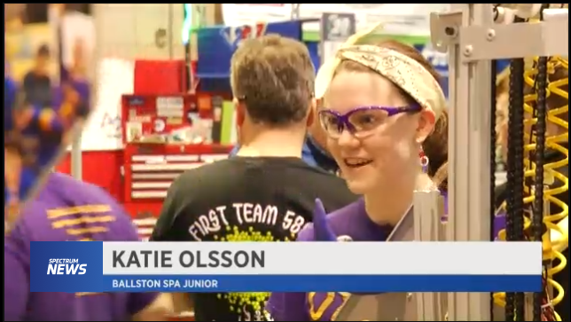

ROBOT COMPETITION NOT JUST FOR THE BOYS
By Barry Wygel | March 16, 2018 @6:40 PM
SHARE
TROY, N.Y. -- It has fans, it has teams, it has an announcer -- but this is a sport of the mind.
"I love figuring out how things work, so to be introduced to this where I can help build something like this is super cool," said Katie Olsson, a junior at Ballston Spa.
Thirty-one teams of high-schoolers have come to Troy from as far away as Brazil and Quebec to showcase their talents and their robots.
"My job personally is to check anything that may have broken on the robot. We have a lot of issues where we get hit by other robots and the vibrations can loosen a wire," said Madeleine Welch, a Ballston Spa senior.
It is no secret that this is a field and a sport dominated by men, but that certainly hasn't stopped these two young women.
"This is something I have love to do, so I will do it. There's no stopping me," said Olsson.
"I feel pretty proud of myself and I don't feel intimidated by anyone. I think they are intimidated by us females," said Welch, a team captain.
Teams are assigned a task and spend months building the machines from scratch. Friday's task was to pick up yellow crates and drop them in designated areas, competing with and against the other teams. And aside from the judges, there is not an adult in sight.
"My brother was on the team, and my mom thought it would be good for me ,since he got into a lot of colleges. She was like 'you can do the same thing,' " said Olsson.
It's not only fun, but it's also a career launch pad, with companies like Global Foundries and Bechtel in Schenectady sponsoring the teams and helping with scholarships and job placements.

