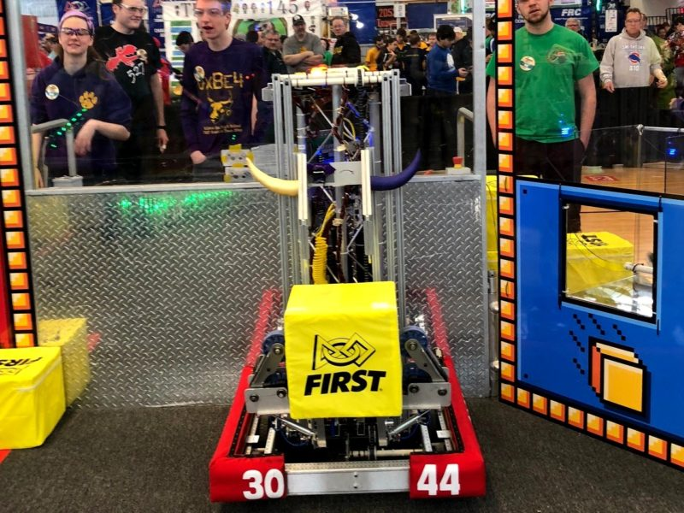

Ballston Spa FIRST Robotics Team Headed to Global Championship
- Aaron Dorman
- School News
- No responses
- March 14, 2018
BALLSTON SPA – The Ballston Spa High School’s FIRST Robotics Competition (FRC) Team 3044 earned the Engineering Inspiration Award at the Central NY Regional FIRST Robotics Competition held recently in Utica, NY. This award reflects the work that the team does in inspiring younger students through efforts like mentoring FLL and FTC teams and teaching elementary students how to do computer coding, among other activities. 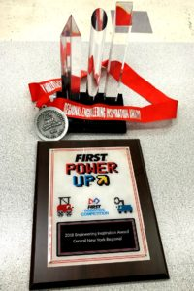
The award comes with a donation from NASA that will pay for the team’s registration fee for the 2018 FIRST Championship event in Detroit at the end of April. In addition, they will compete in the New York Tech Valley FIRST Robotics Tournament at Rensselaer Polytechnic Institute on March 15-17, 2018.
FIRST Robotics Competitions combine the excitement of sport with the rigors of science and technology. Under strict rules, limited resources, and time limits, teams of 25 students or more are challenged to raise funds, design a team “brand”, hone teamwork skills, and build and program robots to perform prescribed tasks against a field of competitors. The 2018 robotics challenge FIRST POWER UP includes two alliances of video game characters and their human operators who are trapped in an arcade game. Both alliances are working to defeat the boss in order to escape! 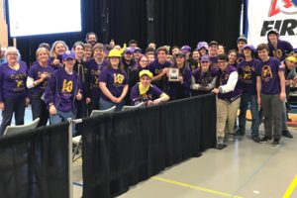
The district’s Robotics initiative is possible based on the support from the Ballston Spa National Bank to fund $6,000 towards the team’s participation in the annual US FIRST Robotics competition. In addition, Bechtel has donated $5,000 this year to also help the team design and construct a robot, participate in regional competitions, and continue to expand the Robotics initiatives to additional students in the district.
Additional sponsors include the GLOBALFOUNDRIES/Town of Malta Community Foundation, General Electric Power & Water, Malta Business & Professional Association, TBS Controls, National Grid, CSArch, PVA, Ballston Spa Education Foundation and Ballston Spa High School.
The High School Team 3044 Robotics website is https://frcteam3044.team/ or visit the FIRST Robotics website directly at http://www.usfirst.org/ for additional details.

