Times Union

Ballston Spa FIRST robotics team headed to global championship at RPI
By Wendy Liberatore on March 13, 2018 at 9:44 PM

- 0
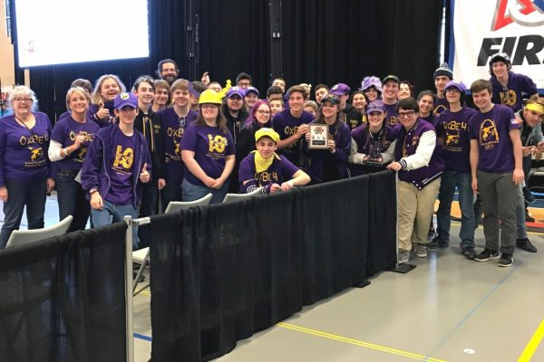The Ballston Spa High School’s FIRST Robotics Competition (FRC) Team 3044 earned the Engineering Inspiration Award at the Central NY Regional FIRST Robotics Competition held recently in Utica. This award reflects the work that the team does in inspiring younger students through efforts like mentoring FLL and FTC teams and teaching elementary students how to do computer coding, among other activities.
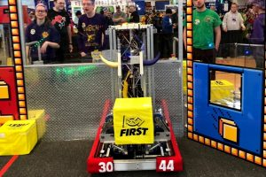The award comes with a donation from NASA that will pay for the team’s registration fee for the 2018 FIRST Championship event in Detroit at the end of April. In addition, they will compete in the New York Tech Valley FIRST Robotics Tournament at Rensselaer Polytechnic Institute on Thursday to Saturday, March 15-17.
More information is available by contacting Ballston Spa K-12 Science Coordinator Diane Irwin, dirwin@bscsd.org, or at the high school by calling (518) 884-7150. The High School Team 3044 Robotics website can be found at https://frcteam3044.team/. The FIRST Robotics website is at http://www.usfirst.org/.

