Hello teams!!

Team 3044 0xBe4 would like to invite you to our Virtual Learning Center on January 5th after kickoff. We will have access to the virtual field during the afternoon hours with our students available to assist teams with use of the virtual reality equipment, in order to gain insight on field dimensions and views from the driver stations.

If your team can not make it on January 5th, our students will also be taking recordings of the field that will be available on our website. The team has reserved the VR room for each Saturday during build season and Tuesdays and Thursdays during the week. Contact 3044oxbe4@gmail.com for field time requests or any questions that your team may have.

Here’s to another great build season!! Good luck to all!

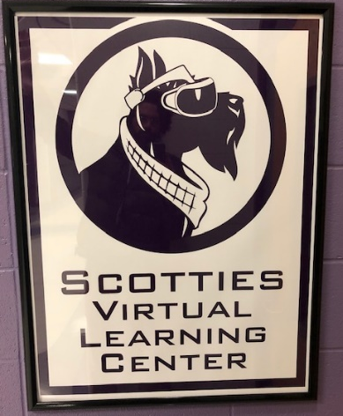
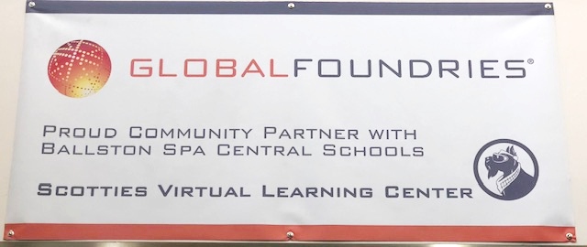
Team 3044

