THURSDAY, 26 JANUARY 2023 13:25

BSNB Recognized for Support of BSCSD Robotics Program
BY SARATOGA TODAY | EDUCATION
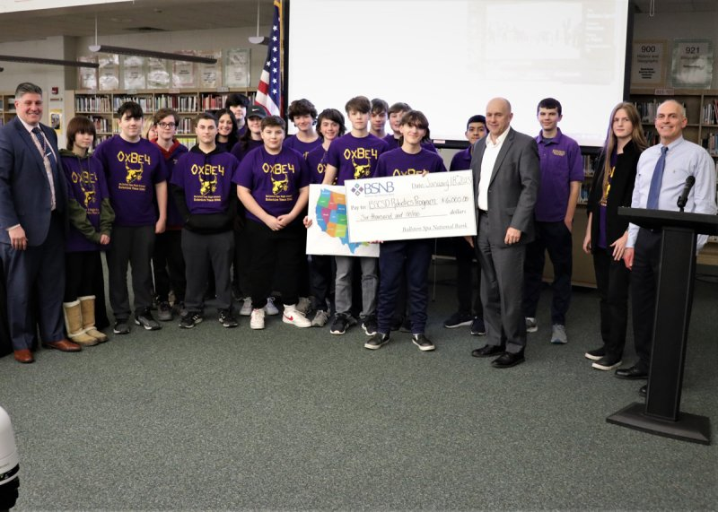Photo provided by Ballston Spa Central School District.
- FacebookTwitterPrintEmailMore
BALLSTON SPA — The Ballston Spa Central School District has once again received support from Ballston Spa National Bank (BSNB) to fund the Ballston Spa High School Robotics Team’s participation in the annual US FIRST Robotics competition.
The $6,000 in funding, combined with additional corporate sponsorships and team fundraising, will allow the district’s high school team to design and construct a robot according to this year’s specifications, participate in regional competitions, and continue to expand the robotics initiatives to additional students in the district.
“On behalf of our team at BSNB, I would like to congratulate the Ballston Spa Central School District and the other corporate partners for their efforts to develop this highly successful program,” said Chris Dowd, president and CEO of Ballston Spa National Bank. “Thanks to strong leadership and the active engagement of students, the program provides a meaningful and very effective complement to the educational infrastructure in this region. For those not familiar with the program, I encourage attending a competition to see firsthand the energy generated and the impressive results of the students’ efforts.”
The district continues to focus on partnerships with business and non-profit organizations throughout the region as part of the Partnership for Innovation in Education program. The Ballston Spa High School Robotics Team uses the support they receive to mentor and sponsor three other STEM related teams in the middle school and high school, and to participate in regional competitions for 2022-2023.
“Since sponsoring the first High School team in 2009, BSNB’s ongoing commitment has helped our program grow across the district and helped our students compete three times in the World Finals,” said Dr. Gianleo Duca, Interim Superintendent of the Ballston Spa Central School District. “The district would not be able to provide this opportunity for the current students involved on teams and the numerous alumni that have benefitted from the program without BSNB’s partnership and leadership through the years.”
FIRST Robotics competitions combine the excitement of sport with the rigors of science and technology. Under strict rules, limited resources, and time limits, teams of 25 students or more are challenged to raise funds, design a team “brand”, hone teamwork skills, and build and program robots to perform prescribed tasks against a field of competitors.
Volunteer professional mentors lend their time and talents to guide each team. Through the program, students can learn 21st Century skills from professional mentors, build and compete with a robot of their own design, learn to use sophisticated software and hardware, and compete and cooperate in alliances and tournaments.

