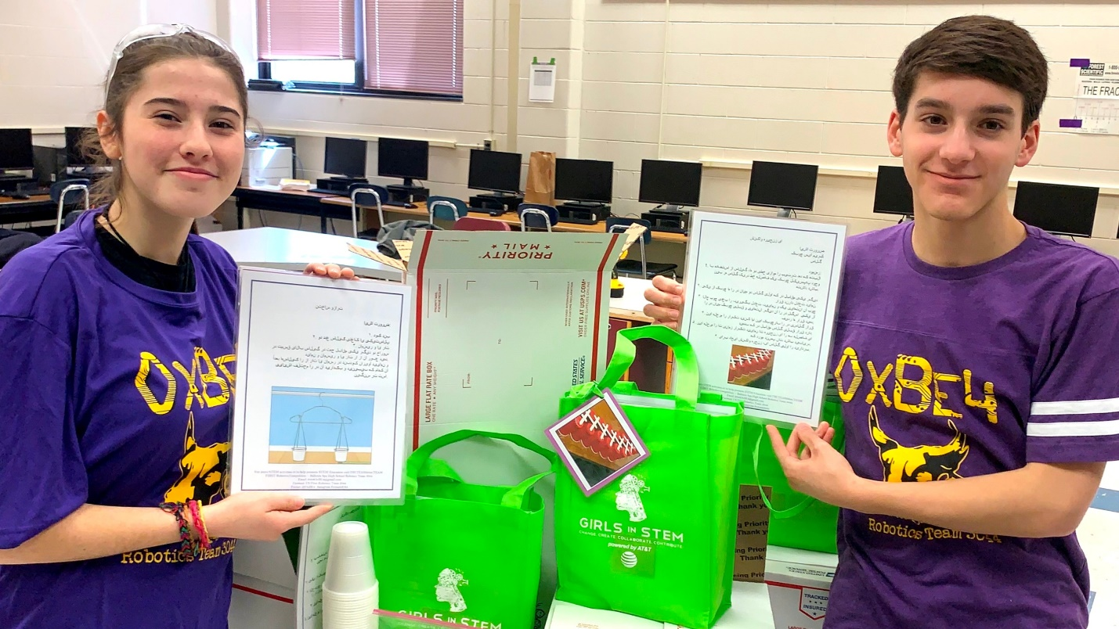
Ballston Spa High School Robotics Team 3044’s Co-Captain Maddie West and business team member Charlie McKeon prepare STEM kits for mailing to students in Afghanistan. Read More
NEWS

Ballston Spa HS robotics team aims to spread interest in STEM
by: Sarah Darmanjian
Posted: Mar 26, 2020 / 11:41 AM EDT
Updated: Mar 26, 2020 / 11:41 AM EDT
BALLSTON SPA, N.Y. (NEWS10)- The Ballston Spa High School Robotics Team is doing its part to keep elementary school kids interested in STEM while they are at home by providing activities on its website. The team’s goal is to spread a love of science, technology, engineering, and math.
In 2018 the team, OxBe4, gathered donations and sent LEGO Mindstorm kits to rural Afghanistan teens. This year they collected STEM activities, along with needed materials, to give to children in the same region. The STEM activities/materials will be sent this week.
“We believe that no matter who you are or where you come from, everyone should have a chance to create their own future and strive to be the best you can be,” said Team 3044’s Co-Captain Maddie West.
The team’s website and link to activities can be found here.

