SPIKE LEGO KIT INFO

SETS
Lego Education SPIKE Prime Set - $399.95
Contains:
- Color sensor
- Distance sensor
- Spike Prime Hub
- 1 large motor
- 2 medium motors
- Force sensor
- Bricks
- SPIKE Coding app

TECH INFO
Information on Lego Tech was gathered from the following websites:
- https://community.legoeducation.com/blogs/31/220
  - Provides a rundown on each sensor, and challenges that utilize the sensors’ functionalities
- https://education.lego.com/en-us/products/lego-technic-large-hub-for-spike-prime-/45601/
  - Description of the SPIKE Prime Hub

Color Sensor
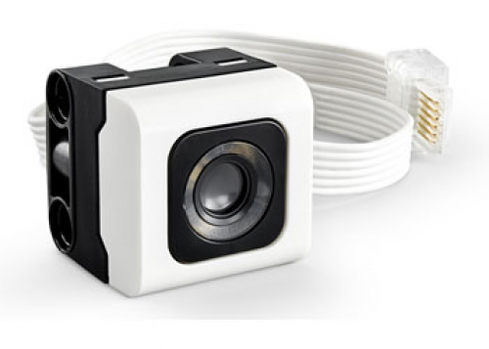
The color sensor has 3 main modes: Color, reflected, or ambient light (ambient light can only be coded in python). It has an optimal reading distance of 16mm (depending on object size, color, and surface) (Exploring SPIKETM).
- COLOR - The color sensor is able to detect 8 different Lego colors: Black, Magenta, Blue, Turquoise, Green, Yellow, Red, and White. It’s also able to output the raw RGB values separately (Exploring SPIKETM)
- REFLECTED LIGHT INTENSITY - The color sensor is able to emit a light and measure how much light is reflected back into the sensor. The output ranges from 0% - 100%, with 0% being very dark, and 100% being very bright (Exploring SPIKETM)
- AMBIENT LIGHT INTENSITY (Python only) - The color sensor is able to measure the light in the environment without emitting its own light. Similar to the reflected light mode, the output ranges from 0% - 100%, with 0% being very dark, and 100% being very bright (Exploring SPIKETM)
The following is a data table representing the mode and output range of said mode:
MODE | OUTPUT RANGE
Color | -1 = No object  0 = Black  1 = Magenta  3 = Blue  4 = Turquoise  5 = Green  7 = Yellow  9 = Red  10 = White
Reflected Light | 0% = No reflection  100% = Very reflective
Ambient Light (Python only) | 0% = Dark  100% = Bright
(Exploring SPIKETM)

Ex. The following program has Motor B moving until Color Sensor A detects the color red
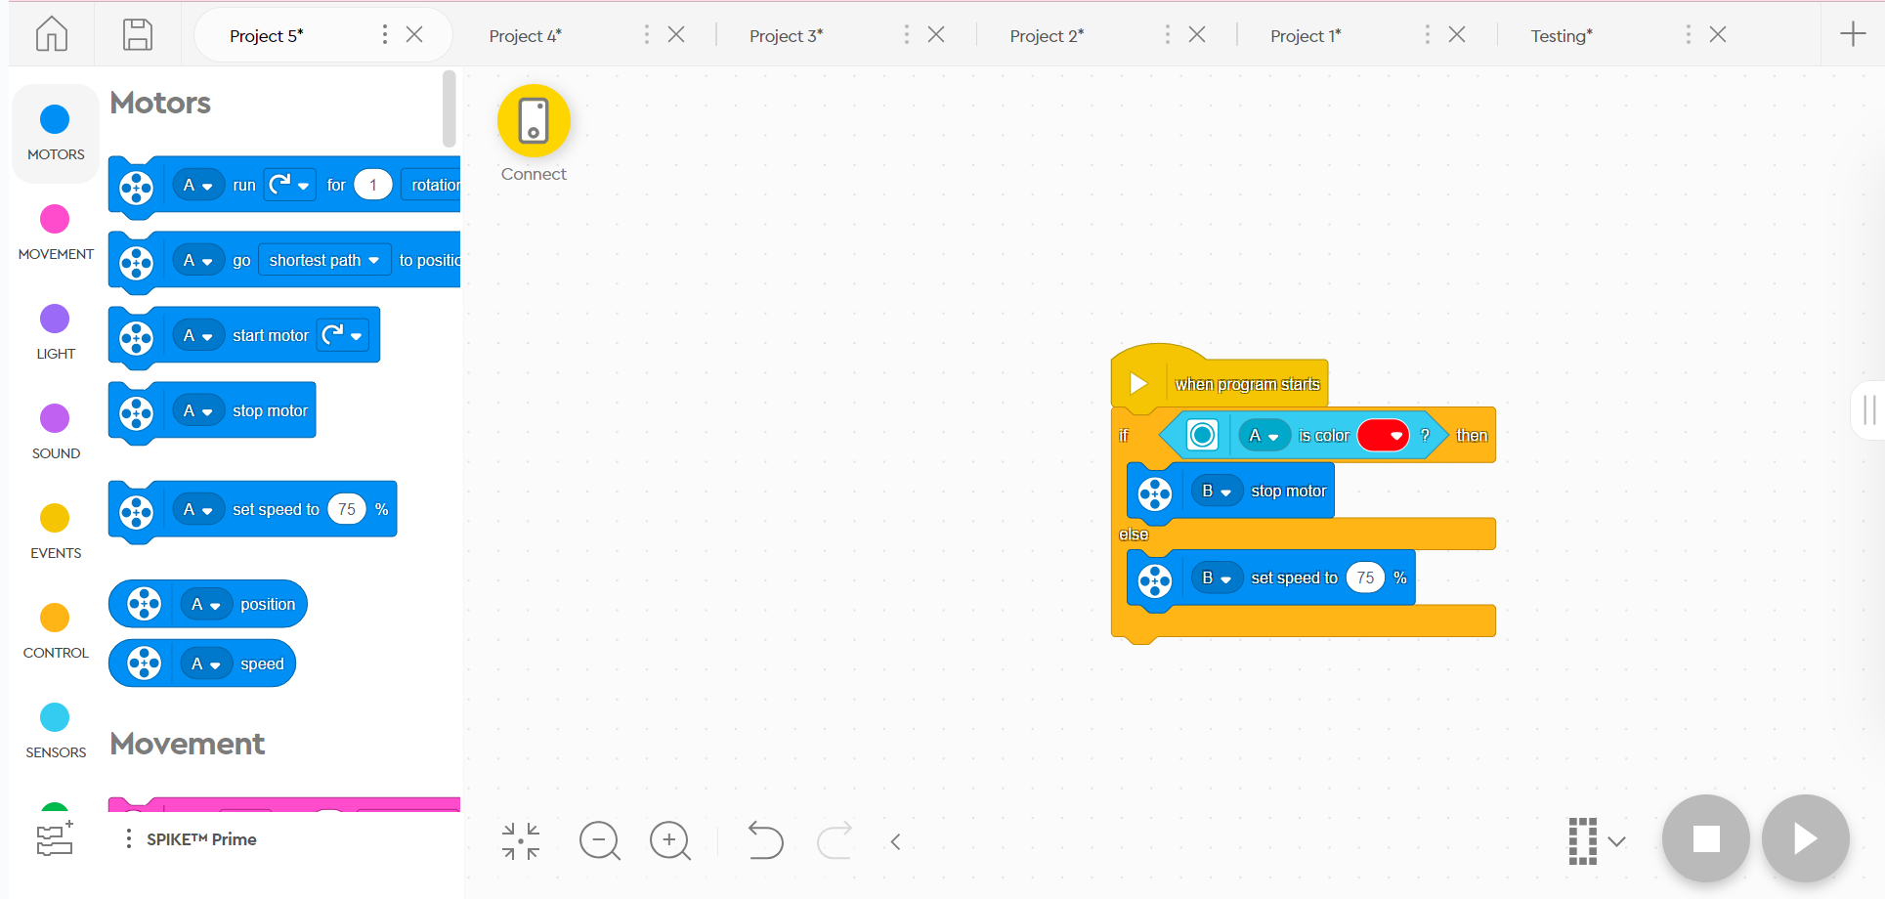

CHALLENGES
- Lay out different colors of paper, and code the robot to complete different actions depending on the color of paper it detects
- Gather an assortment of objects and record the reflectiveness of each object
- (Python only) Program the robot to emit a light source when it detects the environment is less than or equal to 50% brightness

Distance Sensor
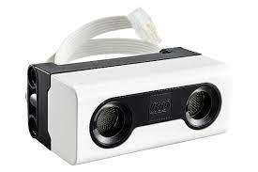
The distance sensor is able to measure the distance of an object / surface from the sensor using ultrasound. High frequency sound waves emit from the sensor and bounce off any object / surface ranging from 50 - 2,000mm away. The sensor determines how long it takes for the sound waves to return to the sensor. If you’re using python, you can also mess around with the sensor's “eyes” :) They consist of 4 LED segments that can be controlled individually. (Exploring SPIKETM)

Ex. The following program moves forward until it detects an object closer than 30cm from the robot, in which it turns right and continues moving forward.
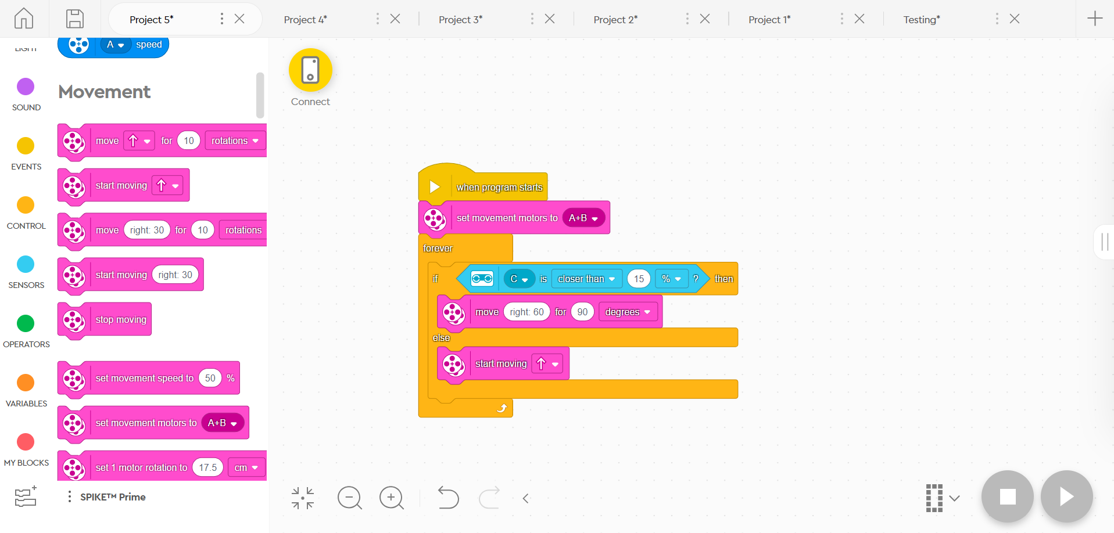

CHALLENGES
- Program the robot to change directions if it’s getting too close to an object / surface
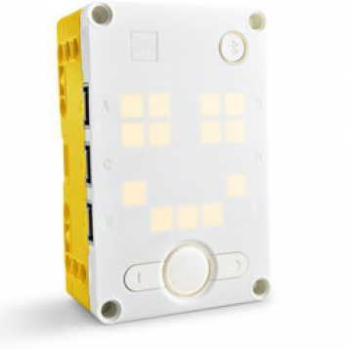
- Make the robot do a little dance if someone comes close to it
- Program the robot to move and stop before it hits something

Spike Prime Hub
This is essentially the heart of your robot. The Spike Prime Hub consists of 6 input / output ports (used to connect sensors and motors), a customizable 5x5 light matrix, Bluetooth connectivity, speaker, 6-axis gyro, rechargeable lithium-ion battery, and a micro USB port (used to connect to computers or tablets) (LEGO® Technic™). The Spike Prime Hub also has its own sensors built in, being a 3-axis accelerometer and a 3-axis gyroscope. This combination allows for the hub to determine its orientation (front, back, top, bottom, right side, left side). The gyroscope specifically is used to measure rotation of the 3 axes, being the yaw, the roll, and the pitch (Exploring SPIKETM). The diagram below, provided by Lego Education, gives a visual on what these measurements are:
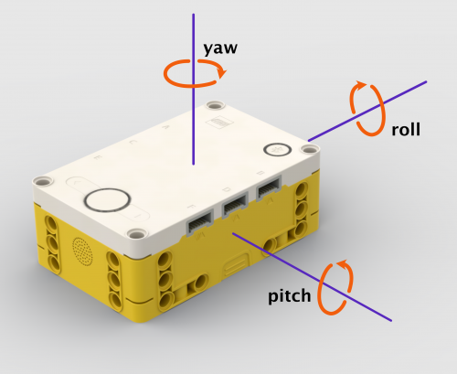
These sensors and their abilities can help program the robot to turn a specific amount, or detect if it has fallen over (Exploring SPIKETM).

Ex. The robot will only move if the Spike Prime Hub is facing upward.
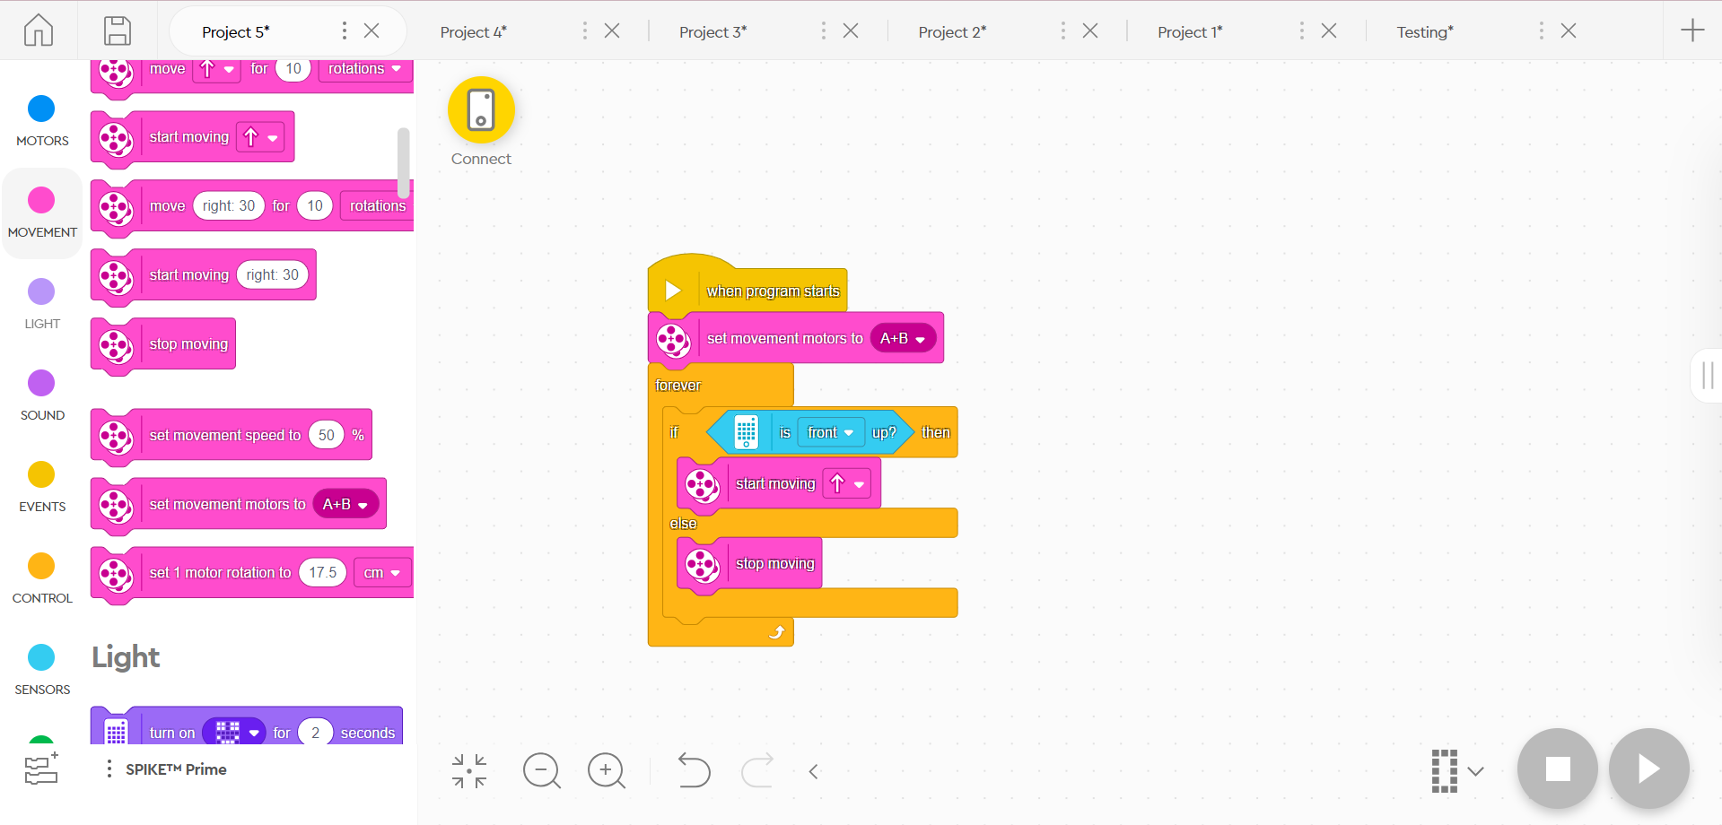

CHALLENGES
- Program the robot to turn a specific angle
- Have the robot react to being upside down

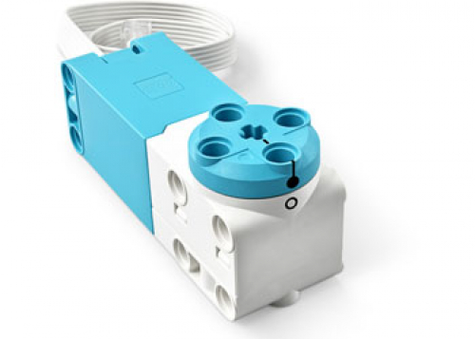
Large & Medium Motors
These motors contain internal rotation sensors that allow you to measure the speed and position of a motor. If you rotate the motor by hand, it’ll output its position (Exploring SPIKETM). Very useful if you want your robot to move a specific distance.

Ex. Motor A turns 180* in one direction, then 180* in the opposite direction
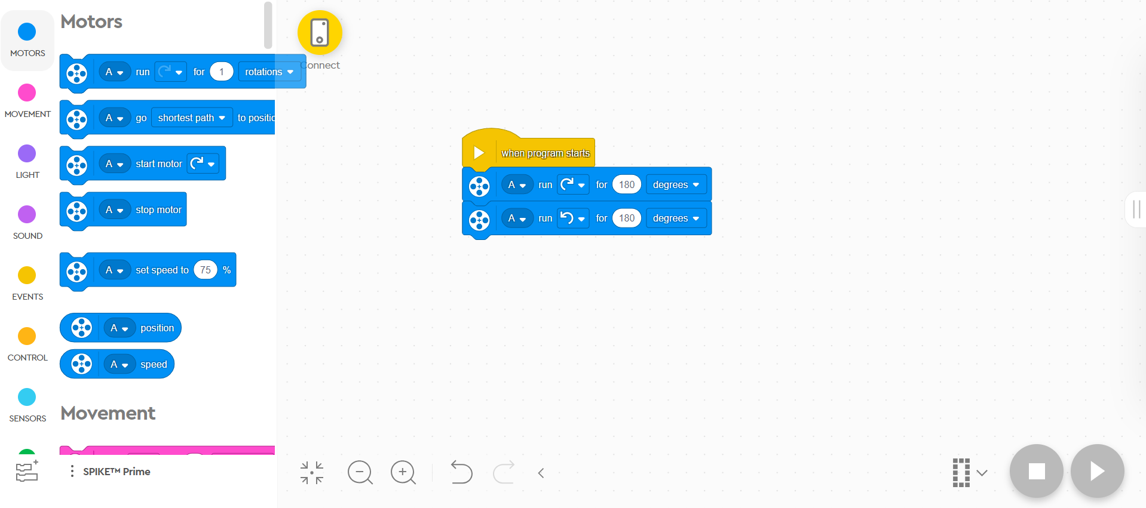

CHALLENGES
- Program the robot to travel to a marked point (specific distance)
- Create a combination lock out of one motor
- Program the robot to spin 180 degrees and then go straight, then spin 180 degrees a go straight again

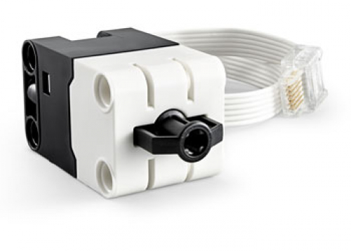
Force Sensor
The force sensor is capable of detecting if it’s being pressed, and the amount of force being exerted onto it. The measurement of force is given in Newtons or as a percentage, with 100% being equivalent to 10 Newtons (Exploring SPIKETM).

Ex. The robot moves forward until Force Sensor C is pushed all the way, in which the robot stops.
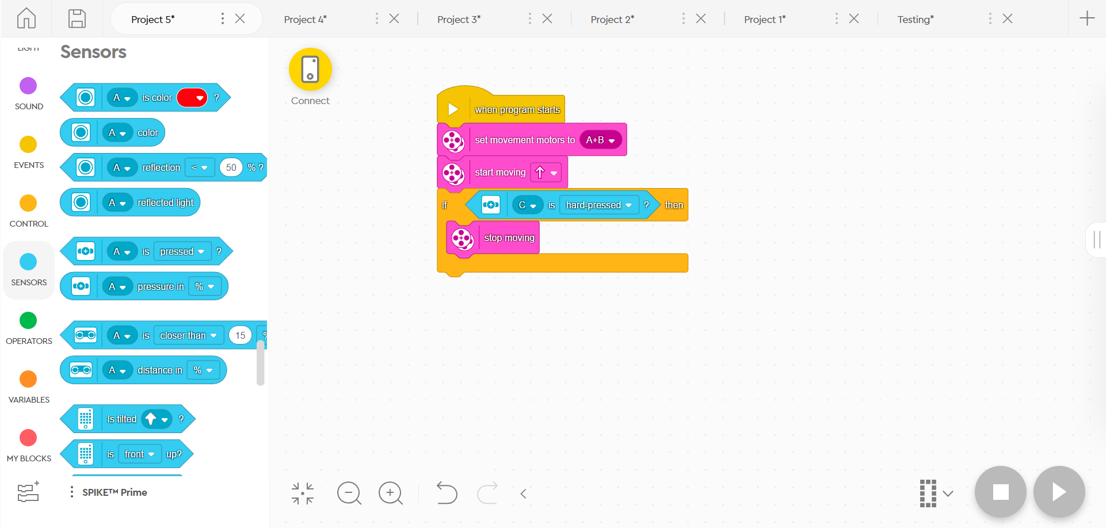

CHALLENGES
- Cookie Clicker: Have the robot count how many times the force sensor has been clicked
- Program the force sensor to be a remote control, changing the speed depending on how much force is exerted onto the sensor
- Program the robot to move when the sensor is pressed

CODING
To access the coding program for your robot, use this link: https://spike.legoeducation.com/prime/lobby/. You’ll be met with this screen:
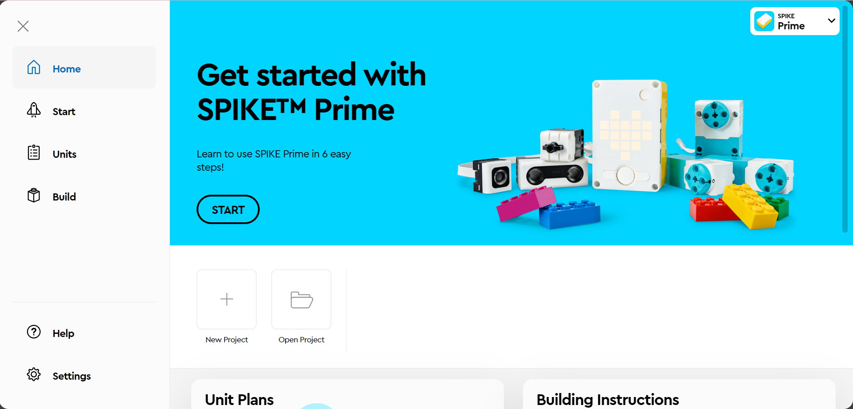

There’s for main sections of the page: Home, Start, Units, Build.
- “Home” is where you can open existing projects, or create new ones
- “Start” gives you tutorial activities on how to utilize various parts of the SPIKE kit
- “Units” will give you various activities / lessons for students to complete
- “Build” gives you instructions on how to build various robots, mechanisms, and objects

When creating a New Project, you’ll be presented different options for coding:
Icon Blocks
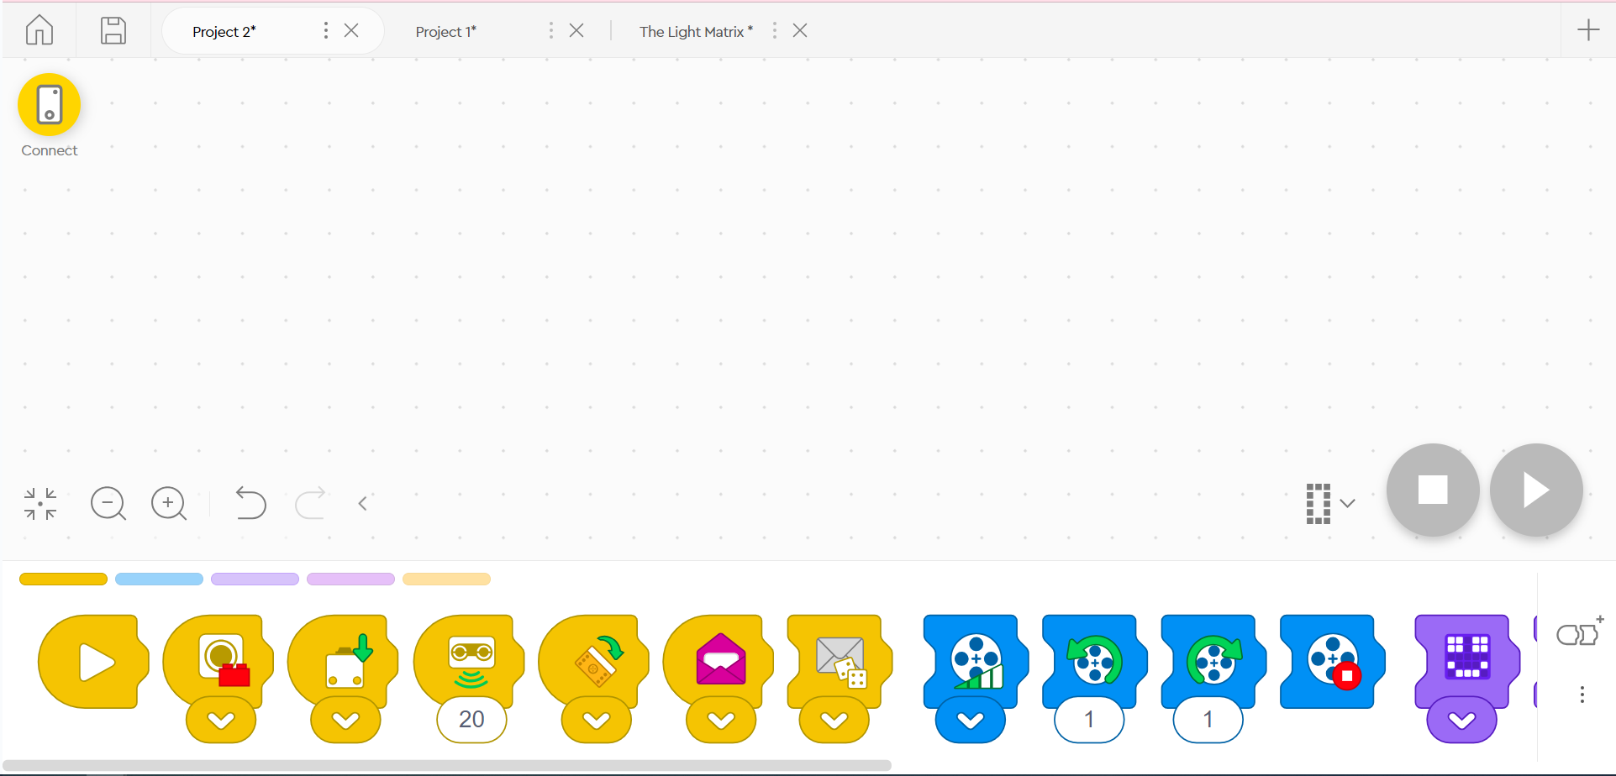
Icon Blocks are the simplest out of the 3 options, and perfect for beginners. You’ll be given blocks with icons that display what action will be performed by the robot. Some blocks have drop down menus for various options (ex. The color sensor has a drop down menu so you can select the color being detected). There’s also some blocks that require you to type numbers into them (ex. The “turn motor” block needs a number input for how many times the motor will spin)

The blocks come in 5 different colors:
- YELLOW -
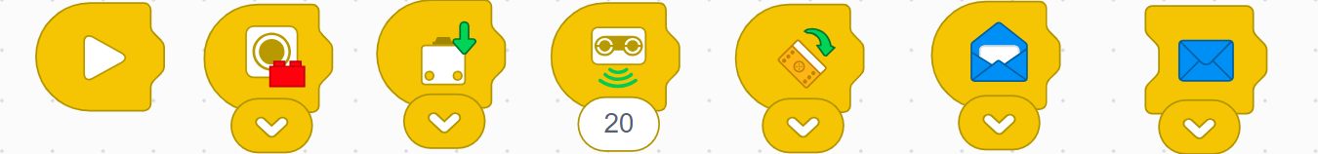
These blocks control sensors! You can detect color with the Color Sensor, detect if the Force Sensor has been pushed or released, detect objects up to 200mm away with the Distance Sensor, detect if the Spike Prime Hub has been tipped, and use the message blocks to “send a message” to a different string of actions to run those actions. This is also where you’ll find the “Start” block, which will allow your program to run.
- BLUE -
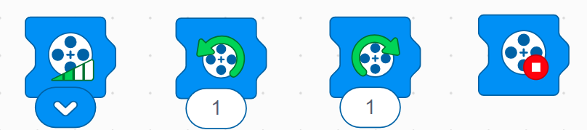
These blocks control motors! You can adjust the speed of a motor, control how many rotations a motor makes, and stop motors.
- PURPLE -
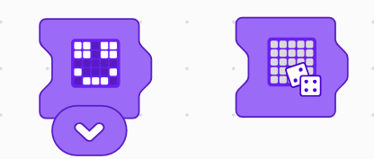
These blocks control the lights on the Spike Prime Hub! You can customize which lights activate, or randomize it!
- MAGENTA -
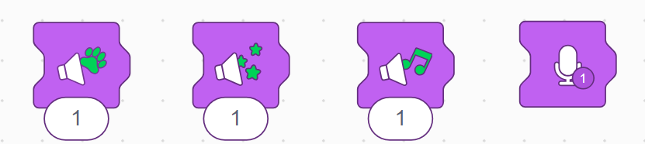
These blocks allow the robot to make sounds! The numbers change which sound plays, or you can record your own voice clips!
- ORANGE -
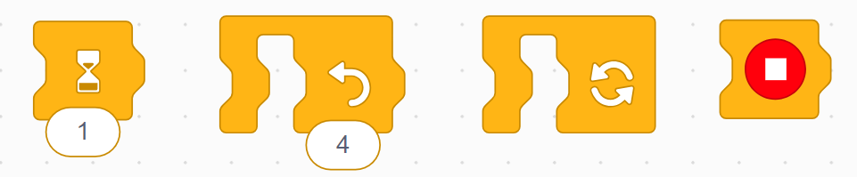
These blocks control how the code runs! You can make the robot wait for a set amount of seconds, repeat a specified number of times or infinitely, or stop entirely.

Word Blocks
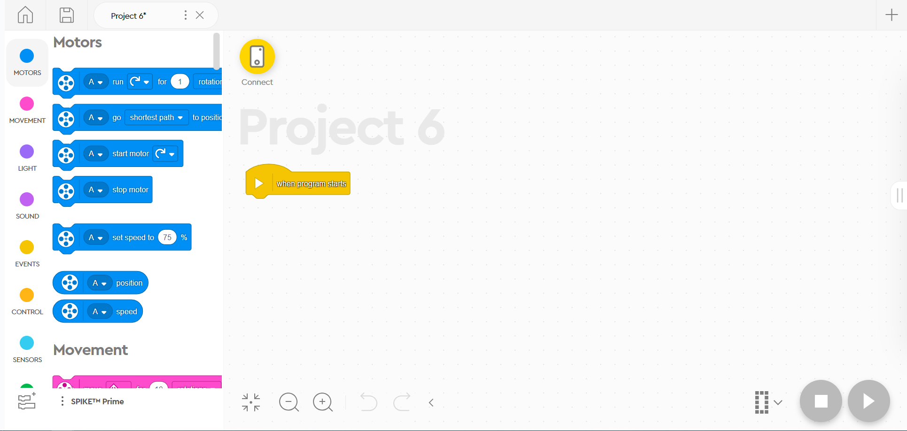
Word Blocks are very similar to Scratch programming. They connect to each other in a blocky format, similar to Icon Blocks, but they use words instead of icons. They also require a little more user input for each block, as well as a greater amount of blocks, allowing for more advanced movements of the robot.

There are 10 different sections for the blocks
- MOTORS - All of these blocks are blue. They allow you to set the position or speed of a motor. Each motor will be plugged into a port on the robot, all listed by letters. You can change which motor you want to control by clicking on the letter drop down menu on the block, and selecting one or multiple motors. 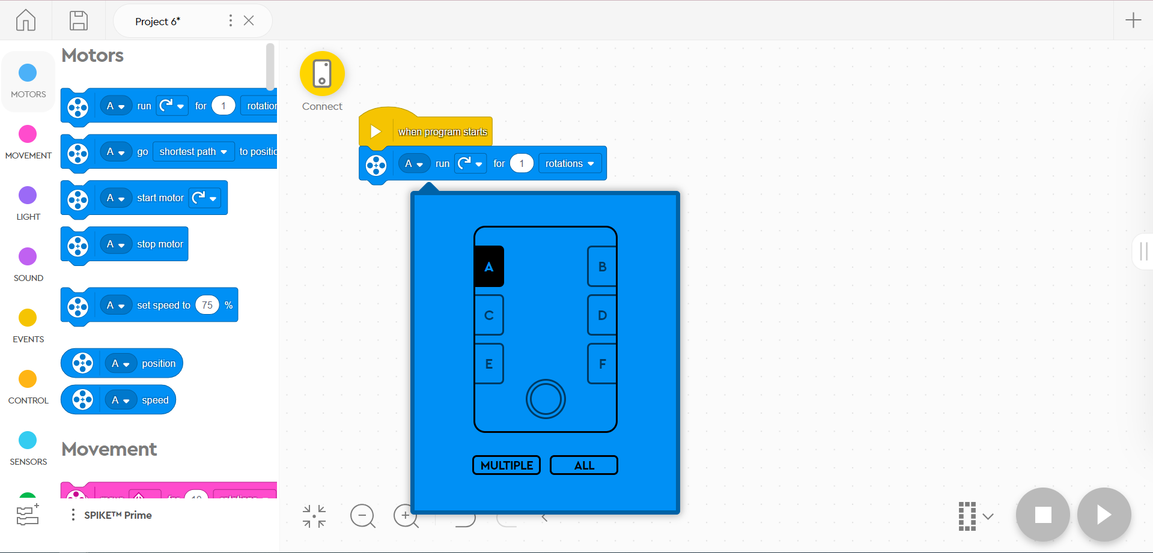
You can control how the motor runs by using rotation, degrees, seconds, or percentage. Rotations refer to how many times the motor makes a full rotation, degrees is the angle at which the motor turns, seconds is running the motor for a set amount of time, and percentage runs the motor at a set speed.
- MOVEMENT - All of these blocks are pink. They focus more on the overall movement of the robot, rather than just one motor. Movement motors can be set using the “set movement motors to ___”, with users having to set which motor ports to combine in order to make the robot move. Movement can also be measured by rotations, degrees, and seconds here, with the addition of inches and centimeters, measuring how far the robot moves.
- LIGHT - All of these blocks are purple. With these blocks, you can turn on and customize the light matrix in the Spike Prime Hub and light up the “eyes” on the distance sensor.
- SOUND - All of these blocks are magenta. These can make the robot play a variety of sounds, as well as set the pitch and volume of sounds.
- EVENTS - All of these blocks are yellow. They will start a list of actions if something happens. The most common one is “When program starts”, which will run a list of actions when you start the program on the robot. There are also others if a sensor detects something. This is also where you can find the “broadcast ____” block, where you can broadcast a message.
- CONTROL - All of these blocks are orange. These control how often actions happen. You can make the robot wait before doing another action, have actions repeat for a specific amount of time or forever, or stop the code.
- SENSORS - All of these blocks are turquoise. This is where you’ll find all of your sensor commands. You can use the Color Sensor, Force Sensor, Distance Sensor, and the accelerometer and gyroscope in the Spike Prime Hub. You can also set a timer in this section.
- OPERATORS - All of these blocks are green. If you like messing with math, you’ll like this section. You can do equations, use relational operators (<, >, =), create “and” or “or” statements, etc…
- VARIABLES - All of these blocks are two darker shades of orange. In this section, you can create your own variable or list. Variables are strings of text that can be associated with values. There are a variety of things you can do with variables, but we don’t recommend using them if you’re a beginner.
- MY BLOCKS - All of these blocks are red. This is where you can create your own blocks if a block you need doesn’t exist, creating more freedom when creating code.

Python
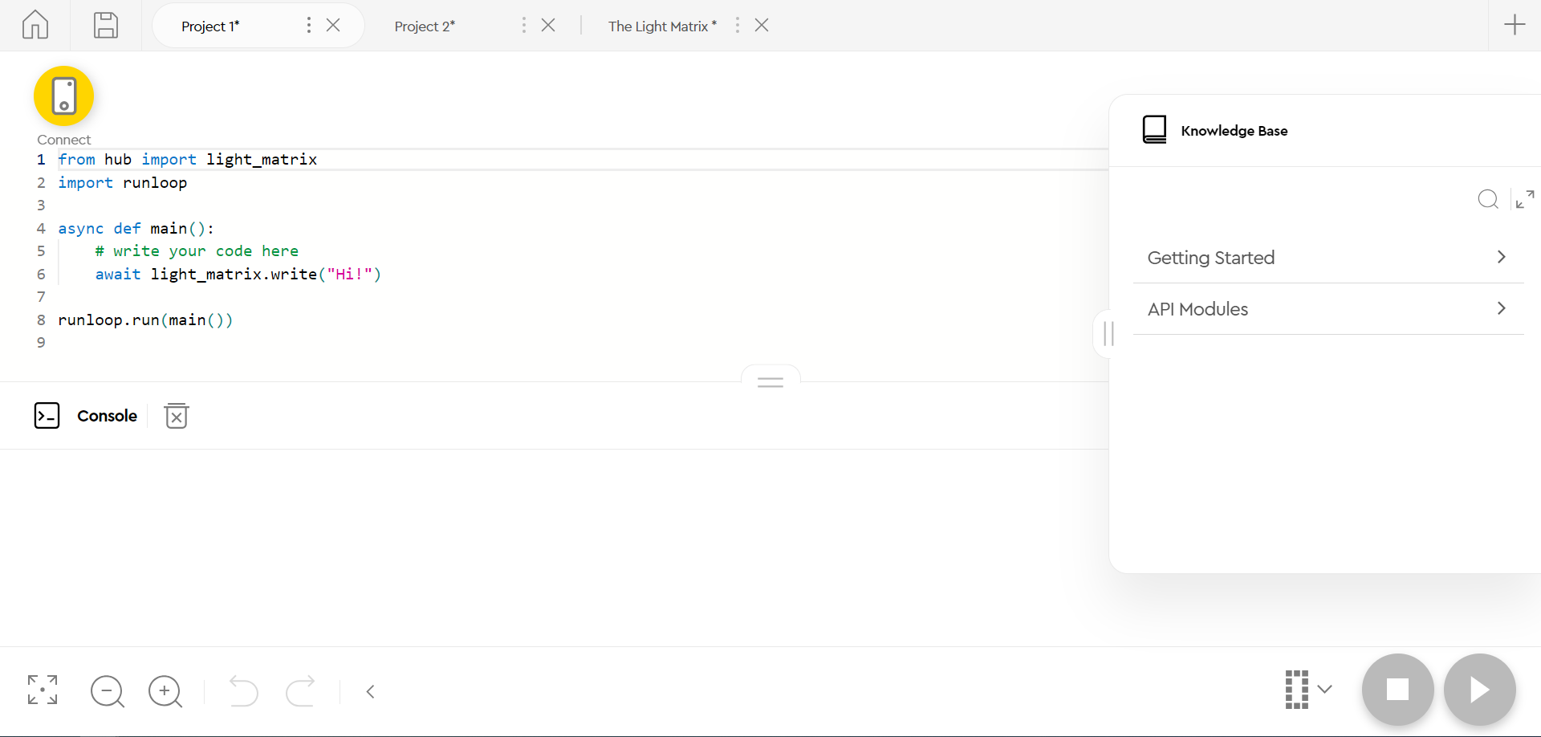
Python is the most advanced out of these options, because it’s straight up python code. This is great for anyone who would like a bit of a challenge, and would like to learn a pretty useful coding language. On the right hand side of the screen, there’s a “Knowledge Base”. Clicking “Getting Started” will bring students to a variety of useful information on how to get started with coding in Python.

Once you finish writing your code, you now need to upload it to the robot!
- Press the connect button
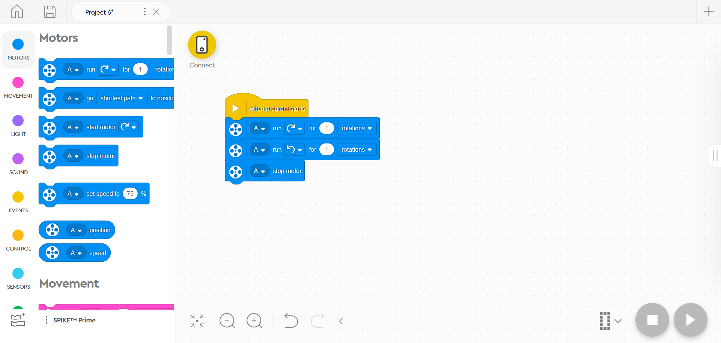

- Press the power button on the robot
- It will ask what color your power button glows
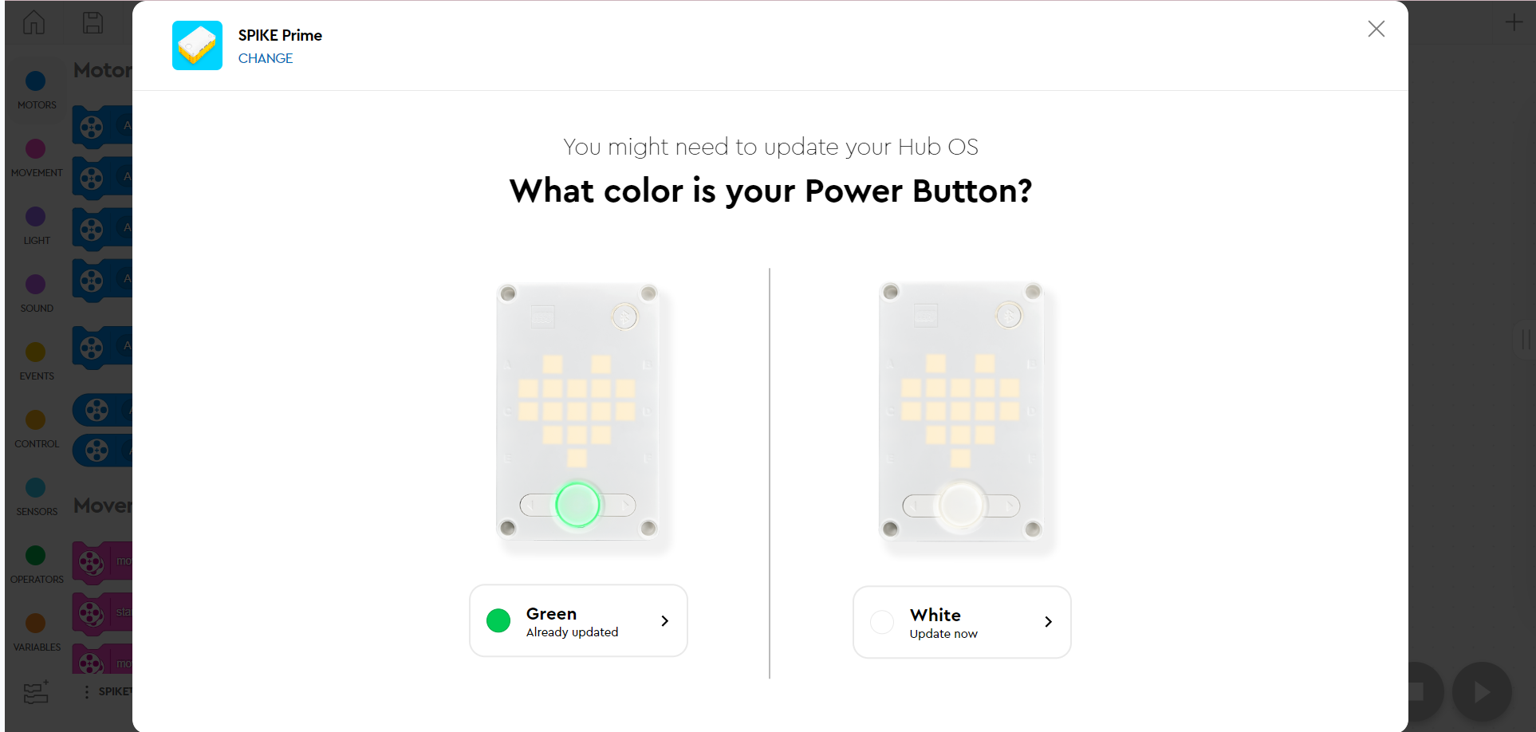
- After selecting color you will need to press the bluetooth button on the robot
- Then press the open button and you should be connected
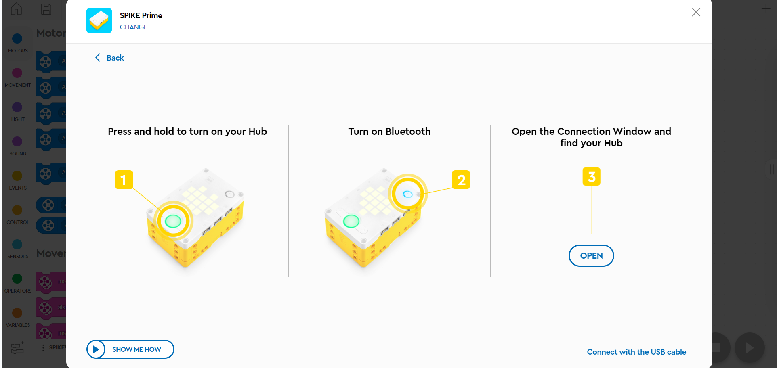

If you have trouble connecting wirelessly
- Follow previous steps 1-3
- After selecting your robots power button color instead of pressing open, click connect with usb cable

- After plugging your cable into both the computer and the robot, select open
