GlobalFoundries-Town of Malta Foundation awards annual grants for 2022

Foundation presents 12th consecutive year of grants to local organizations
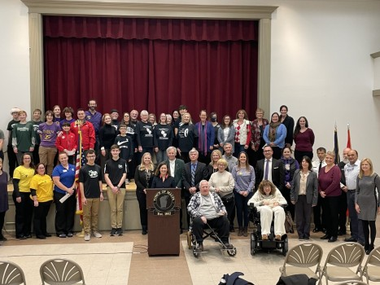
The GlobalFoundries-Town of Malta Foundation awards grants to the community each year. This year a total of $154,200 was awarded to 23 local organizations. (Photo provided)
By SARATOGIAN STAFF |
January 3, 2023 at 8:30 a.m.
MALTA, N.Y. — The GlobalFoundries-Town of Malta Foundation recently awarded its annual grants to the community for the 12th consecutive year, supporting a variety of community needs and programs with 23 grants totaling $154,200.
With the 2022 grants, the foundation, formed by GlobalFoundries Inc. and the Town of Malta, has placed more than $1.73 million into service in the Malta community since 2011.
In 2010, as part of the development of the Fab 8 project, GlobalFoundries invested a total of $5 million to fund two stand-alone 501 (c)3 charitable foundations: the GlobalFoundries-Town of Malta Foundation and the GlobalFoundries-Town of Stillwater Foundation. Each foundation is managed by a separate, independent board of directors and uses income earned from investments to fund a wide variety of local community programs.
The GlobalFoundries-Town of Malta Foundation was developed to fund organizations, programs and projects that provide tangible benefits of a public nature to diverse group serving the citizens of the Town of Malta including not-for-profit corporations, charitable organizations, community arts and theater groups, community historical sites, special events, education programs, and sports and recreation activities.
Each year, the GlobalFoundries-Town of Malta Foundation looks for projects that are creative, innovative, and inclusive in their scope and opportunities that will provide the maximum amount of benefit to the local Malta community.
This year’s Malta grant awards were presented in December at the David R. Meager Malta Community Center at the annual awards ceremony, where the foundation board and organization representatives celebrated funding the following projects and programs:
• Ballston Spa High School Parent Teacher Student Association (PTSA): $4,500
• Ballston Spa High School: $4,000
• Ballston Spa Soccer Club: $1,000
• Chango Elementary School: $3,500
• Community Foundation for the Greater Capital Region – Ballston Spa: $6,000
• Friends of Shenendehowa Crew, Inc.: $3,000
• Malta Avenue Elementary School Parent Teach Association (PTA): $3,500
• Malta Ridge Fire Company/Round Lake Fire Department/Fire Companies of Malta: $45,000
• Malta Senior Citizens, Inc.: $7,500
• Malta Spotlighter’s Theatre Troupe: $5,200
• Malta Veterans Appreciation Program: $10,000
• Malta Youth Commission: $4,200
• Miss Scotties Softball, Inc.: $2,500
• Rebuilding Together Saratoga County: $10,000
• Round Lake Library: $1,200
• Roundabout Runners Club: $6,000
• Rugrunners Robotics, Inc.: $10,000
• Saratoga Bridges: $10,000
• Saratoga Lake Protection and Improvement District: $3,000
• Saratoga Regional YMCA – Malta Branch: $1,500
• St. Peter Lutheran Church: $5,000
• Town of Malta Parks, Recreation and Human Services – Town of Malta Summer Concert Series: $3,600
• Town of Malta Parks, Recreation and Human Services: $2,000
• Town of Malta Veterans Committee: $2,000
The foundation’s history of giving includes:
• 2011: $37,500 to 13 local organizations
• 2012: $60,000 to 23 local organizations
• 2013: $164,000 to 38 local organizations
• 2014: $172,915 to 43 local organizations
• 2015: $160,853 to 39 local organizations
• 2016: $146,583 to 35 local organizations
• 2017: $159,000 to 38 local organizations
• 2018: $165,500 to 39 local organizations
• 2019: $160,437 to 41 local organizations
• 2020: $142,964 to 31 local organizations
• 2021: $159,767 to 24 local organizations
• 2022: $154,200 to 23 local organizations
Information on the 2023 grant application process will be available next August on the foundation website at https://sites.google.com/site/gfmaltafoundationorg/home.
GlobalFoundries, headquartered in Malta, is one of the world’s leading semiconductor manufacturers. More information about the company is available online at www.gf.com.

