THURSDAY, 03 NOVEMBER 2022 13:34

Robot Rumble Returns to BSHS
BY SARATOGA TODAY | EDUCATION
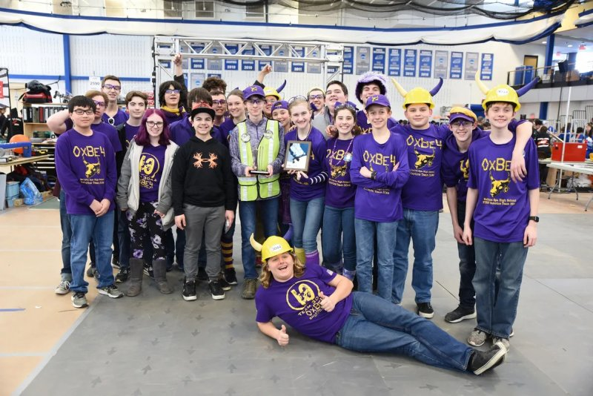Photo provided
- Google BookmarkFacebookTwitterPrintMore
BALLSTON SPA — Robotics teams from throughout the Capital Region, other areas of New York, Connecticut and Massachusetts will be convening at Ballston Spa High School on Saturday, Nov. 5 for the 2022 Robot Rumble Off-Season Robotics Competition. Those interested in learning more about the “For Inspiration and Recognition of Science and Technology” or FIRST programs are invited to stop by to see the teams and robots in action.The Robot Rumble will take place from 8:30 a.m. until 4 p.m. on Nov. 5 at the Ballston Spa High School, located at 220 Ballston Avenue in Ballston Spa. The event is free and open to the public.
FIRST Robotics competitions combine the excitement of sport with the rigors of science, technology and engineering. Under strict rules, limited resources, and time limits, teams of 15 students or more are challenged to raise funds, design a team “brand,” hone teamwork skills and build and program robots to perform prescribed tasks against a field of competitors. Volunteer professional mentors lend their time and talents to guide each team. Through the program, students get to learn 21st century skills; build and compete with a robot of their own design; learn to use sophisticated software and hardware; and compete and cooperate in alliances and tournaments. The FIRST programs provide students interested in the STEM fields with real-world engineering in a high school setting.
“Ballston Spa High School is excited to be able to host this great opportunity to interest students in the STEM fields again after not being able to hold the event for the last two years due to the pandemic,” said the school district in a statement. Four area FIRST Robotics teams from Ballston Spa, Shenendehowa, Shaker, and Colonie have collaborated to organize this year’s event. The GlobalFoundries / Town of Malta Foundation provided a grant that will allow the FIRST competition’s Rapid React from last season to be brought to Ballston Spa High School for the Robot Rumble event. Off-season competitions provide an opportunity for teams to have fun and to recruit new students, industry mentors and sponsors as they begin preparing for the FIRST Robotics Regional Competition in March 2023.
Similar competitions for elementary and middle school aged students will take place in December and January. The 2023 season for the FIRST Robotics Competition teams begins in January 2023 with a regional event being held at the Times Union Center on March 30th to April 1st. For more information on the robotics program please visit the team website at FRCTeam3044.team or follow the twitter feed @OxBe4. Please contact Ballston Spa K-12 STEM Coordinator Diane Irwin at the Ballston Spa High School (884-7150) for additional information on the district’s robotics initiatives or by email at dirwin@bscsd.org.

