CAPITAL REGION

Robotics team shows off skills
March 25, 2011
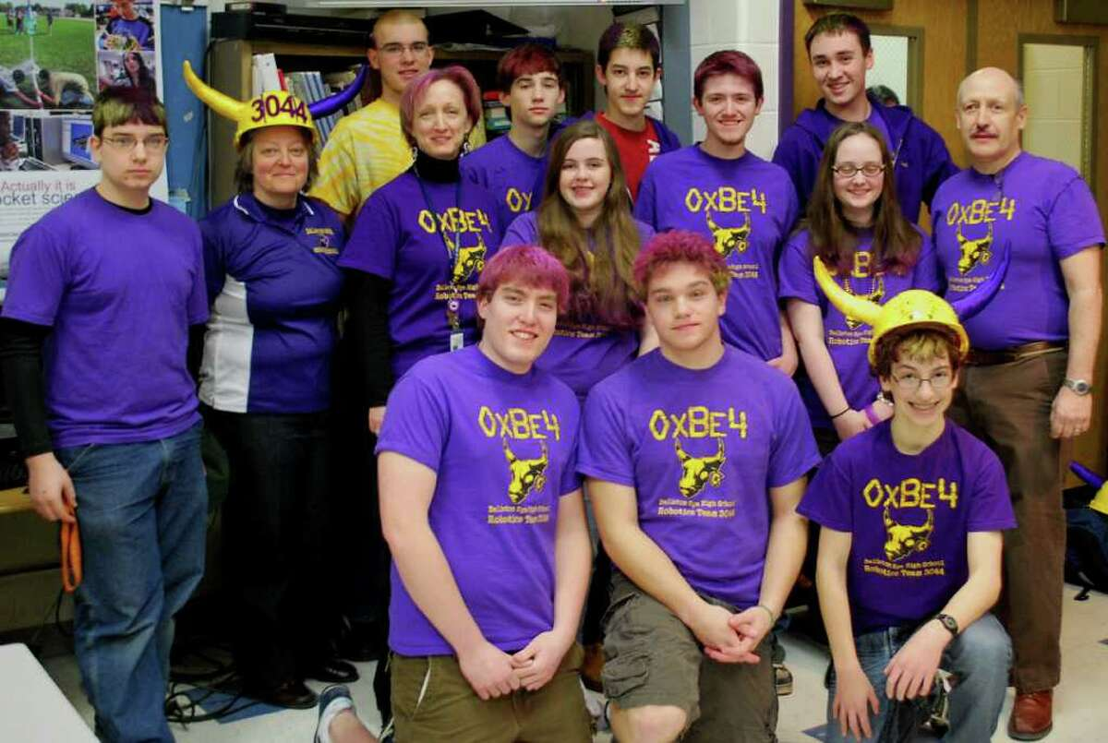Members of the robotics team from Ballston Spa High School include, from left, back row, Jeff Carminati, Jeremy Hoose, Ryan Gifford and Jared Farrar; middle row, Andrew Campese, Principal Kristi Jensen, Mentor Cindy Van Wyk, Lauren Brady-Haskell, Tom Havens, Claire Freehafer and Mentor Greg Roberts; front row, Jake Torrey, Mike Mahoney and Mike Maiellaro.
BALLSTON SPA -- Dedication and hard work paid off for 20 Ballston Spa High School students at the recent FIRST Robotics Regional Competition in Worcester, Mass.
Even after their mini robot, Squee, was run over by larger robots, the team proved itself and was chosen to take part in the semifinals.
"This is a big accomplishment and means that the team was recognized as a team that is competitive," said Cindy Van Wyk, a chemistry teacher at the school who helps mentor the robotics team.
The FIRST (For Inspiration and Recognition of Science and Technology) program was founded by inventor and entrepreneur Dean Kamen to inspire high school students to pursue careers in science, technology, and engineering. The effort appears to be working at Ballston Spa: At least three seniors who are members of the robotics club say they plan to major in engineering in college, including Jake Torrey, the team's co-captain, Lauren Haskell, a first-year club member who originally considered a music major, and co-captain Mike Mahoney, who plans to attend Cornell University.
The FIRST program pairs students with engineers, computer programmers and other professionals to create robots designed to carry out specific tasks at competitions. Participating students also have a chance to receive more than $12 million in scholarships from some of the best science, technology, and engineering schools in the country. This year six teams from the Capital Region competed at Worcester. The top teams from around the country will square off in April at the FIRST Championships in St. Louis.
Van Wyk said the program is an enriching experience for students who take part.
"FIRST Robotics enables them to take what they learn in class and expands on it," she said.
The theme of the Worcester competition was ''Logo Motion.'' Teams were required to build robots designed to hang inflatable rings on posts at different heights. Teams could also gain bonus points by building a second, smaller robot.
In January, the team received a kit that included motors, batteries, a control system, a PC, and a mix of automation components -- but no directions. They had just six weeks to design and create their main robot.
Mahoney estimated that the team spent 2,000 hours creating their main robot, named Rosie, and Squee, fitting in the hours around jobs and schoolwork.

