Know Your Numbers!

If it’s not Measured - it’s not Managed
The golden rule of the shop. In the auto repair world, many owners are brilliant under the hood but feel like they’re driving blind when they step into the office. Without the right data, you’re just "working hard" while profits leak out through the bay doors.
To move you, the owner, from "greasy-fingers or service advisor" to "CEO," you need to master these 4 financial principles.
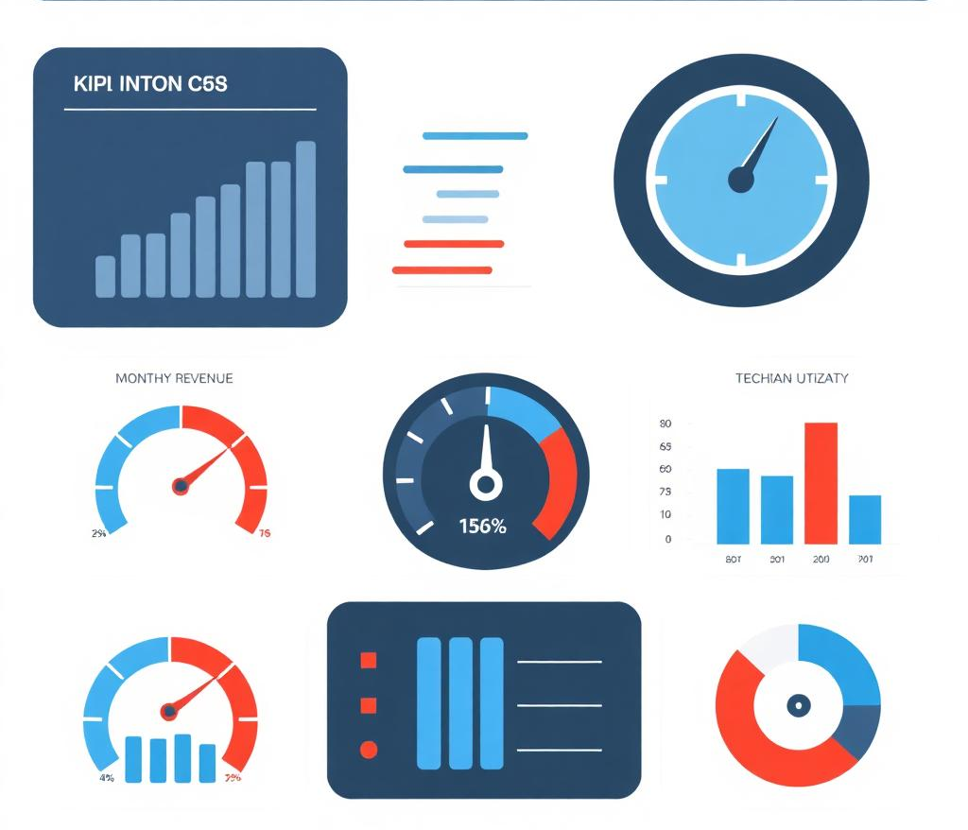

1. The "Big Three" Efficiency Metrics
These tell you if your talent is actually making you money or just keeping the lights on.
- Productivity: Are your techs clocked in and actually turning wrenches?
- Efficiency: If the book says a job takes 2 hours, is your tech finishing in 1.5 or 3?
- Effective Labor Rate (ELR): This is the "real" money. If your door rate is $150, but discounts and slow techs bring the actual collected revenue per hour down to $90, you have a massive leak.

2. Gross Profit (GP) Targets
In auto repair, your GP should be a non-negotiable benchmark. If you aren't hitting the right numbers, your business is "surviving," not "thriving." You need to monitor Parts, Tires, and Labor GP.
3. The ARO (Average Repair Order)
The ARO is the pulse of the service advisor.
- Low ARO usually means the team is "order-taking" (just doing what the customer asked) rather than "health-checking" (performing Digital Vehicle Inspections).
- The Goal: Increase the ARO through education and transparency, not high-pressure sales.

4. Marketing ROI (Acquisition Cost)
Owners often throw money at "the internet" and hope for the best. They need to measure:
- Customer Acquisition Cost (CAC): How much did you spend to get one new car?
- Retention Rate: It’s 5x cheaper to keep a customer than to find a new one. If they aren't coming back for their next oil change, your marketing is a bucket with a hole in it.

How we can help you:
In the simplest terms, we measure your Key Performance Indicator (KPI).
Think of KPIs as the dashboard gauges of the business. Just like a car has a temperature gauge to warn you before the engine blows up or a fuel gauge to tell you when you're running empty, KPIs tell you if the business is healthy or heading for a breakdown.
Without KPIs, an owner is driving a car with a blacked-out instrument cluster—they might be moving, but they have no idea how fast they’re going or if they’re about to overheat.

The Three Parts of a KPI management
To be effective in an auto shop, your KPIs must be:
- Measurable: You can put a specific number on it (e.g., "$450 ARO").
- Influencable: The team can actually do something to change it (e.g., performing more inspections).
- Critical: It actually matters to the bottom line (e.g., tracking "number of floor sweeps" isn't a KPI; tracking "billable hours" is).
We can help you analyze your numbers. A good "Weekly KPI Report" needs to be more than a spreadsheet—it needs to be a story. It should tell you, the owner, exactly where you won, where you lost, and what you need to fix immediately.



