Preferred Vendors List
( from Makeup by Maggie Rose)

Type | Business | Sample of Work | Information
Photographer | D. Batista Photography | 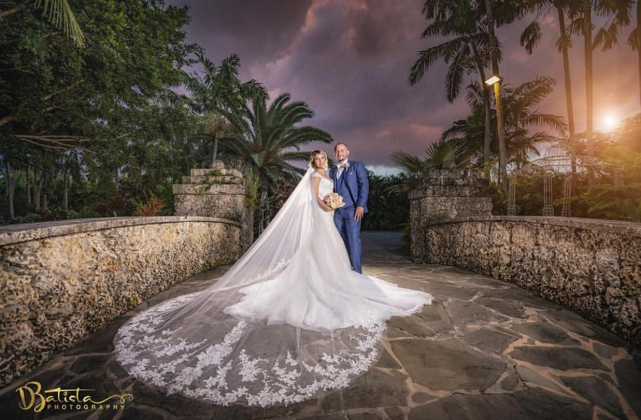 | Orlando/On Location Photographer.  407-925-8594
Photographer | Nikki B. Photography | 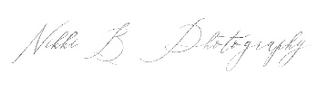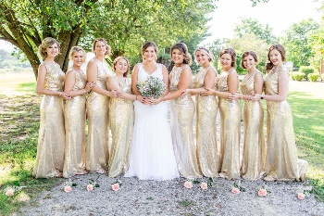 | Jacksonville/On location Photographer.  904-376-0314
Photographer | Liz Scavilla Photography |   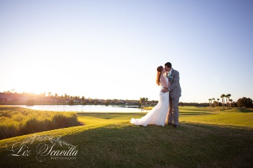 | Ormond Beach/On Location Photographer.  774-236-9420
DJ/Entertainment | DJ Dynasty Entertainment |   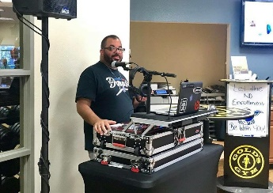 | Daytona Beach/On Location  407-308-0337

Venue | The Crystal Ballroom  At Sunset Harbor |   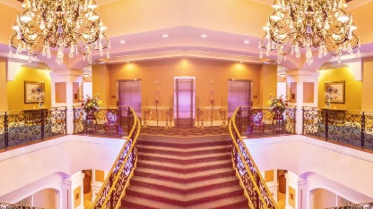 | Daytona Beach, FL.  Inside Venue as well as overlooking the ocean.  386-301-4040
Wedding Planner/Beach Wedding/Officiant Services | Paradise Beach Weddings |   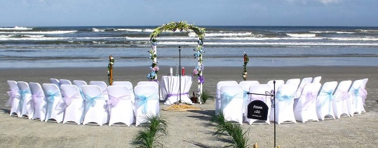 | New Smyrna Beach, FL.  Outside Ceremony Services (specialize in beach weddings).  386-401-9698
Bridal Dress Shop | Lola Grace Bridal | 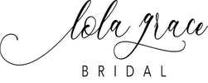  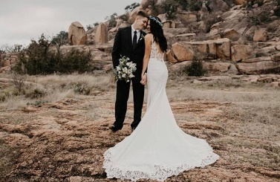 | Daytona Beach, FL.  Bridal Dress Shop located in the heart of Daytona Beach.  386-310-4907
Florist | Impekable Designs |    | Deland, FL/On Location of your choice.  386-785-8719

