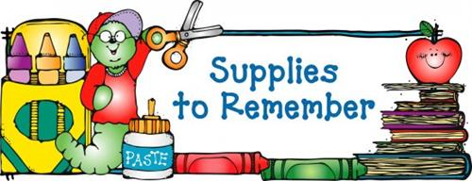

K-3 Classroom Supply List
- (2) boxes of Kleenex
- (2) packages of Wet-Wipes
- (4) boxes of 24 count Crayola Crayons
- (2) packs of Glue Sticks
- Regular Sized book bag (no wheels & it must fit into the cubby)
- (1) pack of small paint brushes for kids
- (1)- 1 inch Durable View Binder w/ clear pocket on front of binder - “D” Ring
(no black binders please)

Personal Items Needed:
- Complete Change of Clothing; pants/shorts, shirt, underwear, and socks. Please send in a Ziploc Bag with your child’s name on the outside.
- Crib Size blanket and small soft stuffed animal for naptime.
Please note: All nap items are to remain at school for the week. Please do not send a ‘special’ blanket or animal that would need to go home daily.
- Reusable Water Bottle
- Please label all clothing and nap items with your child’ name.

Classroom Wish List for Student Treasure Box (small items such as):
- Bracelets
- Matchbox Cars
- Rings
- Party Size Favors, i.e. bubbles, stamps, mini Play-Doh, Slinkies, etc…
- Candies- suckers, tootsie rolls, sweet tarts, etc… (no small hard candies)

Thank you,
K3 Teachers

