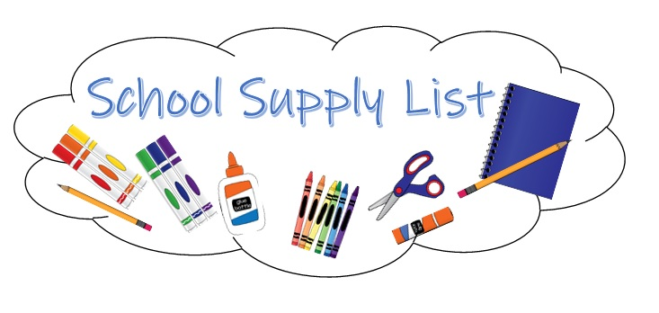

K-4 Student Supply List
- (1)- 1 inch Durable View Binder w/ clear pocket on front of binder - “D” Ring
(no black binders please)
- (2) boxes of Kleenex
- (3) packages of Baby-Wipes
- (4) boxes of 24 count Crayola Crayons
- (8) small glue sticks (NO jumbo sizes please)
- (1) pair of children’s blunt tip scissors (Fiskar’s)
- (1) pack of Dry Erase Markers
- 1 Pack of pencil top erasers
- Regular sized book bag (no wheels & it must fit into the cubby)
- Oversized T-shirt for Art Projects

Personal Items Needed:
- Complete Change of Clothing; pants/shorts, shirt, underwear, and socks. Please send in a Ziploc Bag with your child’s name on the outside.
- Crib Size blanket and small soft stuffed animal for naptime.
Please note: All nap items are to remain at school for the week. Please do not send a ‘special’ blanket or animal that would need to go home daily.
- Reusable Water Bottle
- Please label all clothing and nap items with your child’ name.

Classroom Wish List for Student Treasure Box: (small items such as)
- Bracelets and Rings
- Matchbox Cars
- Party Size Favors, i.e. bubbles, note pads, mini Play-Doh, Slinkies, etc…
- Candy for Special Work Awards
Such as: Smarties, Dum Dum Pops, Tootsie Rolls (chocolate or fruit) and starburst. NO HARD CANDIES. NO large BULK bags please.
Note: All candy must be individually wrapped

Thank you,
K4 Teachers

