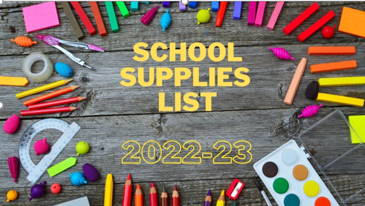

**Kindergarten Student Supply List**

* Book bag (no wheels)
* (1)- 1 inch Durable View Binder w/ clear pocket on front of binder - “D” Ring

(no black binders please)

* (2) boxes of Kleenex
* (1) pack of Baby-Wipes
* Plastic Pencil box (no zippers)
* Pencils – small pack
* (4) boxes of 24 count Crayola Crayons
* 1 – 8 pack Crayola markers
* (1) pair of children’s blunt tip scissors (Fiskar’s)
* 4     **regular** size cans of Play-Doh in any color with child's name on it.

**Personal Items Needed:**

* Complete Change of Clothing; pants/shorts, shirt, underwear, and socks. Please send/keep in your child’s bookbag in case of emergency.
* Reusable Water Bottle

Note: Please label all items with your child’s name.

**Classroom Wish List for Student Treasure Box: (small items such as)**

* Bracelets and Rings
* Matchbox Cars
* Party Size Favors, i.e. bubbles, note pads, mini Play-Doh, Slinkies, etc…
* Candy for Special Work Awards

Such as: Smarties, Dum Dum Pops, Tootsie Rolls (chocolate or fruit) and starburst. NO HARD CANDIES. NO large BULK bags please. Note: All candy must be individually wrapped

Thank you,

Kindergarten Teacher