FEE SCHEDULE AGREEMENT – PRIVATE INSURANCE

Client Fiscal Responsibility Policy

I understand that I am expected to pay the agreed upon fee at the time services are rendered.

Proof of income may be required for sliding scale options. (Copy of income tax return or recent pay stub.)

**These are the cash rates charged by ITS of OK and the rates billed to insurance – contracted rates can vary by insurance company.

The fee for intake services is $250.00 per intake.

The fee for psychotherapy services is $200.00 per hour.

The fee for psychosocial rehabilitation and case management is $50.00 per hour.

Group Psychotherapy is $20.00 per person per hour.

Group Psychosocial rehabilitation is $10.00 per person per hour.

**Requests for court-related services may incur additional costs. These services have a base rate of $200 PER HOUR.

I understand that I am expected to pay my session fees not covered by insurance, fees due as part of co-insurance or deductibles required by insurance at the time services are rendered – or if a missed appointment fee is charged. Missed session fee: _______________

I agree to provide Integrated Therapy Solutions of Oklahoma, LLC with a credit/debit card to keep on file to bill sessions fees AND MISSED APPOINTMENT FEES; I consent to the billing of session fees through a remote biller.

Past Due Accounts: If your account becomes past due, and we have to refer your account to a collection agency, you agree to pay a collection fee of 35% of your delinquent amount. If the collection agency is unable to collect your balance due and pursues litigation, you agree to pay an increased collection fee of 50% of your delinquent amount.

___________________________________________ ____________________________________________
Client/Guardian Signature Date Staff Signature with Credentials Date

SAMPLE SLIDING FEE SCHEDULE

Maximum Annual Income Amounts for each Sliding Fee Percentage Category (except for 0
percent discount)

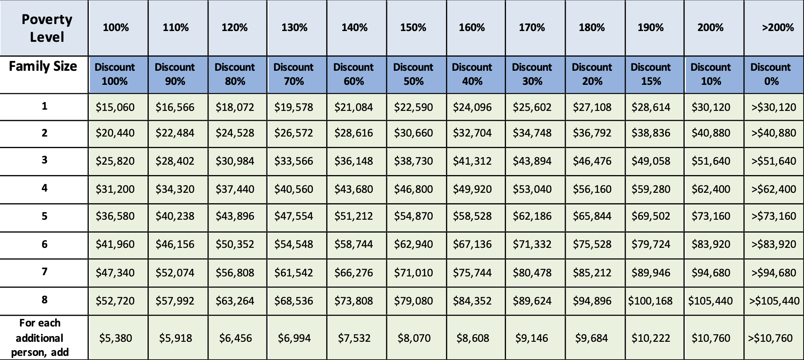

*Based on the 2024 Federal Poverty Guidelines for the 48 contiguous states and the District of
Columbia. Please note that there are separate guidelines for Alaska and Hawaii, and that the thresholds
would differ for sites in those two states. Sites in Puerto Rico and other outlying jurisdictions would use
the above guidelines.

