FEE SCHEDULE AGREEMENT

Client Fiscal Responsibility Policy

I understand that I am expected to pay the agreed upon fee at the time services are rendered.

Proof of income may be required. (Copy of income tax return or recent pay stub.)

The fee for intake services is $250.00 per intake.

The fee for psychotherapy services is $200.00 per hour.

The fee for psychosocial rehabilitation and case management is $50.00 per hour.

Group Psychotherapy is $20.00 per person per hour.

Group Psychosocial rehabilitation is $10.00 per person per hour.

I will talk to my therapist if I am unable to for any reason to abide by the above regulations.

**Requests for court-related services may incur additional costs as they are not SoonerCare approved services. These services have a base rate of $200 PER HOUR.

Medical Records Requests: Base rate is $25 for the first 75 pages and $0.10/per page after + cost of mailing (if requested). Invoice must be paid in full before request is processed.

I understand that I am expected to pay my insurance co-payment in the amount of $__0___ at the time services are rendered for therapy services. (Court costs and medical records requests not included)

Sliding Scale Fee has been adjusted from 100% to _0_%, due to:__SoonerCare Coverage ___.

(We) agree to the (adjusted) fee of $__0__. (Court costs and medical records requests not included)

I acknowledge that failure to provide appropriate insurance information, including coverage other than SoonerCare will result in full financial responsibility for any sessions and services accrued.

___________________________________________ ____________________________________________
Client/Guardian Signature Date Staff Signature with Credentials Date

SAMPLE SLIDING FEE SCHEDULE

Maximum Annual Income Amounts for each Sliding Fee Percentage Category (except for 0
percent discount)

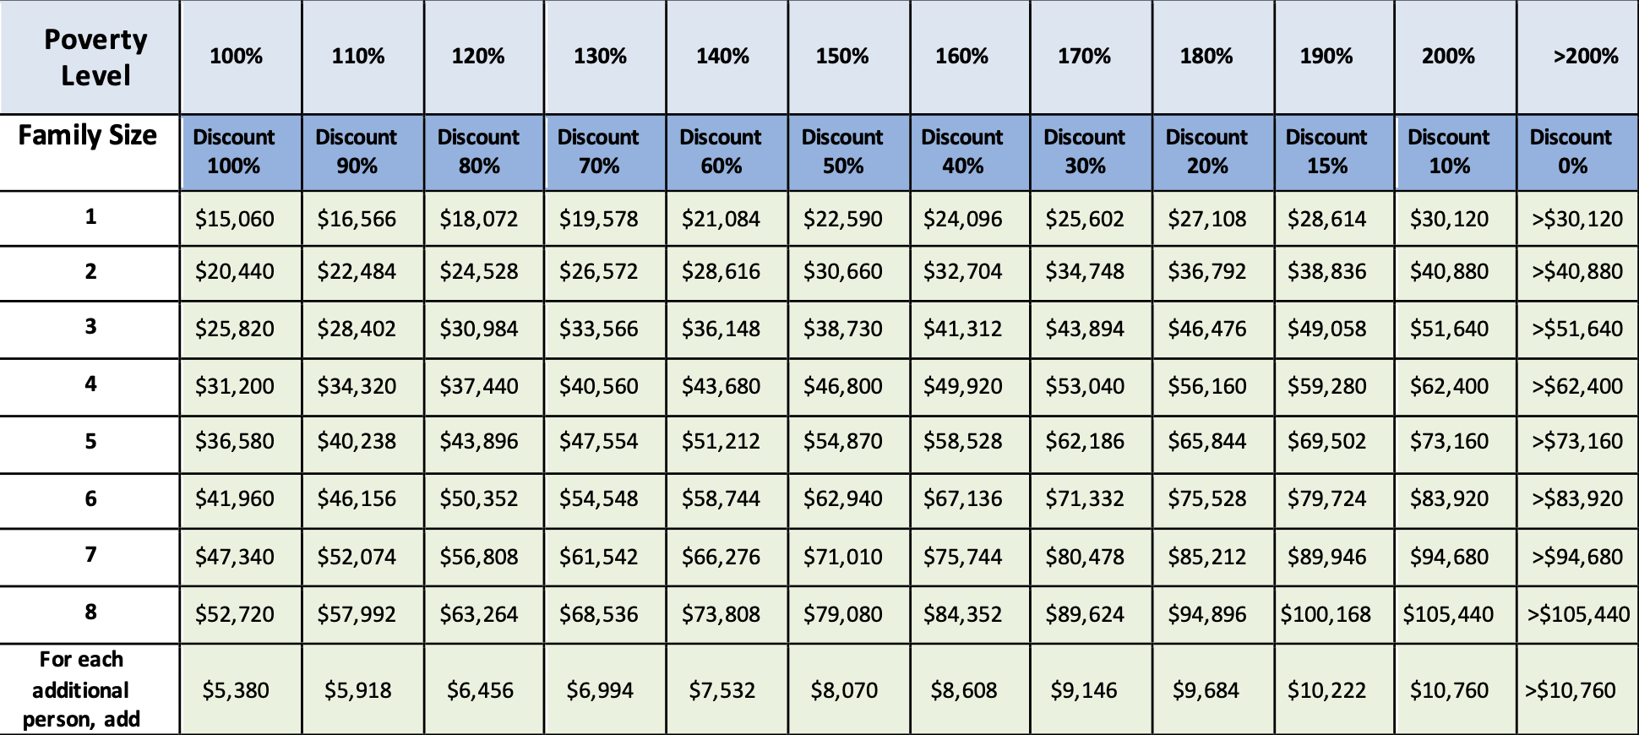

*Based on the 2024 Federal Poverty Guidelines for the 48 contiguous states and the District of
Columbia. Please note that there are separate guidelines for Alaska and Hawaii, and that the thresholds
would differ for sites in those two states. Sites in Puerto Rico and other outlying jurisdictions would use
the above guidelines.

