There are a variety of ‘scorecards’ in use today in the business world, across the government and the military. Scorecards can be developed at many levels including: strategic, balanced, financial, operational, and tactical. This paper will focus on is the development and implementation of operational scorecards.

Most manager when first faced with the requirement to develop an operational scorecard have five primary questions:

* What is an operational scorecard?
* What will this scorecard do for me as a manager?
* What will this scorecard do for the operation?
* What will this scorecard do for the workforce?
* What will this scorecard do for the Board of Directors?
* How do we develop these scorecards – and how much time and effort will this scorecard require?

**What is an operational scorecard?**

An operational scorecard is a management tool that will help you better manage your operation by developing a set of performance metrics tailored to your operation. The ‘operation’ can be an entire company, a single division, a line of business formed by multiple operations, a single program, a single project or a series of linked projects.

The scorecard will display the performance metrics on a frequency agreed to by you and your senior management. It will assist you in tracking the status of your operation and indicate trends for your operation. And it will also serve as a communications tool to assist you in telling the real story of your operation. It will quickly become the backbone of your management process.

There are many different formats for operational scorecards, which range from the simple spreadsheet to the more complex balanced scorecard type. There are scorecards built in Microsoft Excel and there are elaborate standalone scorecard programs costing thousands of dollars. The simple scorecards have a single level of measurement while the more complex programs can provide multiple levels and linkages. Some programs will perform trend analysis while others require trend analysis to be done ‘off scorecard’.

It is your choice as to which style and level of complexity best fits you and your operation. Dunkirk Partners will provide you with a basic scorecard built in Excel as part of any scorecard development assignment and instruct your operation’s staff on its utilization and maintenance.

Example: Spreadsheet Operational Scorecard



Example: Balanced Scorecard Format

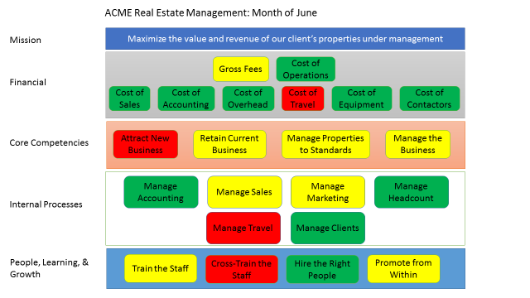

**What will this scorecard do for me as a manager?**

The process of developing the scorecard will allow you as a manager to work ‘on’ your business rather than ‘in’ it for a while. This process will give you a better understanding of the way your operation really works – particularly if you involve the other members of the operation in the development of the scorecard.

Once the scorecard is completed and operating it will give you a picture of where your whole organization stands at a glance. It will provide a holistic operational picture and a reminder of the linkages and mechanisms of how your operation works. It will also provide you with an indication of where your operation is headed in the future and help you prepare for what’s next.

**What will this scorecard do for the operation?**

A well-built scorecard implemented with enthusiasm will make the operation more effective and efficient on multiple levels. The scorecard will provide a direct linkage between the budget process, financial reporting, operational reporting, and operational success.

The scorecard brings together all of the key performance indicators in one place. It provides a holistic picture of the status of the operation and leads to better management by the leadership and the Board. It also provides a communications tool to better tell the operation’s real story.

**What will this scorecard do for the workforce?**

If the workforce is involved in the development of the scorecard it will provide a team building opportunity as well as informing the members of the workforce how the operation works as a whole. It will also provide insights into the linkages of various parts of the operation that may not have been readily evident to the workforce prior to this even. The scorecard provides an opportunity for the ‘view from the shop floor’, which is often different than management’s view, to be discussed and considered

The scorecard will also provide the workforce with a current status report on how ‘their’ operation is doing so they can be better prepared for changes as they are required.

**What will this scorecard do for the Board of Directors?**

The scorecard is a huge assistance to the Board of Directors. It portrays the status of the entire operation at a glance, shows them how the operational linkages and mechanisms work, and provides them with a guide on which parts of the operation need attention and assistance.

The scorecard will improve the Board’s capability to understand what is going on and as a result the Board can better do its job of providing oversight and direction.

**How do we develop these scorecards?**

The operational scorecard development process has nine (9) primary steps. But most importantly the process is a highly participatory event. In the past the scorecard development might have been left to a small group of senior management, who would examine the operation, determine what needs to measured, provide the performance metrics, and publish the scorecard. The result would be a ‘top down’ product, which the workforce and the Board of Directors might not agree with. Without the participation of the workforce and the Board the scorecard has a diminished probability of success.

Step 1: Decide what areas of the operation need to be measured

Step 2: Decide who should form the ‘scorecard team’. The team should have participants from the work force, management, and the Board

Step 3: Decide what needs to be measured

Step 4: Decide what the individual measures should be

Step 5: Decide how often the measurements should be made

Step 6: Decide on the format for the scorecard

Step 7: Produce a draft scorecard

Step 8: Review and test drive the scorecard for:

* + The proper focus – does it measure the right things?
  + Is the scorecard easy to understand by all the parties?
  + Is the scorecard easy to maintain – are the measurements simple enough and easy enough to obtain?
  + Does the scorecard tell the real story of how the operation is doing?

Step 9: Implement the scorecard

**How much time and effort will this scorecard require?**

The answer to this question varies with the size and composition of the operation, the frequency and complexity of the measurements, the willingness of the scorecard team to play their part, and most importantly the level of enthusiasm of the senior leadership for the scorecard.

Operational scorecards can be produced in as little as two meetings of the scorecard team, but the normal development time is four to five meetings of the team, a review by the senior management and a final review by the Board.

It has been our experience that the development and implementation of any type of scorecard is best accomplished in partnership with a qualified facilitator. The facilitator should have a thorough knowledge of scorcarding and working knowledge of the business of the operation he/she is assisting.

Dunkirk Partner’s Principal and its Strategic Partners have extensive experience in developing and implementing scorecards for all types of operations at all levels. We would be pleased to discuss in more detail what the development and implementation of a scorecard can do for you and your operation.

Stewart Brown

Principal

Dunkirk Partners

703 624 8546

[stewart.Brown@dunkirkpartners.com](mailto:stewart.Brown@dunkirkpartners.com)