The primary goals of any strategic planning process are to:

* Help the organization move from where it is today to where it wants to be at some time in the future

and

* Make the organization more effective and more efficient. In the commercial sphere this translates into becoming more profitable. In the government arena this means achieving better mission accomplishment.

There are many formats for a strategic plan. The example below is a graphic representation of a strategic plan that was prepared for a US Army organization, US Army Forces Command Intelligence. The strategic plan includes:

* The Strategic Thrust, which serves as a short term mission statement
* Four Primary Lines of Effort, which contain a total of fourteen specific projects that the organization has determined need to be accomplished in a specific time frame to move the organization to where they want to be while improving their efficiency and effectiveness.

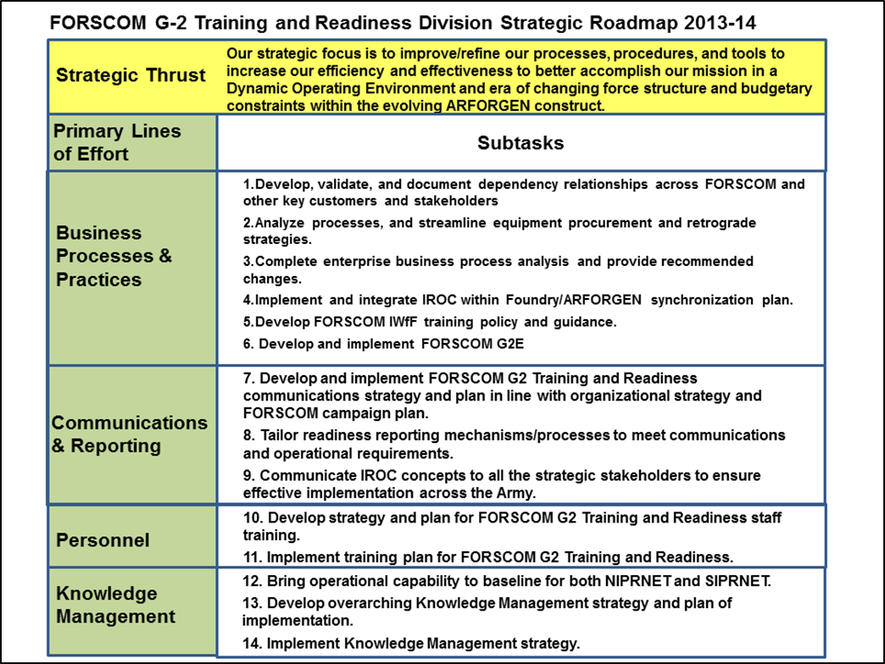

While the strategic planning process is different from one organization to the next, there are standard tasks that must be conducted in order to reach the goal of developing and implementing a successful plan. The strategic planning process is broken down into four primary parts:

* Environmental Scan
* Analysis
* Plan Development
* Implementation

Within each of these four primary areas are a series of subtasks that when completed fit together to provide the foundation for the development and implementation of the strategic plan.

There are a wide variety of benefits beyond the two primary goals that can be achieved through the strategic planning process. These benefits are by-products of the strategic planning process and can contribute greatly to the organization’s short and long term success. These benefits include:

* Organizational team building
* Clearer definition and understanding of organizational purpose, mission, vision, core competencies, and internal processes
* Better identification and understanding of customers, competitors, and other stakeholders
* Better grasp of what the future may bring for the organization
* Heightened awareness of risk and better risk management strategies
* Better understanding of the marketplace
* Better linkage between the budget and the strategy
* Development of a Communications Plan linked to the strategic plan
* Development of a Change Management Plan to ensure smooth transition throughout the implementation of the strategic plan

Conclusion: There are many benefits that can be reaped from the strategic planning process. While the primary goals of making the organization more effective and efficient and getting to where the organization needs to go are always up front, the benefits that can be garnered from the process itself and its by-products make the whole process more valuable to the organization, its members, and its customers.

Stewart Brown

Principal

Dunkirk Partners

703 624 8546

[stewart.brown@dunkirkpartners.com](mailto:stewart.brown@dunkirkpartners.com)

Appendix: Subtasks and Process Flow

The Gantt chart below is a generic time-phased plan for the development of a strategic plan from the beginning of the effort up to, but not including, the details of the implementation. The chart shows the subtasks that form the strategic plan development process. The development and implementation of a strategic planning process should always be tailored to the requirements of the specific organization, so the chart developed for your organization may appear in a different sequence or have additional or different tasks as required.



The specifics of the additional benefits that flow from the strategic planning process include:

**Organizational team building:** The best results from a strategic planning process are achieved through a participatory planning process where all of the various areas of the organization are represented and involved. Using this approach not only produces a better product, but it helps to make the strategic plan everybody’s business. This in turn makes the probability of a successful implementation higher.

**Team Building:** Another significant by product of the strategic planning process that falls into the ‘team building’ category is the conversations that are engendered by the participants as part of the process. The strategic planning process requires that the participants step back and ‘work on the business rather than in it’. This means that the participants are required to take a larger more strategic view of the organization and all of its parts than they usually do. This also requires discussions between members of the organization who might not normally interact.

There is value to the organization as a whole from the diverse outlooks and the personal interactions that occur during the strategic planning process.

**A clearer definition and understanding of organizational purpose, mission, vision, core competencies, and internal processes:** In order to develop a cogent and workable strategic plan it is imperative that there is consensus around the organization’s purpose, mission, vision, core competencies and internal processes. Each one of these items receives considerable attention during the development of a good strategic plan. While many organizational leaders may believe at the outset of a strategic planning process that they have complete understanding of these elements, it has been our experience that this is not necessarily the case. The view from the middle or the bottom of an organization is different than it is from the top and is sometimes more informed. All of these viewpoints need to be accounted for in the development of a sound strategic plan – because it takes all levels of the organization to make the plan work.

**A better identification and understanding of customers, competitors, and other stakeholders:** Every organization is driven by its customers and stakeholders. A very thorough identification and understanding of the organization’s customers and stakeholders is critical to its success. No valid strategic planning process can be conducted without spending considerable time in the identification and analysis of the customer and stakeholder base. This holds true for both commercial and government organizations.

**A better grasp of what the future may bring for the organization:** Developing a sense of what the future might bring and then ‘test driving’ the newly developed strategic plan in that possible future is a process that can yield significant benefits. This process, which was once the domain of military planners has been adapted to the commercial arena and has proved most successful. The process of developing a series of possible futures is based on a gathering current trends, analyzing those trends to discern the real drivers, and then developing possible future worlds based on those drivers. This process is not specifically ‘predictive’, but provides the organization with a look at what might be before it occurs.

**A heightened awareness of risk and better risk management strategies:** Developing an understanding of what risks exist to the successful implementation of the organization’s strategic plan and then developing appropriate risk mitigation strategies can make the difference between success and failure. The risk identification and analysis process is a continuous function of a quality strategic planning process.

**A better understanding of the marketplace:** The marketplace – or the environment – in which the organization operates is another critical element that requires careful data gathering and analysis. The concept of the ‘environmental scan’ comes from the military planning process which is based on the basic steps of ‘see the enemy, see yourself, see the battlefield’. The environmental scan portion of the strategic planning process has been expanded to consider many elements and is foundational to the development and implementation of a good strategic plan.

**A better linkage between the budget and the strategy:** The strategic plan should link directly to the shorter term annual plan and the budget to ensure success. A well thought out strategic plan is the foundation for the shorter term implementation plans, which must be firmly linked and aligned with the budget process. The strategic planning process requires the examination of the budget and plan linkage, which is a function that is sometimes missed in business as usual.

**Development of a Communications Plan linked to the Strategic Plan:** Part of any good strategic plan includes the development of a communications plan that will have both an internal and external focus. The days of developing a strategic plan in the corner office and implementing it by fiat are over. A successful plan needs to be owned as much as possible by as many of the people in the organization as possible. This requires that the process itself be a participatory one and that there be a well thought out plan on how to communicate the strategic plan both internally and externally. The mere effort of developing the communications plan has significant advantages for the organization as the strategic planning team is required to focus on the requirements of the various constituencies. A well implemented communications plan further increases the probability of a successful strategic plan implementation.

**Development of a Change Management Plan to ensure smooth transition throughout the implementation of the strategic plan:** Most strategic plans will result in changes to the organization. Some changes may be in the area of revised and improved business processes. Some changes may be in the organizational structure. Sometimes changes are required in the organizational culture itself. Whatever changes are required, it is incumbent upon the strategic planning team to prepare for and plan on how these changes are to be made to ensure as smooth a transition as possible.