Successful organizations, particularly those in transition, find having a strategy at the core of their efforts to be significantly important in their movement forward. But the development of a strategic plan is only the first of many steps to make the strategic plan operational and successful. The implementation of a strategic plan is the hard part of the process and where most strategies fail. So, it is imperative that the organization dedicate the appropriate time and resources to the development and implementation of a Strategy Implementation Plan to ensure success.

There are several pieces to the Strategy Implementation Plan which include:

* Communications Plan – internal and external
* Human Capital Strategy and Plan
* Change Management Plan
* Initiative Management Plans – the ‘Executable Strategic Plan’
* Risk Identification and Mitigation Plan
* Linkage and alignment between the Budget and the Strategic Plan

**Communications Plan**

The purpose of the Communications Plan is to ensure that the right message about the strategic plan gets to the right people at the right time and place. The Communications Plan is a document that expresses the goals, methods, and tools of the organization’s outreach activities both internally and externally.

A Communications Plan for the launch of the Strategic Plan provides the answers to the perennial questions:

* Who are our target customers for this strategy – both internal and external?
* What do our customers and stakeholders want from us in relation to the strategy?
* What message(s) do we want to provide about our strategy?
* Where can we best reach our customers and stakeholders?
* When is it best to communicate with our customers and stakeholders?
* Why should our customers and stakeholders ‘buy’ what we are ‘selling’ in our new strategic plan?
* How do we best accomplish our communications efforts, and what are the metrics by which we can measure our success?

There are five primary elements to a Communications Plan

* Determine your communications goals and objectives
* Identify your target audience(s)
* Create your message(s)
* Determine what media you will use to deliver your message(s)
* Design and implement a management and assessment process

**Determine your communications goals and objectives**

The organization’s leadership needs to come to a consensus on three primary questions regarding the goals and objectives of the Communications Plan.

What is it we want to accomplish? Be succinct in the formulation of what the organization needs to accomplish with its Communications Plan. Look to the time frame and the resources available and chose achievable goals and objectives.

Do these goals link and align with the strategy? Ensure that the organization’s communication goals and objectives do in fact link and align with your longer-term Strategy and the Executable Strategic Plan

Have we clearly defined out goals and objectives? Make sure that all communication goals and objectives are easily, objectively, and cost-effectively measurable.

**Identify your target audience(s)**

It is important to give consideration to whom the organization is targeting its message(s). Answering the following questions and using the processes outlined below can help the organization make the right choices.

Who do you need to communicate this message to? Doing a ‘customer and stakeholder analysis’ - if you have not already done one - is an important part of this set of tasks, but for the Communications Plan the bulk of the focus will be internal to the organization – the employees and staff.

Is this an internal or external audience? It is important to understand who internally and who externally needs to hear the organization’s strategic message(s) and to realize that there may be multiple messages for the multiple audiences.

What are the attributes of the target audience(s)? As part of the customer and stakeholder analysis, the organization must determine the attributes of each audience. This is particularly true as part of the development of the Change Management Plan, which is discussed later in this paper.

Prioritize your audiences. No customer or stakeholder wants to hear that they are not number one in the organization’s priorities, but in fact some customers are more important than others and may require additional resources in the communications efforts. When the organization completes its prioritization of its audiences, it should be mindful of potential conflict if the results become public. This list of prioritized customers and stakeholders should be safeguarded appropriately.

**Create your message(s)**

Creating the right message or messages is one of the most difficult parts of the development of a Communications Plan – and the most likely to stir up controversy. The organization needs to develop the message(s) that fit the organization’s goals and objectives and the attributes of each of the target audiences. Answering the following questions will assist the organization formulating better targeted messages.

What are you selling? When the organization is communicating its strategic plan, it must have a clear concept of what it is ‘selling’. This is not selling in the same manner of selling a car or a bar of soap, but there are many similarities in the analysis, the planning, and the implementation.

What are the customers buying? Every strategic plan has multiple parts and some parts of the plan will appeal to some of the customers and some won’t. Therefore, it is incumbent on the organization to understand the wants and requirements of its target market(s).

Why would the customers/stakeholders want/need what you are ‘selling’? This is part of the ‘know your customer’ requirement, but this part of the process focuses mostly internally. Organizations find that they often know much more about the wants and needs of their external customers than they do about their internal customers – the employees and staff. A careful examination of the organization’s workforce is foundational to an effective Communications Plan and the success of the Strategic Plan.

What words or phrases are key in this message(s)? Every message will have a key word or phrase that form the core of the message. It is important to have these key words and phrases link and align to the strategic plan and be properly targeted to the customers and stakeholders the organization needs to communicate with. It is often these key words and phrases that keep the Strategic Plan with its goals and objectives at the forefront.

Create strong clear message(s). There is only one thing worse than no message and that is an unclear or confusing message. Make sure that the organization’s message is clear and concise and use the language that the target audience will readily understand.

**Determine what media you will use to deliver your message**

This may seem like a strange requirement when the target audience is internal, but experience indicates that the selection of the medium or media can be every bit as important at the message itself. One can readily imagine that the media used to communicate the Strategic Plan to an audience that is predominantly young computer coders might be different than the media used to communicate to a group of middle-aged industrial engineers.

What is the best medium or media to use to get your message(s) delivered to your customers and stakeholders? There are many choices for the media: print, PowerPoint presentations, in-person meetings, road-show type presentation, videos, video teleconferences, SharePoint/Blackboard/Canvas, internally focused Face Book type systems – or something more creative such as presenting the message(s) in a song or as part of an onstage vignette. The open and regular display of the Strategy Map and the Executable Strategic Plan graphics is a successful communications medium in many cases. The goal is to get the message to the target audience in a fashion that they will understand and accept and that will help the message stick.

What are the costs involved? Clearly the costs are an important element that needs to be considered when developing the Communications Plan. A full-fledged 45-minute video produced by a world-renowned videographer may be suitable for a large geographically dispersed audience but would be too expensive for a smaller organization. In-person small meetings may work well for a small company with its employees concentrated in one area, but would not be a cost-effective method for a large multi-national company.

What is the timing? Timing is an important part of the ‘unstated message’ of how much the leadership really cares about the target audience. If the communications plan is launched four months after the plan was completed and the contents have already leaked out, then the target audience is going to quickly grasp that they are not considered to be very important. ‘Striking while the iron is hot’ is important.

Are there any ‘unintended consequences’? The unknown is always a risk. There may be no way to prepare for every turn of events that can hinder the communication of the strategy. It behooves the organization to be thoughtful and attempt to determine risks to the successful launch of the Strategic Plan when developing the Communications Plan. Here the organization should try to determine those exogenous events that might require modifications in the strategy as a first step. (See ‘Risk Identification and Mitigation, page 10.)

**Design and implement an assessment process**

Every plan needs to have an assessment process to ensure the organization can measure the success of the implementation of strategies and plans. This is a more difficult task in the case of a communication plan, as the assessment requires subjective measurement of human reactions. It is important that the organization focus on both attitudinal aspects as well as the more observable physical outcomes.

Look to the goals and objectives of the Strategy for guidance. The goals and objectives of the Strategic Plan are the easiest place to start for the development of metrics. There are different types of metrics and it is good to realize the type or combination of types that will serve best.

* Lag measure – a measure of an event in the past
* Leading measure – a measure of an event in the past that has an inference as to the outcome of future events
* Input measure – a measure of the number or quality of inputs to a process
* Process measure – a measure of the whether the process has been done or not or how many times the process has been done
* Output measure – a measure of the output of a process
* Outcome measure – a measure of the outcome of a process, which can include multiple other ramifications and different types of measures
* Objective measure – a measure of an observable nature where there is no question as to the occurrence and its value
* Subjective measure – a measure that relies on a subjective decision of the measurer to determine its occurrence and value
* Count measure – a measure that is a simple count of events
* Quality measure – a measure of the quality of the output or the outcome

Develop ‘SMART’ metrics.

* **S**pecific – target a specific area for improvement
* **M**easurable – quantify or at least suggest an indicator of progress
* **A**ssignable – specify who will do it
* **R**ealistic – state what results can realistically be achieved, given available resources
* **T**ime-related – specify when the result(s) can be achieved

**Human Capital Strategy and Plan**

Every organization has three principle elements – people, processes and tools. The people are the most important, but often the least considered in the implementation of a strategic plan. In order for a strategic plan that requires any kind of meaningful change to be successful the organization must develop a Human Capital Strategy and then a Human Capital Plan that flows from the Strategy.

There are myriad works written on the art and science of developing a Human Capital Strategy. Once the Strategy and the Executable Strategic Plan are in place, the process of developing the Human Capital Strategy and Plan is much simpler.

The key to Human Capital Strategy development is that it links and aligns with the Strategy and the Executable Strategic Plan as closely as possible. The Human Capital Strategy and Plan are derivatives of the Strategy and the Executable Strategic Plan. The organization must have the right people in right place at the right time in the right functional areas to make the Strategy and the Executable Strategic Plan work to their fullest potential.

The same processes that were used to develop the Strategy and the Executable Strategic Plan can be readily adapted to the development of the Human Capital Strategy and Plan. Start with the development of a Human Capital Strategy Map, determine the issues, which can be worked into initiatives, and then determines which initiatives can then be prioritized as the foundation for the Executable Human Capital Plan.

**Change Management Plan**

Every Strategic Plan calls for change of some sort. The Change Management Plan details how the organization will orchestrate changes to ensure their adoption and integration into every-day operations. Change is something that humans often find threatening, particularly when it affects what they do and how they earn their livings. The level of acceptance of the Strategic Plan by the organization’s people may form a bell curve running from enthusiasm to outright rebellion. With these issues in mind, the answers to the following questions are key in the development of a Change Management Plan.

Will everyone be enthusiastic about the new strategy? It is very rare that everyone in an organization will be enthusiastic about the changes called for in a new Strategic Plan. Emotions can run even stronger when dealing with the Executable Strategic Plan – as it is more specific, more ‘in the now’, and can therefore can be more threatening.

Who will embrace the changes that come with a new strategy? The organization’s leadership needs to determine the number and identity of the people who will adhere to the new plan and its changes without significant protest. This group is usually the largest in size, and while they may not be enthusiastic, they are key to the success of the Strategy.

Who will feel threatened? Almost certainly, someone in the organization will feel threatened. The organization needs to identify those who will feel threatened and develop a plan of action to either mitigate those fears, isolate, neutralize, or remove those individuals who might threaten the success of the Strategy.

A good Change Management Plan should take into account all of the feelings and responses of the organization’s people and set out to mitigate or ameliorate any issues that are going to be an impediment to the success of the Strategy. The tools to accomplish mitigation and amelioration range from rational conversations (to convince people of the efficacy of the new Strategy) on one end of the spectrum, to removal of certain individuals who have been adjudged to be impediments to the success of the strategy. Since these mitigations and ameliorations can be severe in some cases, it behooves the organization to give careful thought to their Human Capital Strategy and to seek the advice of specialists in the field of Human Relations and Employment Law in the development and implementation of the Human Capital Strategy.

**Strategic Management Plan**

Once the Strategy and the Executable Strategic Plan have been developed and implemented they will need to be managed in an organized fashion to maximize their usefulness and to ensure the success of the Strategy. There are many ways to accomplish this task and what is offered here are some of the lessons learned over many years of implementing Strategic Plans and Executable Strategic Plans.

Management with the Executable Strategic Plan is the management of the individual initiatives that were developed through the strategy development process, then prioritized and made part of the Executable Strategic Plan. Each initiative is in and of itself a project, with a start date, an end date, and specific achievable goals.

Best practices for project management - Every initiative is a ‘project’ and must have a:

* Clear statement of the issue being addressed
* Clearly stated and achievable set of goals
* Identified leader who is accountable
* Set of assigned resources
* Delineated execution plan
* Start point and an end point
* Set of milestones
* Set of appropriate Performance Metrics

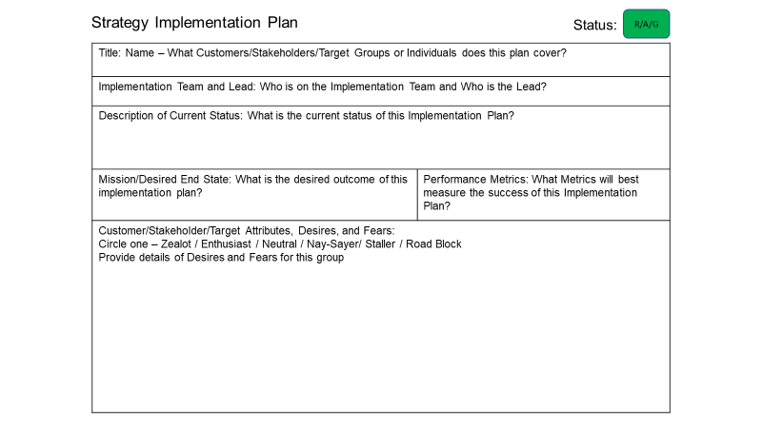

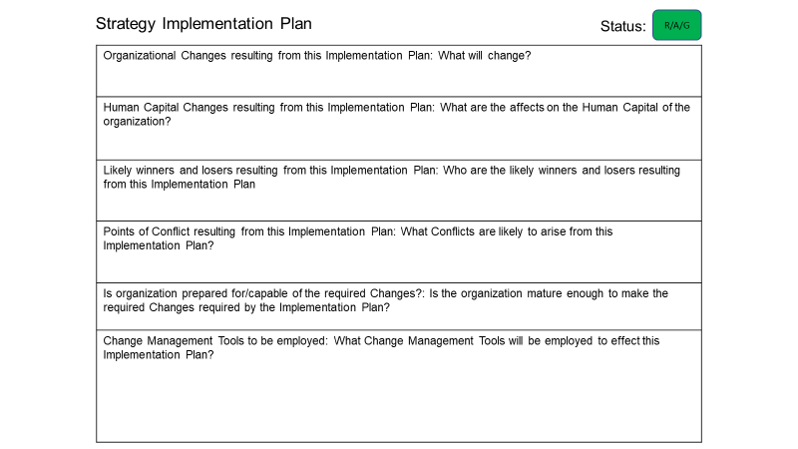

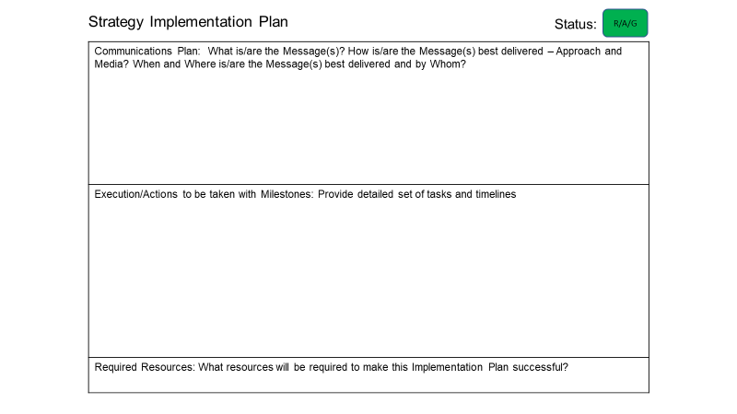

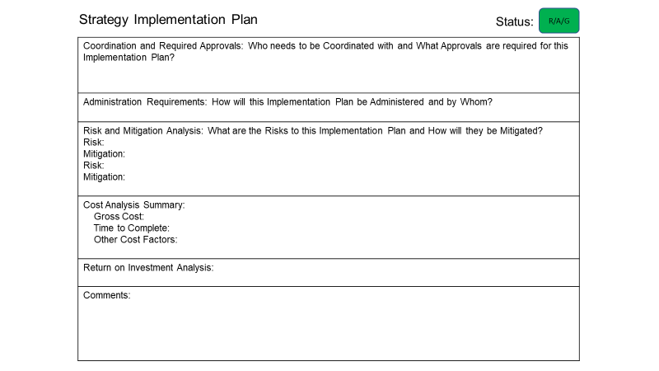

There are several ways to conduct Strategic Management, but one way that has yielded good results is to hold regular meetings with the Executable Strategic Plan as the centerpiece. The frequency of these ‘Strategic Management Meetings (SMMs)’ varies with each organization. Some will make the SMM part of the monthly management reviews, some will make the SMM a separate meeting and hold them monthly, every other month, quarterly, or semi-annually.

During the SMM the person accountable for the subtask and his/her team reviews the progress for each subtask on the Executable Strategic Plan using the forms provided above. These forms are updated for each meeting and scored as ‘Red, Amber or Green’ overall based on metrics developed by the organization.

**Metrics for Initiative Management**

There are a set of standard metrics that apply to most projects that are often employed in initiative management with the Strategic Roadmap.

* Time line – on time, ahead of schedule, or behind
* Budget – on budget, under budget, or over budget
* Resources – on plan, over plan, under plan
* Quality – on, under, or over the planned quality
* Risk – level of risk to the successful completion of this task

The Executable Strategic Plan Management Meeting should be:

* Intended to make sure that all of the initiatives are being worked according to plan
* Focused on the allocation of resources to ensure success
* Run as part of a larger corporate meeting or as a separate meeting
* Held on a routine frequency
* More of a working meeting than a presentation meeting
* Attended by the senior leadership, all the initiative leaders, the initiative staffs, appropriate SMEs, and other relevant individuals
* Ended with a recap of what has been discussed and what decisions have been made
* Have notes of the proceedings kept and published

Example of an Executable Strategic Plan in MS Excel for Management Reporting



Behind each of the subtasks lie the detail contained on the previous set of forms that should be updated on a regular basis.

**Risk Identification and Mitigation Plan**

There are risks that will threaten the success of the implementation of the Strategy. It is incumbent on the organization to identify those risks and develop strategies and plans to mitigate those risks when possible**.** Below is a diagram of the classic risk management process, which can be readily adapted to the ‘risks to the strategy’.



**Linkage and alignment between the Budget and the Strategic Plan**

Lastly, the Strategy and the Budget must be linked and aligned. If they are not - the probability of failure of the Strategy increases dramatically. While this point seems to be completely obvious, we have seen many instances where the Budget and the Strategy are developed independent of each other and the result is failure of the Strategy.

**Conclusion**

The management of the Strategic Process has many moving parts and can consume considerable resources, so the organization needs to be mindful not to over manage the process. The organization will need to decide what level of effort can be appropriately dedicated to Strategic Management – too little and the process may wither – too much and it can become an end unto itself and self-defeating. Proper management and dedication of resources to the Strategic Process will increase the probability of success for the Strategy and the organization.