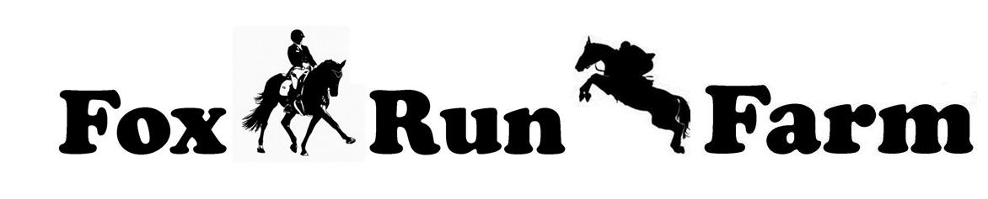

DRESSAGE & JUMPING SHOW ENTRY FORM

Saturday, May 18th, 2019
Closing date: May 13th, 2019

ONLY ONE HORSE/RIDER PER ENTRY FORM

Rider’s Name:____________________________________________ Rider’s Age (Jr.):______
Full Address ___________________________________________________________________
E-mail____________________________________________Phone: ______________________
Horse’s Name: ________________________________________________________________
Horse's Breed : _________________________________________ Mare_____Gelding_____

Draw checks to: Fox Run Farm
Mail entries to: Kim Holbrook, 906 Van Buren Ave., Oak Grove, KY 42262
Class # | Class/Division Description Fees
____ I am a FRRIENDS member now or ____ I want to join FRRIENDS (OPTIONAL) $40
FRRIENDS membership must be paid before year end awards points begin to be accrued
Enclose proof of  negative Coggins test within 1 year or text to 931-216-4471 |  | Office Fee  Friday Night Stabling - $20 | 5.00
 |  | TOTAL
WARNING: Under Kentucky law, a farm animal activity sponsor, farm animal professional, or other person does not the duty to eliminate all risks of injury of participation in farm animal activities. There are inherent risks of injury that you voluntarily accept if you participate in farm animal activities.
Failure to comply with the requirements concerning warning signs and notices provided in this section shall prevent a farm animal activity sponsor or farm animal professional from invoking the provisions of KRS247.401 to 247.4029.
Nothing in KRS 247.402 to 247.2049 shall create a duty for a farm animal activity sponsor, farm animal professional, or other person to give a warning to a participant engaged in a farm animal activity with his own farm animal, or to a participant whom the farm animal activity, farm animal professional or other person knows to possess reasonable knowledge of or experience with the inherent risk of farm animal activities, or who has represented to the farm animal activity sponsor, farm animal professional, or other person that he possesses reasonable knowledge or experience with the inherent risks of farm animal activities.
I understand that riding/showing horses is a high risk sport and I am participating (or allowing my child to participate) at my (his/her) own risk. I hereby assume this risk and release and hold harmless Fox Run Farm, Elizabeth Wallace, volunteers, farm staff, judges and officials from all liability for negligence resulting in accidents, death, damage, injury or illness to myself, my horse(s) or to my property during the above show.
Signature (Parent/Guardian if a minor): Date:

