Revelation 17’s Key to Unlocking the Cosmic Conflict Explanations

L.S. Baker, Jr., PhD

*Andrews University*

**Abstract**

The number of sequences (often termed “visions”) in the book of Revelation, has long been debated, with some suggesting seven and other suggesting eight. Both might be correct. The first four (lampstands, seals, trumpets, and cosmic conflict) have been recognized as providing a historical foundation from the First Advent to the Second Advent. The purpose of the final three or four may be to explain in greater detail topics introduced in the cosmic conflict sequence (particularly those found in chapter 14). Might this understanding help to explain the reason scholars have contemporaneously seen both three sequences and four sequences (“visions”) to finish off the book (roughly chapter 15 through 22)? The identification of the woman as the great city (Rev. 17:18), provides the key.

**L.S. Baker, Jr., PhD** is the associate director of Andrews University Press and also serves as an adjunct professor in the Seventh-day Adventist Seminary on the campus of Andrews University. In his work at the Press, he is the managing editor of the *Andrews Study Bible*, *Andrews Bible Commentary*, and *The Great Prophetic Books of Daniel and Revelation: A Bible Study Journal*. He also is the project coordinator for the Daniel 11 positions project. Dr. Baker is also an epigraphist at the Great Hypostyle Hall project in the Amun precinct of the Karnak temple complex at Luxor, Egypt under the direction of Drs. Peter Brand of Memphis University and Jean Revez of the University of Quebec at Montreal. Currently he’s tasked with helping identify the hieroglyphs of the Hittite Treaty on the exterior of the western wall of the Cour de la Cachette as well as checking the collation of the epigraphic work of the Merenptah battle scenes that surround it (this part of the project is headed by Dr. Mark Janzen of Lipscomb University, where Dr. Baker is also a research associate). As a biblical scholar, he specializes in biblical narrative and apocalyptic prophecy.

And the woman whom you saw is that great city which reigns over the kings of the earth.

Revelation 17:18 (NKJV)

**The Set-up**

It has long been recognized that the vision of Revelation begins when John both hears and sees “in the Spirit” while on Patmos (Rev. 1:9–10).[1] And although it has been a common practice to refer to the various sequences within this vision as “visions”[2] this practice is often difficult for church members to grasp since there is never a clear start or stop to any of the multiple sequence of events of the book that scholars generally refer to as visions. Rather, once John goes into vision, he never really comes out of vision; the book finishing with him never again mentioning Patmos. That is not to say that there are not definable beginnings and endings to these sequences of events, because there are.[3] It is to say that the language used in the book itself describes an ongoing experience[4] rather than an in-and-out-of-vision experience as is often assumed by church members who hear the word “visions” (whether that be seven or eight) and imagine something like they are familiar with from the book of Daniel, where Daniel saw something, had it interpreted, and the vision was over. Since the vision of Revelation is presented in either seven or eight clear sequences of events, I will use the term “sequence” to convey the idea that there is a definable shift in topic (even if the exact moment of the shift is debatable). Keep in mind, however, that the term “sequences” is synonymous with the common academic use of the plural term “visions”.

After initially being “in the Spirit” while on Patmos and interacting with glorified Jesus, who was seen standing in the midst of seven lampstands and holding seven stars, John moved “in the Spirit” three other times in the book (Rev. 4:2; 17:3; and 21:10) to three different locations.[5] These are effectively scene changes. His body never left Patmos, but “in the Spirit” he was carried up to heaven (where he remained for the rest of the vision and where he repeatedly witnessed a review of salvation history from the First Advent to the Second Advent). In chapter 17, he was carried to the wilderness that he had previously seen in the cosmic conflict sequence was the place the woman was carried to (Rev. 12:6, 13), but even then he could hear what was happening in the heavenly court he had just left and what the great multitude (i.e. the symbolic 144,000) was saying (Rev. 19:1–8). In the wilderness, unsurprisingly he saw the woman. What was surprising is that she looked nothing like she did when he previously saw her.[6] Then, in chapter 21, he was carried to the mountain that he had also previously seen in the cosmic conflict sequence (Rev. 14:1) as the place the Lamb and the 144,000 were harmoniously located. He had initially seen both the Lamb and the 144,000 in the seals sequence (Rev. 5:6; 7:4–9) earlier in the vision that was connected with the salvation of the saints.

|  |  |  |
| --- | --- | --- |
| **“in the Spirit” Phrases** | | |
| **Scene Location** | **Text Location** | **In reference to:** |
| Patmos | Rev. 1:10 | — |
| Heaven | Rev. 4:2 | — |
| Wilderness | Rev. 17:3 | Cosmic Conflict Sequence (Rev. 12:6, 13) |
| Mountain | Rev. 21:10 | Cosmic Conflict Sequence (Rev. 14:1) |

Through all of this, John never went out of vision. But it is important to recognize that while in vision, John had another layer of what might be called visions that both he and the heavenly court witnessed together. One way it might be useful to consider this is that John joined an audience that itself was watching something. Sometimes John was watching the audience, sometimes he was watching what the audience was watching, and sometimes (like when he participated on the stage, so to speak) he was what the audience was watching. Other times (such as being carried to the wilderness and later to the mountain) it is like he was going behind the scenes to see details from the cosmic conflict sequence’s sets. Because of this, and because the vision was meant to reveal something to its readers, it is entirely conceivable that John wrote the vision of Revelation in a way that his original audience would have immediately recognized as familiar. Because it was a familiar model, the original audience likely found it simple to follow.[7] As a result, it is possible he wrote Revelation using the model of a Roman theatre to communicate the intricacies of the layering of the things he saw and did all while he himself was in vision and his body was still on Patmos.

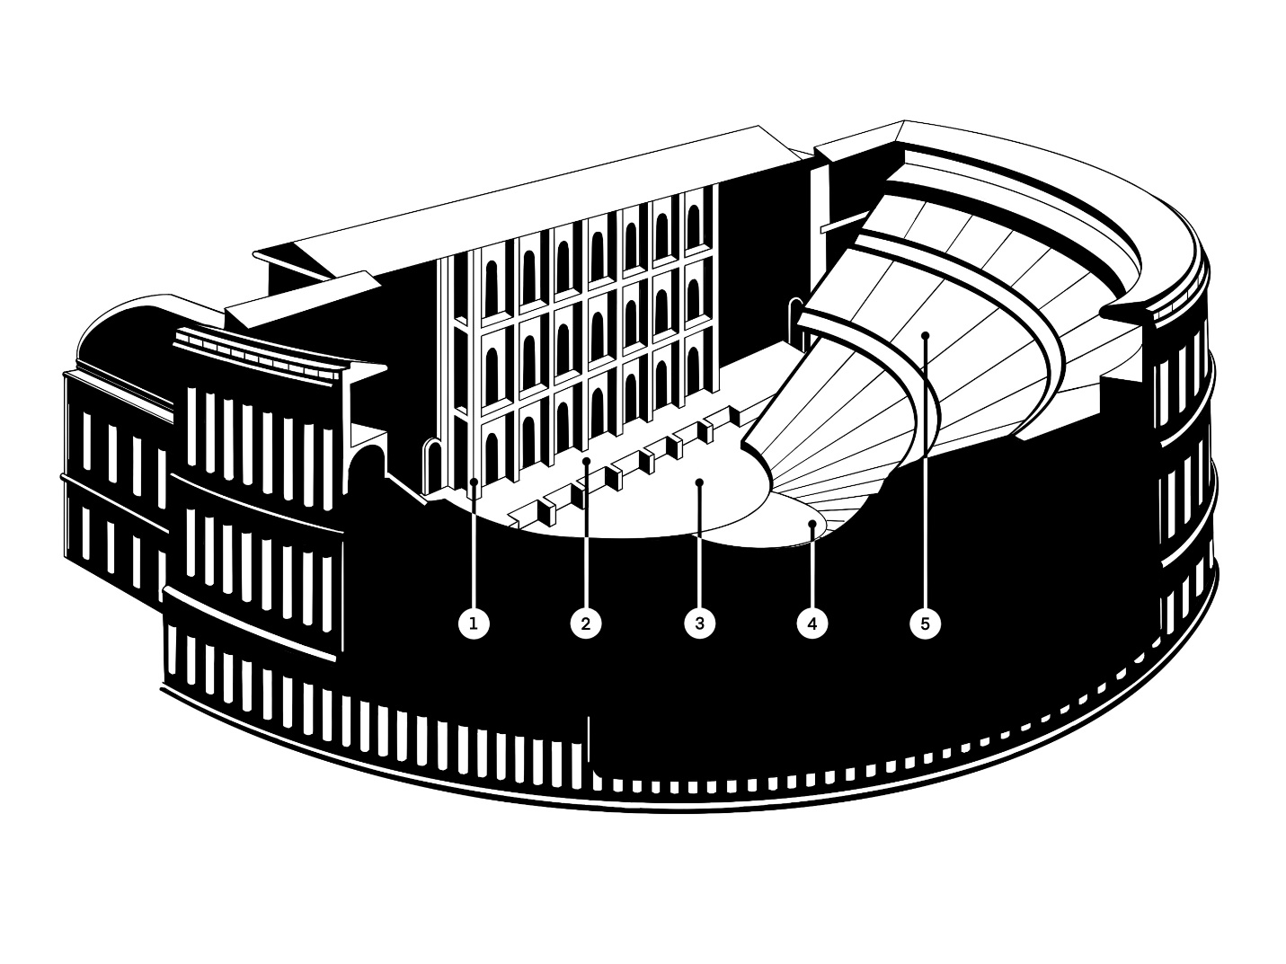

Roman Theatre Model, L. S. Baker, Jr.

1: Scaenae Frons; 2: Palpitum; 3: Orchestra; 4: Dignitaries; 5: Cavea

When viewed through the lens of the Roman theatre model, the throne (Rev. 4:2–3) might be considered to be located in a central location of the cavea (the seats where the audience sits but the dignitaries typically sat lower down and set apart from the normal people, usually cut back into the seating area in a semi-circle on a temporary platform that ate up those seats in front of and below it). Around the throne in the dignitary area of the seats, but situated so they could still see the palpitum (i.e. the stage), were four living creatures (Rev. 4:6) and twenty-four elders on thrones (Rev. 4:4). Between the seating area and the stage was the orchestra area that was seen to be like a sea of glass (“before the throne”) where the seven lamps (Holy Spirt) were located (Rev. 4:5–6). An innumerable number of angels were somewhere in the seating area or the sky around (Rev. 5:11; the size of the heavenly court, obviously, being considerably larger than any earthly example). The Redeemed (i.e. the people who make up the seven lampstands and overcame) were in the seating area, perhaps even sitting in sections arranged by church periods (Rev. 7:9). Sometimes the Redeemed came down to the orchestra area (“the sea of glass”) to participate in worship (Rev. 15:2–4) as they pronounced God’s judgment to be just. Each seal that opens and each trumpet that blows begins a scene on the stage that the entire audience witnessed (including John). We might even consider that these could have happened in sequence from one end of the stage to the other, perhaps in the scaenae frons that makes up the large structural backdrop to the stage. Toward the end of the presentation of the trumpet scenes, John was asked to participate in two audience-participation sketches (Rev. 10–11) that both illustrated the truth of what he had just seen. All of this sets up the greatest scene of all, the cosmic conflict sequence that also takes place on the stage. Thus, when the Spirit takes John to the wilderness (Rev. 17:3) of the cosmic conflict sequence and then later to the mountain of the cosmic conflict sequence (Rev. 21:10), it is as if John is going to a section of the stage or perhaps behind the backdrop itself to see more information, a place where he could still hear the audience even if he was no longer a part of the audience. In this way, the Roman theatre model provides a simple method to keep track of the various layers of the vision of Revelation and would have greatly aided the understanding of the original audience. Simplicity is important, as the vision itself is made up of symbols and so has a level of complexity built into it that can make it seem confusing for a time.[8]

So, when John saw God’s people representing seven distinct church periods (First Advent to Second Advent) with Jesus in their midst in the lampstands and stars sequence (while still on Patmos) He was seeing God’s preferred location in relation to His people. When John (after entering heaven in vision; i.e. after entering the theatre, so to speak) in the seals sequence that followed saw the redeemed in heaven around the throne with God in their midst, we are meant to recognize that God’s preferred eternal position is in the midst of His people. This motif is also true of His position corporately, as in the wilderness sanctuary in relation to the camp of the Hebrews around it[9] and personally, as seen when He was with the Hebrews in the fiery furnace or Daniel in the den of lions.[10] This is an important principle when considering the woman (the symbol for God’s people in Scripture)[11] in Rev. 17. God always desires to be in the midst of His people. However, in Rev. 17, He is not. The reason why He is not must be deduced from the description and symbolism as it relates to the structure of the vision of Revelation.

In Rev. 17, the woman John saw is notably different then how he saw her in Rev. 12.[12] What is most notable is that she does not have God in her midst. In the cosmic conflict sequence, she is presented in the Garden of Eden motif, robed in light[13] and opposed to the serpent of old.[14] That light was not of her own making. Her head was adorned (perhaps governed or informed) by God’s messengers (the garland of stars on her head; compare Rev. 1:20 with Dan. 8:10; 12:3), she was clothed in Scripture (i.e. the sun, the greater light; Gen. 1:16; 2 Pet. 1:19); and she was guided by the spirit of prophecy (i.e. the moon, the lesser light; Gen. 1:16; 2 Pet. 1:19; Rev. 19:10).[15] Whereas in Rev. 17 she has no light at all. Rather, she had decked herself out with jewels (no stars), clothed herself (but as a prostitute so in a revealing, almost naked, way and thus no sun), and she is guided by the beast she rides (rather than the moon).

|  |  |  |
| --- | --- | --- |
|  | **Woman in Rev. 12** | **Woman in Rev. 17** |
| **Adorned** | Stars on her head | Gold, precious stones, and pearls |
| **Clothed** | Robe with the sun | Purple and Scarlet |
| **Supported** | Standing on the moon | Riding on the Scarlet Beast |

The woman, because she was the first human combatant in the cosmic conflict, is a symbol of God’s people. This is true when she is pure and it is true when she is defiled (see seen throughout Scripture).[16] And because, in Rev. 17, she is riding the scarlet beast that has all of its heads, it is a depiction of God’s people in the final church period—Laodicea.[17]

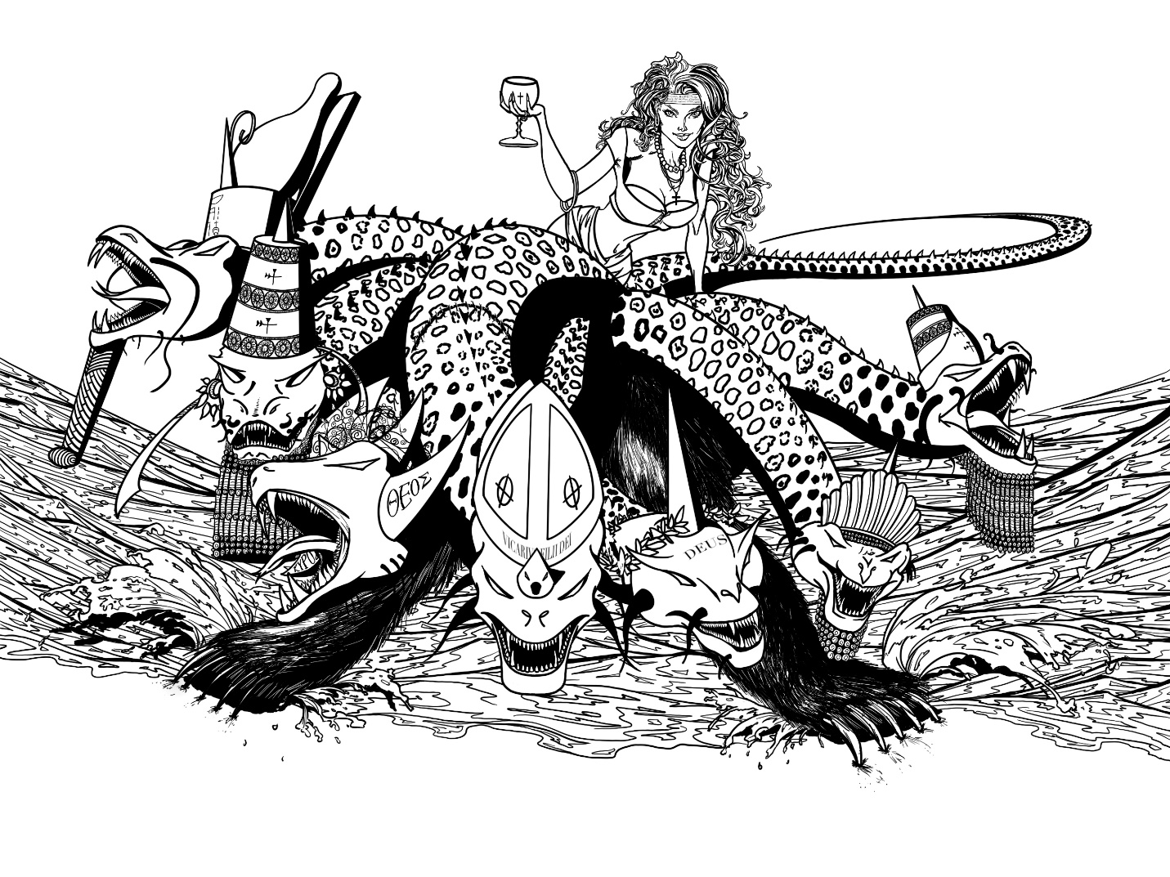

Woman, Beast, and Sea of Rev. 17, L.S. Baker, Jr.

God’s people, in the Laodicean period, are described as poor, but thinking they are rich, naked, but thinking they are clothed, and blind but thinking that they can see (Rev. 3:17–18). This is a description of the woman in Rev. 17. She has provided for herself gold and jewels (Rev. 17:4). She has dressed herself as a prostitute (Rev. 17:1–5) and thus thinks she is clothed when in reality she is quite naked. And because of her position atop the scarlet beast, she is the seeming master, but is blind regarding her true condition[18]. After all, the authority of this beast is not the woman but the dragon himself (Rev. 13:2). And finally, because Jesus is on the outside knocking, seeking entrance into her life (Rev. 3:20) we know for certain that the reason she appears the way she does is because God is not in the midst of her life but rather on the periphery (John 14:17). Originally (Rev. 12) she was depicted as having God’s light radiating from her to the world. In Rev. 17, she is depicted as being quite apart from God but seemingly not realizing it, since she is still depicted as a woman (i.e. still considering herself to be God’s people). And this is the reason, only a few verses later, the final call goes out for her to leave Babylon and enter God’s kingdom, “Come out of her, My people…” (Rev. 18:4).

|  |  |  |
| --- | --- | --- |
|  | **Laodicean Church Period** | **Woman in Rev. 17** |
| **Wealth** | Think they are wealthy but are poor | Provides her own gold and jewels |
| **Clothing** | Think they are clothed but are naked | Clothes herself as a prostitute (i.e. naked) |
| **Sight** | Think they can see but are blind | Thinks she’s the master of the beast |

The timing of Rev. 17 and the rest of the book in relation to the first four sequences needs to be determined. How does this timing relate to the debate regarding the number of sequences remaining (after the cosmic conflict sequence; three or four) and their relation to the cosmic conflict sequence itself? And how does the description of the woman in Rev. 17:18, as people who believe they are God’s people but are confused regarding their true condition, help unlock this understanding?

**The Debate**

The number of sequences that end the vision of Revelation is in question. This is important since Rev. 17 is directly affected one way or the other. Either it is included with Rev. 15–18 or it is just grouped with Rev. 18, leaving Rev. 15–16 on their own. Some scholars have argued for eight total sequences. Other scholars have argued for seven total sequences.[19] Is it possible that both could be correct depending on what is being considered? And, could what’s being considered, affect the nuance of what is emphasized in Rev. 17:18?

If we first consider that there might be four distinct sequences following the cosmic conflict sequence, we would logically separate these into something like: the plagues (roughly Rev. 15–16), the fall of Babylon (roughly Rev. 17–18), conflict ended (roughly Rev. 19–20), and eternity (roughly Rev. 21–22). The plagues sequence explains in more detail what the “wrath of God” is that was mentioned in the third angel’s message and that is the third great sign (Rev. 15:1). The fall of Babylon sequence explains in more detail what was meant by “Babylon has fallen” in the second angel’s message. This is a reverse couplet, where the items in the text that are nearest are compared and then the items in the text that are furthest are compared, with both comparisons being related to each other (why it is understood to be coupled). The inner items that are compared are Rev. 14:9–12 with Rev. 15–16 and the outer items are Rev. 14:8 with Rev. 17–18. These are coupled because the topic is the same: how the wrath of God brings about the fall of Babylon. Ultimately, both deal with God’s character.

The next reverse couplet is with the next two sequences. The conflict ended sequence explains in more detail what the eternal end will be for the grapes of wrath in the harvest scene of the cosmic conflict sequence and the eternity sequence explains in more detail what the eternal reward will be for the grain in the harvest scene of the cosmic conflict sequence. In this reverse couplet the inner items that are compared are Rev. 14:17–20 with Rev. 19–20 and the outer items are Rev. 14:14–16 with Rev. 21–22. These are coupled because the topic is the same: a revelation of the eternal end of humanity for worse or for better. Ultimately, both deal with God’s judgment. These two reverse couplets are united in that all four sequences explain key elements in the final revelation of the cosmic conflict sequence (meaning, all topics come from Rev. 14). After all, when God’s wrath brings about the fall of Babylon, it is important to understand what happens to humanity. This nuance (that humanity’s end is distinctly described separately from the end of Babylon although it is related) is crucial because it helps us when we begin to define Babylon and particularly what fell in Rev. 17–18.[20]

|  |  |  |  |  |  |  |  |
| --- | --- | --- | --- | --- | --- | --- | --- |
| **Explanations of the Cosmic Conflict** | | | | | | | |
| ***First Reverse Couplet*** | | | | ***Second Reverse Couplet*** | | | |
| **Wrath of God** | | **Final Fall of Babylon** | | **Eternal end of Sinners** | | **Eternal reward of Saints** | |
| 3rd Angel | Plagues | 2nd Angel | Fall of Babylon | Grapes of Wrath | Conflict Ended | Harvest of Grain | Eternity |
| 14:9–12 | 15–16 | 14:8 | 17–18 | 14:17–20 | 19–20 | 14:14–16 | 21–22 |

In this way, it seems like the purpose for the final four sequences is to explain four specific details in the cosmic conflict sequence’s Rev. 14 related to issues surrounding the character and judgment of God, using a very clear reverse couplet literary device. This also confirms what many have noted, that although it is clear that the cosmic conflict sequence covers the same historical period (roughly) as the lampstands, seals, and trumpets (First Advent—Rev. 12 to Second Advent—Rev. 14), and so, in some ways can be considered part of the historical part of the Revelation vision, the fact that the final sequences of the book explain key concepts in the closing part of the cosmic conflict sequence, can also be a strong argument for grouping the cosmic conflict sequence with the remaining sequences in the vision. In this understanding, the transition between the two halves of the Revelation vision should be marked at the transition between Rev. 11 and 12, making the appearance of the ark of the covenant in heaven (Rev. 11:19) the thematic middle of the book. Truth is, both are correct at the same time because the cosmic conflict sequence as a whole is itself the middle of the vision and ties both halves together. The cosmic conflict sequence reveals Jesus’s role in combating Satan’s sin (the reason the saints are lampstands holding up the light that is Jesus, the reason the saints must be saved, and the reason the wicked must be warned). The cosmic conflict sequence also reveals Jesus’s role in bringing an end to sin (the reason His wrath and the fall of Babylon must be explained, and the reason the eternal end of sinners and saints must be described).

So while the existence of eight sequences in the vision is seemingly undeniable, it should not be surprising to see that there is also a clear way to see only seven sequences for the vision of Revelation by recognizing that there are just three distinct sequences following the cosmic conflict sequence. This is done by focusing on the sanctuary imagery in Revelation.

Because the ark appearing in heaven is obviously a symbolic use of sanctuary imagery and because sanctuary imagery or related themes appear six other times in the vision, seven sequences have been suggested for the vision. Lampstands appear in the first sequence, Christ, the slain Lamb appears in the second sequence,[21] the golden altar of incense appears in the third sequence, the ark appears in the fourth sequence, and the temple itself is mentioned in the fifth sequence. It has been suggested that the celebration in heaven in Rev. 19 and the fact that there is no need for a temple on the new earth in Rev. 21 should also be considered to be related to sanctuary imagery and thus providing seven sequences. As a result, Rev. 17 falls into the sequence related to the temple in heaven and specifically the close of probation (Rev. 15:5–8). In this way, chapters 15 through 18 are all considered one unit because all relate to the closing of probation and the ending of intercession in the heavenly temple for the wicked who refuse to repent (Rev. 16:9, 11) and thus an argument for seven sequences is a thematic argument.

|  |  |  |  |  |  |  |
| --- | --- | --- | --- | --- | --- | --- |
| **Seven Sequences in the Vision of Revelation** | | | | | | |
| **Sanctuary Imagery** | | | | | **Supporting Imagery** | |
| Lampstands | Slain Lamb | Gold Altar | Ark | Temple | Celebration | No Temple |
| 1:12 | 5:6 | 8:3 | 11:19 | 15:5–8 | 19:1–8 | 21:22 |

Because the vision of Revelation is intentionally complex, we are meant to see various thematic groupings. This is why we see one total vision, two main sections (historical and eschatological), three main sections (first century church, historical sweep, and eschatological conclusion),[22] seven sequence (sanctuary imagery), and eight sequences (courtroom deliberation). So, considering both views regarding the total number of sequences (seven or eight) Revelation 17 is both related to the second angel’s message regarding the fall of Babylon (when coupled with Rev. 18) and to the close of probation with the mention of the heavenly temple in Rev. 15 (when coupled with Rev. 15–16, and 18). How do both considerations, then, help us understand what John saw in Rev. 17:18 as it relates to the woman and her relationship to Babylon?

**The Solution?**

The second angel’s message is quite literally repeated between when the angel explains the symbolism of what John saw in Rev. 17 (that ends with the identification of the woman as the great city; Rev. 17:18) and John seeing the fall of Babylon (Rev. 18:9–24). This announcement, that Babylon has fallen (Rev. 18:2–3), has strong echoes of the second angel’s message (Rev. 14:8), with many of the same phrases. Thus, because both the seven- and eight-sequence understandings of the vision of Revelation group chapters 17 and 18 together, whatever John saw in Rev. 17 is what fell in Rev. 18. However, before the ultimate fall, for one final time, God’s people are called out of Babylon (Rev. 18:4). In this way, Rev. 17 reveals the nature of what falls (i.e. all that is included in the description of the woman on the beast on the waters) and Rev. 18 reveals who mourns for Babylon and why. And, most importantly, Rev. 17 explains what God’s people have to do at all with Babylon, and their condition during the final period of time (“time of the end”) in earth’s history. This is obviously eschatological.[23]

Thus, in this context, God’s people (symbolized as a woman) are being called out of Babylon (Rev. 18:4). Whatever Babylon is, people who consider that they belong to God are in it. It is thus important to determine what is ultimately meant by “Babylon” in the vision of Revelation as this will help us sort out the meaning of Rev. 17:18.

The first time the word “Babylon” appears in Revelation is in the second angel’s message, where we are told that it has fallen. There are a few descriptors that begin to inform us of its identity: (1) it is called the great city, (2) we are told that it “made all nations drink of the wine of the wrath of her fornication,” and (3) Babylon is also referred to in the female gender (“she” and “her”). This matches well with how the woman is described in Rev. 17:18 where she is said to actually be the great city. Earlier in Revelation, the great city was the place where both Jesus was crucified and the location of the street in which His two witnesses lay (Rev. 11:8), which was related to the atheistic movement of the French Revolution (indicating that the great city comprises more than just followers of God; it includes those who do not recognize the authority of God and may even be anti-theist). That Babylon has wrath (“of her fornication” that is likened to wine) puts Babylon in opposition to God who made her drink “of the wine of the fierceness of His wrath” in the plagues sequence, and ultimately, it’s that wrath of God (which are the plagues; Rev. 15:6–7) that brings about the fall of Babylon (Rev. 16:19).

When, in the fall of Babylon sequence, Babylon is mourned over (not by God’s people but three other groups of people who are in her and benefit by her),[24] she again is called the great city (Rev. 18:10, 16, 18–19). And finally at the actual fall, Babylon is once again called the great city (Rev. 18:21). However, the term “great city” is not synonymous with Babylon because after the destruction of Babylon, God’s New Jerusalem is called the great city (Rev. 21:10), indicating that “great city” is a symbol of what comprises Babylon and later, of what comprises New Jerusalem. Thus, while there was an actual, historical ancient city called Babylon that was great in its day, what is referred to here cannot be that city. And also, while there was a city called Jerusalem, and it was great in its own way, it too cannot be what is referred to here. The term, “great city” is itself a symbol that both relates to Babylon (as in Rev. 17:18) and also to the New Jerusalem (as in Rev. 21:10). The term “great city” was previously used in Jonah 3:1–2 in an evangelistic context (also Jonah 1:2; 4:11),[25] which might provide relevant meaning to the symbolic use of the term “great city” in Revelation. After all, God’s people (i.e. the woman) are called the great city (Rev. 17:18) and they are being evangelized in the immediate subsequent verses (Rev. 18:1–4; ignoring the artificial chapter breaks that were introduced much later and were not part of John’s original composition).

That God’s people are confused about their true condition is clear not only by the symbolism in Rev. 17 but also by their description in the final church period (Rev. 3:14–22).[26] This confused state is at the root of the Hebrew term for Babylon—Babel (Gen. 11:9). In the description of the seven church periods, God’s people are there represented as lampstands holding up the light. The seven distinct lampstands have the same purpose as the one united lampstand (seven united into one)—to hold up the light so the work of the gospel could be accomplished (the exact description of the Gospel Commission; Matt. 24:18–20). Thus, every single lampstand (i.e. church period) is working for God in the Gospel Commission capacity (even the corrupt, dead, and confused churches—Thyatira, Sardis, and Laodicea). This is a key point. Although God’s people, in the last church period (Laodicea) are confused, they still think they are God’s people and thus in Rev. 17 are shown as a woman. Chronologically, when intercessory work in the temple in heaven is completed (meaning, every living person has made a final permanent decision), probation is considered to be closed. Probation is not closed at some arbitrary decision by God but rather, each created being has made their final binary decision to be either sealed by God or marked by the beast (the same beast that the woman is shown riding in Rev. 17). That probation closes by the decision of the people themselves, is seen when in the fourth and fifth plagues, the people do not repent (Rev. 16:9, 11), meaning they have made a permanent decision. On the other hand, the woman who is shown riding the beast in Rev. 17 is called out of Babylon (Rev. 18:4) before its fall, indicating that probation has not yet closed (although it is near at hand) in the timing of what John saw in Rev. 17. This sort of temporal resetting (a chronological step-back) is common in the visions of Daniel and Revelation when a related theme but new subject is introduced.

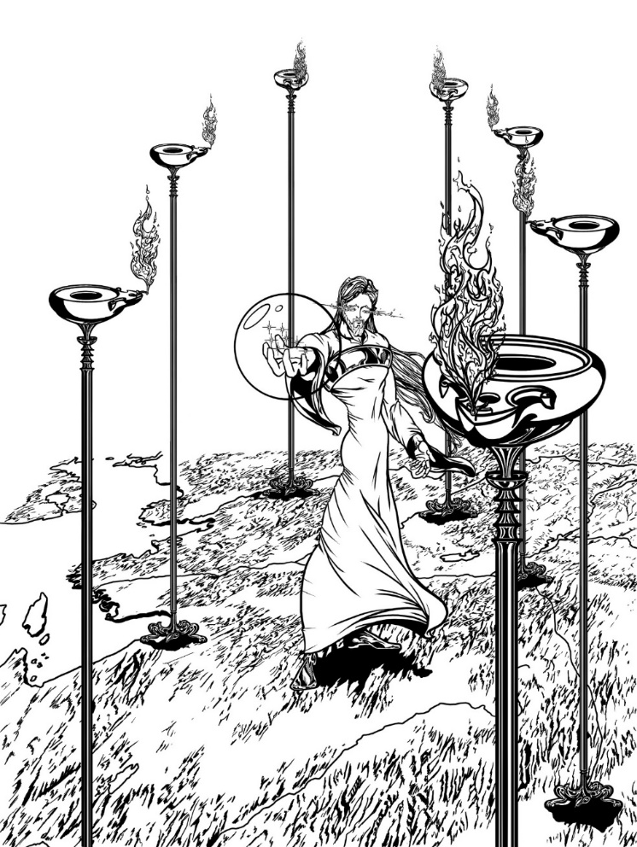

Jesus in the Midst of Seven Lampstands and Holding Seven Stars, L.S. Baker, Jr.

Thus, while the woman is a description of God’s people (misguided) and in Babylon, this is not meant to suggest that all of God’s people at the end of time will be riding the scarlet beast. Just as not all of God’s people were corrupt during the period of Thyatira or spiritually dead during the period of Sardis, not all of God’s people are confused in the period of Laodicea. Presumably some will (have and will continue to) open their hearts to Jesus and let Him in (during earth’s final period) or else none would be sealed with the seal of God (an indication of their firm permanent decision to be a follower of the Lamb; Rev. 7:1–10; 14:1–5). From all of this, it is possible, then, to suggest that while Babylon includes people who consider themselves God’s people, not all of God’s people are in Babylon. In fact, since those in the French Revolution and those who mourn the fall of Babylon are in Babylon as well, Babylon should not be considered to be limited to just misguided Christians. Babylon (in Revelation generally) is, in fact, everything that is confused (whether it be religious, anti-religious, or secular). Babylon is Satan’s kingdom of confusion and includes everything not in God’s kingdom. After all, there are only two kingdoms: God’s kingdom and not God’s kingdom.[27] So why, then, is the woman identified as Babylon at the End of Time in Rev. 17?

If we consider that Rev. 17 is part of an expansion of a theme in Rev. 14 (the end of the cosmic conflict sequence), then the wilderness we see is the same wilderness the woman went into in Rev. 12, the woman is the same woman as in Rev. 12, the scarlet beast is the same beast that was made in the image of the scarlet dragon and received its power from the dragon that we saw in Rev. 13, the many waters are the same sea from which that beast came from in Rev. 13 (and that were spewed from the mouth of the dragon in Rev. 12), and the reason for seeing this is to explain the concept of the fall of Babylon from Rev. 14. As a result, the cosmic conflict sequence is quite clearly the context for the very important glimpse at the nature of Babylon in Rev. 17–18 and its relationship to God’s people. So, when we realize that Rev. 17 is also in the context of the close of probation (from Rev. 15, because of the focus on the sanctuary imagery from the seven sequence outline of Revelation) and that the woman must choose to leave Babylon behind and join God’s kingdom – a call (Rev. 18:4) that comes as a result of the Latter Rain (Rev. 18:1), then we recognize the timing of what is being shown puts Rev. 17:18 moments prior to the End of Time. The connection between God’s people and Babylon in Rev. 17 is a connection that exists at the End of Time.[28]

Revelation 13 (in the middle of the cosmic conflict sequence) explains that worship is the main topic of the End of Time and is what polarizes the world to receive either the mark of the Beast or not (and thus the seal of God – as exampled in the 144,000 in the first verses of the next chapter). The topic of worship is particularly driven by the Christian world because of how the topic of worship relates (at that time) to a choice between Sabbath-observance or Sunday-observance. This end-time decision is an evangelistic decision either way. Rev. 17 shows that God’s misguided people at the End of Time are (mostly) mistakenly supporting the Earth Beast in promoting worship of the Sea Beast thinking they are promoting worship of God. Rev. 18 shows that God’s remnant people at the End of Time are tasked with calling God’s misguided people out of confusion and back into a right relationship with God (which is the Laodicean message of opening the door and welcoming Jesus in, learning from Him, and worshiping Him the right way – i.e. as He indicates in His commandments), thus helping them know how to overcome and thus be sealed rather than marked.

Because of this evangelistic emphasis (both ways), perhaps the reason the woman is identified as the “great city” in Rev. 17:18 is because of this end-time worship context, again provided by the cosmic conflict sequence.[29] Thus, Rev. 17:18 is the key to help us understand that the woman on the beast on the water in Rev. 17 is a picture of God’s people’s involvement in partnership with the work of the earth beast (of Rev. 13) at the End of Time, which is a union of church and state in an attempt to compel worship (outwardly of God but actually of the Sea Beast on which she is depicted as riding but which actually is worship of the dragon in whose image the Sea Beast/Scarlet Beast is made). This is a depiction immediately prior to the close of probation.

**The Wrap-up**

Using the Roman theatre model makes this slightly easier to understand. We are meant to understand that John and the heavenly court witnessed the cosmic conflict sequence on the stage. To end that sequence, the third great sign was revealed on the stage (Rev. 15:1; the first two being the woman and the dragon—Rev. 12:1, 3). This third sign (the wrath of God) explains (in a chronological step-back) the close of probation and the seven last plagues that took place before the harvest scene at the end of Rev. 14 (which was portrayed on the stage moments earlier). John then is invited to go behind the scenes and see what happened to the woman (in another chronological step-back that temporally takes place right before the close of probation). John is invited to see what eventually happened to her when she went into the wilderness by revealing her condition just before the close of probation. From his description of her in the behind the scenes location, we are able to confirm that what he describes took place just before the close of probation by (1) the nature of the context of the imminent fall of Babylon, (2) the scarlet beast has all of its heads, and (3) that the description of the woman matches exactly the condition describing God’s people in the Laodicean church period (i.e. the seventh and final church period, representing God’s people just before the End of Time).[30]

Not all of God’s people are pictured in Rev. 17, but only those who are confused and participating in the end-time evangelistic effort to compel worship of the beast (she is riding); i.e. those in Babylon (confusion). These are those who moments later are called out of Babylon (i.e. out of confusion) in Rev. 18:4. This calling out, is simply a call to let God into the midst of their hearts and thus their lives, where He has always desired to be (and thus worship Him as He desires, not as they desire), which was the remedy for the Laodicean church period.

A final note—it has been common to associate Babylon with the Roman Catholic Church. This is not wrong, of course, as long as we quickly recognize that Babylon is not limited to the Roman Catholic Church.[31] Roman Catholics are not the only Christians that will be in support of the government’s activities at the end of time, even if they will likely take the lead. We must also recognize that the beast the woman is riding is the scarlet sea beast (made in the image of the dragon, from the cosmic conflict sequence), which itself is the Roman Catholic Church at the end of time. Thus the beast is the political entity (Roman Catholic Church, the driving force of worship at the end of time) and the woman is a depiction of God’s people who are confused. Since, in reality, a political entity needs people to run it, there is some necessary symbolic overlap in interpretation.

It has also been common to associate the Laodicean church with the Seventh-day Adventist Church. This is also not wrong, of course, as long as we quickly recognize that Laodicea is not limited to the Seventh-day Adventist Church. There are Christians from every denomination that will think they are right with God and doing His will that need to be called out of this confused state. It is commendable that the Seventh-day Adventist denomination has taken the lead on this in self-identifying a spiritual problem, but we need to be sure other Christians realize that they too might be in the very same danger. The point is simply that there are various levels of discourse regarding prophecy. Sometimes we must be necessarily simplistic, such as when leading an evangelistic effort for those who know almost nothing about Daniel and Revelation, let alone the rest of Scripture. Sometimes it is necessary to speak in general terms, such as in the Sabbath School lesson or a sermon so that those new church members who also don’t have a strong Scriptural foundation can understand. And then, it is necessary, when speaking among experts to get as intentionally detailed as possible, to provide necessary nuance (this is the level of this conference). There is, however, a forgotten group of church members who often (generally) get overlooked—seasoned, educated church members, who may not be experts but who, nonetheless, know quite a good deal of Scripture and are fluent in the basics of prophecy. We do need to do a better job providing material for them at an appropriate level to help them grow spiritually. This, I see, as being one of the duties of the scholars—to bridge the gap between the scholarly world and the general world for the benefit of the seasoned church member. This would help them grow spiritually and increase the ranks of the experts. And so, while there are very good reasons to continue to identify both Babylon as the Roman Catholic Church and Laodicea as the Seventh-day Adventist church, there are also very good reasons to recognize that there is more involved.

The vision of Revelation is meant to reveal to God’s people exactly what is happening in heaven between the First Advent and the Second Advent (the heavenly ministry of Christ culminating with the pre-Advent judgment and the Second Advent followed by the end of sin) by showing the Redeemed reviewing the work of the pre-Advent judgment during the Millennial judgment review. John may have had a Roman theatre model in mind as it works quite well to easily follow the action of the book and the relationship between the appearance of like-symbols throughout the book. The symbols themselves are quite obviously tied to familiar uses in Scripture. As a result, the meaning of Rev. 17:18 and its relationship to the cosmic conflict sequence particularly (as part of the eight-sequence outline), the close of probation (as part of the seven-sequence outline), and the larger message more generally, can be determined as a depiction of God’s misguided people uniting in the mission of the Earth Beast to evangelistically call people to worship the Sea Beast (why she is depicted as riding the Scarlet Sea Beast) thinking they are calling people to worship God. And because of what comes immediately after (in chapter 18) it can be seen as a warning of the need to hear God’s final call of His people to leave Satan’s kingdom of confusion and obfuscation behind (not just the Roman Catholic Church members, but people from a wide variety of backgrounds, including confused Laodiceans) and make a final, permanent decision to follow Him (i.e. their Lamb) wherever He leads.

Even so, come Lord Jesus.

1. The first to suggest this connection in print is likely Justin Martyr (around A.D. 135 in his debate with Trypho). Irenaeus and others around that time also wrote about the common understanding that John went into vision and saw the Revelation.
2. That these are a series of sequences is reflected even among scholars who have decided for their own reasons to use the term “visions” instead. For example, “…the term ‘visions’ will refer to these eight complete prophetic sequences, not to individual visionary experiences of lesser extent.” Kenneth A. Strand, “The Eight Basic Visions,” in *Symposium o Revelation—Book I*, Daniel and Revelation Committee Series, vol. 6 (Silver Spring, MD: Biblical Research Institute, 1992), 37.
3. This concept is developed further in another paper.
4. The on-going nature of the experience of the vision of Revelation will play a crucial role in the interpretation of symbols in Revelation 17.
5. This term is a linguistic forensic divider. This concept and its application in Revelation is developed further in another paper.
6. This is an example of that on-going experience of the vision (see note 4, above).
7. In the same way that those very well-versed in Scripture would find it simple to follow the meanings of the symbols. Simple to follow does not mean easy to understand as the ease of understanding only comes when the vision is simple to follow, the symbols are familiar ones from well-known Scripture, and one has the historical advantage of hindsight (as those living at the time of the end have).
8. This concept of a Roman theatre as a model for easily following what was written, is developed further in another paper entitled “The Millennium Theatre.”
9. Numbers 2.
10. Daniel 3:24–25; 6:22.
11. For example see, Isaiah 54:1–8; Ezekiel 16:8–14; Hosea 2:19–20; 2 Corinthians 11:2; Ephesians 5:21–23.
12. For an overview of the interpretations of the woman and her connection to Rev. 12, see Hans K. LaRondelle, “Babylon: Anti-Christian Empire,” ,” in *Symposium o Revelation—Book II*, Daniel and Revelation Committee Series, vol. 7 (Silver Spring, MD: Biblical Research Institute, 1992), 151–76. See also, Ellen G. White, *The Great Controversy* (Mountain View, CA: Pacific Press Publishing Association, 1911), 381–82.
13. The clothing of God (Psalm 104:2; compare Malachi 4:2) and a characteristic of His people (Luke 16:8; 1 Thessalonians 5:5–8).
14. They are the first two great signs in the cosmic conflict (the third being in Rev. 15:1), because they were the first two earthly combatants in the cosmic conflict.
15. This concept is developed further in another paper.
16. Israel didn’t cease to be God’s people when portrayed as harlots in prophecy (for example, see Ezek. 16:26–29; 23:3–30).
17. For more on the temporal element of this sequence, see below.
18. “And the term ‘Babylon’—confusion—may be appropriately applied to these bodies, all professing to derive their doctrines from the Bible,” White, *Great Controversy*, 383.
19. Richard M. Davidson, “Sanctuary Typology” (112–15); Jon Paulien, “Seals and Trumpets: Some Current Divisions” (187–88) in *Symposium on Revelation—Book 1*, Daniel and Revelation Committee Series 6 (Silver Spring, MD: Biblical Research Institute, 1992); Jon Paulien, “The Role of the Hebrew Cultus, Sanctuary, and the Temple in the Plot and Structure of the Book of Revelation,” in *Andrews University Seminary Studies*, 33.2 (1995): 247–55; and Stefanovic, 30–31.
20. This concept is developed in more detail in another paper.
21. Since all furnishings come from the Tabernacle (the structure of the Sanctuary and not from the courtyard), the Slain Lamb is likely associated with the Table and its unleavened bread (see Matt. 26:26; 1 Cor. 11:23–24), rather than the bronze altar and the sacrificial system, since (1) all the other furnishings mentioned in Revelation are in the tabernacle and (2) His saving actions took place at the First Advent and the rest of Revelation is about His heavenly ministry after the cross, thus the timing favors a heavenly ministry application (even in Rev. 12:5), which briefly mentions His earthly ministry, the cross is basically skipped quickly past).
22. Stefanovic, 40.
23. Ellen G. White, *Patriarchs and Prophets* (Mountain View, CA: Pacific Press Publishing Association, 1958), 167.
24. Kings of the earth, merchants of the earth, and every shipmaster, sailor, and those who trade by sea (Rev. 18:9, 11, 17).
25. Nineveh is also referred to in prophecy as a harlot and her actions as fornication (Nah. 3:4). The concept of unfaithfulness is intended by this language, as seen when it applies to God’s people (Isa. 1:21; Jer. 3:1; Ezek. 16:26–29; 23:3–30).
26. As discussed above.
27. For more on these two kingdoms, see L.S. Baker, Jr., “Christian Identity in the Laodicean Era: End-Time Polarization into Two Kingdoms and Three Camps,” delivered at the ATS meetings, November 22, 2025.
28. This is not to suggest that God’s people cannot be part of Satan’s kingdom (Babylon) at other periods in history, just that this is the connection revealed in Rev. 17.
29. And, because they consider that they are God’s people (thus portrayed as a woman), they think that by compelling Sunday observance, they are doing God’s work.
30. A fourth indicator probably is a reference to the Battle of Armageddon in the war of the horns of the beast against the Lamb. The Battle of Armageddon is Satan’s last-ditch effort to prevent the Second Advent by force (Rev. 16:14, 16; 17:14; 19:19), that continues immediately upon the wicked waking from the First Death after the Millennium (Rev. 20:7–9). This concept is developed further in another paper.
31. Ellen G. White said it this way, “Since this message follows the warning of the judgment, it must be given in the last days; therefore it cannot refer to the Roman Church alone,” *Great Controversy*, 383.