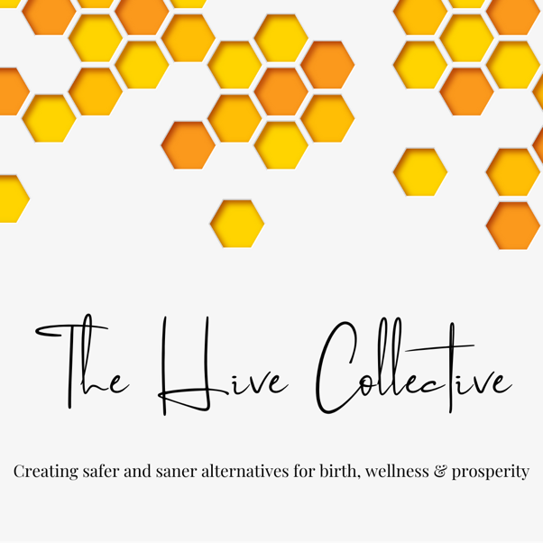

I’d like to connect with a companion

Name:

Location (address or general area within a city/town/village):

When you will reach 40 weeks’ gestation:

Which # baby is this?

Is there anything you’d like a potential companion to know? (vbac, twins, medical condition)

How would you like to be reached?

Email:

Phone (call or text):

Signal:

Telegram:

Other:

Do you give your permission for us to share this information for the purpose of helping to find a traditional birth companion or other support person?

Yes

|  |
| --- |
| [SUBMIT](mailto:findacompanion@protonmail.com?subject=Request%20for%20a%20TBC) |

If you need help, please reach out to us at findacompanion@protonmail.com.