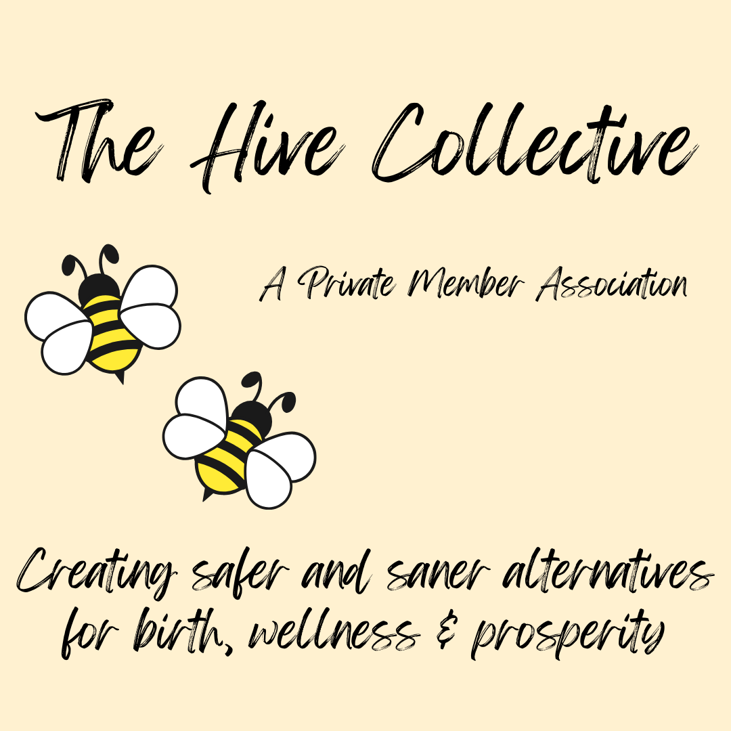

APPLICATION FOR THE 2026 TRADITIONAL BIRTH COMPANION COURSE

Welcome

Thank you for investing your time and passion into applying for this course. This course is an offering under The Hive Collective – a private member association. We have reached a dire crisis in regulated maternity services where interventions and surgery are rising with no improvement in outcomes. Further, one third to one half of all women are traumatised by their experience leaving a lasting impact on families and society. Childbearing families need an alternative.

A traditional birth companion serves her community in the tradition of the village wise-woman with holistic knowledge but coupled with today’s scientific information. This is a 10 month long shared learning journey amongst all the participants with Billie as your guide and mentor. Your avid participation is crucial to both your success and the success of the group as a whole.

In order to qualify for graduation, you will be required to complete all course material including participation in course discussions, posting various assignments, a reflection on Reclaiming Childbirth as a Rite of Passage, a final course reflection and completion of Becoming Trauma Informed and its final reflective assignment.

Once you’ve completed this application, click “submit” and it will be sent to me at billie@billieharrigan.com. If you have any questions, just reach out! I can’t wait to read your submission.

Let’s get started!

The Cold Details

Name:

Address:

Phone number:

Websites:

Social Media Accounts (FB, IG, Twitter, etc):

Age:

Academic background (include any trainings you feel are pertinent):

Work history:

The Warm Details

Your Life Circumstances:
Think about your current life situation that could impact your ability to invest in this course and move towards becoming a TBC. If you’re willing, I’d love to know more about who and what fills your day. How will things need to adjust to accommodate your study hours and time with other participants online?

Your Previous Birth Experiences:
Please share your experiences in the world of pregnancy and birth so far. This could include your personal experiences of giving birth, your work as a doula, childbirth educator, photographer, medical advocate, nurse, midwife, yoga instructor, chiropractor, naturopath, advocate, or birth nerd. How have your experiences impacted you and your desire to become a traditional birth companion?

The One and Only You:
What are you bringing to this learning community? This might be your moral courage; your passion for maternal autonomy; your values around bodily integrity, family values, or feminism; your faith; your collection of articles, journals, studies, videos, and websites; your creativity in imagining things others can't, to create art or music, or to expand in technology; your organisational skills; your technical skills; your dog-whispering skills; your empathy and compassion; your intelligence; your unique YOU!

The Hot Details
This part will be a reflective mini-essay that gets to the heart of why you want to study to become a traditional birth companion.
- Describe what is happening externally, that is, outside of you. What do you see, what is going on around you in your community, in your circle of connection, in your country, in the world that is driving you to answer the call of being an alternative person of support for birthing families? What do you want to see happen as a result of your investment in this path and your investment in families' lives?

- Describe what is happening internally. What is churning within you that will be nurtured, fed, and cultivated by taking this path? This can be anything from overcoming childhood abuse as you step into your worth and value to getting a decent pay for doing something you love.

- Why is this the right time for you?

The Generation of Reclamation Bursary
The Generation of Reclamation Bursary (“The Reclamation Bursary”) provides financial support to students who are committed to reclaiming birth through education, advocacy, and service to others.
Applicants recognise that we are at a turning point in our humanity and feel called to contribute to a path forward grounded in increasing sovereignty, self-responsibility, and compassion for our fellow sojourners. Recipients accept their role in shaping the future our children deserve and understand that this work begins now.
The Reclamation Bursary offers funding of up to $2,000 for eligible candidates, awarded on the basis of application responses and alignment with the values of the bursary. Further details will be provided upon acceptance.
Please indicate if you would like to be considered for this bursary.

The Legal Details

I am a member of The Hive Collective or will become a member if accepted
I have read and agree to the Terms and Conditions.*

____________________________________ ____________________________
NAME (not all capitals) DATE

SUBMIT
PS: Don’t forget to include your letter of reference!

* If you’re having trouble getting that ‘check box’ to work for agreeing to the Terms and Conditions, you can try this
- Go to the top of this word document and click on ‘Developer’ which is alongside the other tabs in the blue header, like ‘Home’, ‘Insert’, ‘Draw’, etc
- Next click on the box beside the ‘Terms and Conditions’ that you’re agreeing to
- Now head back up to the top of the page and see the icon for ‘Options’ in the grey area and click on it
- You’ll see ‘Default Value’ at the top of the dropdown box and you’ll see ‘not ticked’ is already selected
- Click on the ‘ticked’ option and then click ‘ok’
- The box should now have an ‘x’ in it

