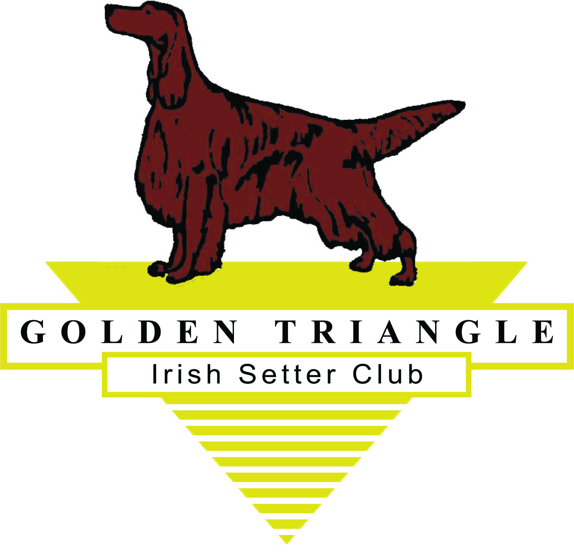

The Golden Triangle Irish Setter Club would like to recognize the accomplishments of our members and their dogs.

We will be issuing awards at the May Specialty to our members who, together with their dogs, achieved an AKC prefix or suffix title (Ch. RN, etc. and any AKC sponsored title such as CGC or TT. We are also honoring our therapy dogs and the Nose work certificates, and we’ve added Barn Hunt and UKC titles.

We will be honoring any title received while you were a member in good standing of GTISC January 1, 2020 through 12-31-20. You must also be a current member of GTISC as of February 1, 2021.

Awards will now be certificates. A certificate will be issued to EACH dog you apply for. If you include a photo by email, I will print the photo on the dog’s certificate.

Awards will be distributed at our Specialty on Saturday, May 29th, 2021. Awards are now certificates.

All members are responsible for applying for their Award.

GOLDEN TRIANGLE IRISH SETTER CLUB

MEMBER ACHIEVEMENT AWARD APPLICATION

Owner: ________________________________________________

Dog’s Name: (including Title) _________________________________

Please list the date each title was earned (2020 only)

Conformation Championship_________________________________________

Obedience Title ____________________________________________________

Rally Title _________________________________________________________

Agility Title ________________________________________________________

CGC ______________________________________________________________

Therapy dog certification ______________________________________________

TT ________________________________________________________________

Trick Dog__________________________________________________________

other______________________________________________________________
(any title or certification )

Please fill out a separate sheet for each dog.

Please mail completed form to Deborah Lawrence, 1497 Lynnwood Dr, Hermitage, PA 16148 by March 31, 2021.

