**School Nurses Organization of Arizona Presents  
32nd Annual School Health Conference**

**Prepare-Promote-Prevent:**

**‘School Health, Turning Knowledge into Action’**

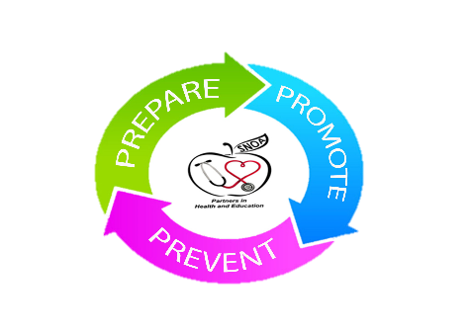**Thursday, June 20, 2019**

7:00 a.m. – 8:00 a.m. **Registration Opens**

7:00 a.m. – 8:30 a.m. **Breakfast with the Vendors**

8:30 a.m. – 9:00 a.m. **Keynote Speaker: TBA**

9:00 a.m. - 10:30 a.m. **Lori Robinson** – **MSW**



ACES - Adverse Childhood Experience

10:30 a.m. – 10:45 a.m. **Break/Vendors**

10:45 a.m. – 11:45 a.m. **TBA -Delta Dental**    
 Dental Emergencies

11:45 a.m. – 12:45 p.m. **Lunch - Vendors**

**Conference facilities are often chilly so bring a sweater or extra layer!**

12:45 p.m. – 2:45 p.m. **Michele Grimaldi -Principal,**

**Nadine Miller RN**

Communication: Building a

Culture of Health

**Melissa Luxton MSN RN and**

 **Tracey Fejt RN - Banner Health**

Injury Prevention

2:45 p.m. – 3:00 p.m B**reak**

3:00 p.m. – 4:00 p.m. **Nerissa Emers RN   
 Karen Reuter RN Marilyn Wyant RN**

**Nadine Miller RN**    
 Panel Discussion

4:00 p.m. – 4:15 p.m. **Raffles and Closing**

____________________________________________________________________________________________________________________________________________________________________________________________________________________________________________________________________________________________________________________________________________________________________________________________________________________________________________________________________________________________________________________________________________________________________________________________________________________________________________________________________________________________________________________________________________________________________________________________________________________________________________________________________________________________________________________________________________________________________________________________________________________________________________________________________________________________________________________________________________________________________________________________________________________________________________________________________________________________________________________________________________________________________________________________________________________________________________________________________________________________________________________________________________________________________________________________________________________________________________________________________________________________________________________________________________________________________________________________________________________________________________________________________________________________________________________________________________________________________________________________________________________________________________________

**School Nurses Organization of Arizona Presents  
32nd Annual School Health Conference**

**Prepare-Promote-Prevent:**

**‘School Health, Turning Knowledge into Action’**

 **Friday, June 21, 2019**

7:00 a.m. – 8:00 a.m. R**egistration / Breakfast**

**UAP’s Track – Cottonwood #1**

8:00 a.m. - 9:00 a.m.  **Jim Lee - Emergency Preparedness Advisor**

**AzDept of Ed – School, Safety and Prevention**

Emergency Supplies and Role of the UAP

9:00 a.m. - 9:45 a.m. **Barbara Weber RN and Carolen Letavec**

The Role of the UAP & Documentation

**Location:**  
Desert Willow Conference Center  
4340 E. Cotton Center Blvd Phoenix, AZ 85040

9:45 a.m. - 10:00 a.m. **Break**10:00 a.m. - 11:45a.m. **Marilyn Wyant RN** Disease Management Basics

**Nurses Track – Cottonwood #2**

8:00 a.m. – 9:30 a.m. **Tina Mahoney RN**

504/IEP

**Conference facilities are often chilly so bring a sweater or extra layer!**

9:30 a.m. - 9:45a.m. B**reak**

9:45 a.m. – 10:45 a.m. **Sarah Portle RN**

Preparing for the Medically Fragile Student

10:45 a.m. – 11:45 a.m**. Jim Lee –** **Emergency Preparedness Advisor**

**AZ Dept. of Ed - School, Safety and Prevention**

Nurse’s Role in Emergency Preparedness



11:45 p.m. – 12:45 p.m. **Lunch – Cottonwood Room**

12:45 p.m. – 1:00 p.m.  **Awards and Raffles**

1:00 p.m. - 1:30 p.m. **TBA**

1:30 p.m. – 2:00 p.m. **Miranda Graves –**

A**Z Dept. of Ed School Health and Nutrition**

WSCC

2:00 p.m. – 2:15 p.m. **Break**

2:15 p.m. – 4:00 p.m. **Stephanie Siete – Public Information Officer**

**Community Bridges** Drug Awareness, Oils and Vaping

4:00 p.m. – 4:15 p.m. **Raffles and Closing**

____________________________________________________________________________________________________________________________________________________________________________________________________________________________________________________________________________________________________________________________________________________________________________________________________________________________________________________________________________________________________________________________________________________________________________________________________________________________________________________________________________________________________________________________________________________________________________________________________________________________________________________________________________________________________________________________________________________________________________________________________________________________________________________________________________________________________________________________________________________________________________________________________________________________________________________________________________________________________________________________________________________________________________________________________________________________________________________________________________________________________________________________________________________________________________________________________________________________________________________________________________________________________________________________________________________________________________________________________________________________________________________________________________________________________________________________________________________________________________________________________________________________________________________