School Nurses Organization of Arizona Presents
34th Annual School Health Conference
Back to Basics:
“The ABC’s of School Health”
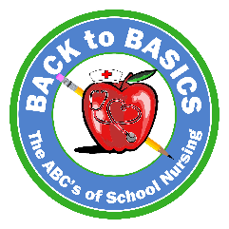
Monday, June 12th, 2023
7:00 a.m. – 8:00 a.m. Registration Opens
7:00 a.m. – 8:30 a.m. Breakfast with the Vendors
8:30 a.m. – 9:30 a.m. Dr. Cori Daines, MD
Pediatric Pulmonology
Acute Lung Injury

9:30 a.m. – 10:30 a.m. Dr. Michael Daines, MD
Pediatric Allergy and Immunology
Asthma and Allergies in the school setting

10:30 a.m. – 10:45 a.m. Break/Vendors
10:45 a.m. – 11:45 a.m. Kristen Meliska DSN, RN, CPN
Trach-Airway Program Coordinator, PCH
Tracheostomy Care in the School Setting

11:45 a.m. – 12:45 p.m. Lunch – Vendors

12:45 p.m. – 1:45 p.m. Rachel Calendo PNP, CDE
Pediatric Endocrinology, Banner
Diabetic updates

1:45 p.m. - 2:45 p.m. Maria Chico ACPNP
Pediatric Neurology, Banner
Seizures and seizure law

2:45 p.m. – 3:00 p.m. Break/Vendors
3:00 p.m. – 3:45 p.m. Nancy Tolman BSN, RN
Sue Ellen Sanchez RN, BSN
Maricopa County Public Health
School Immunizations and updates

3:45 p.m. – 4:00 p.m. Christian David, Comedian
‘Son of a Nurse’

4:00 p.m. - 4:15 p.m. Closing raffles

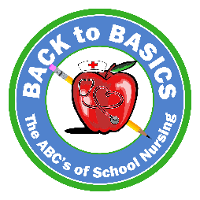
School Nurses Organization of Arizona Presents
34th Annual School Health Conference
Back to Basics:
“The ABC’s of School Health”
Tuesday, June 13th, 2023
7:00 a.m. – 8:00 a.m. Registration / Breakfast

8:00 a.m. - 9:30 a.m Shannon David BSN, RN, NCSN
Christine Mahoney MSN-Ed, RN
‘Its Elementary! The ABC’s of developing Plans’

Raffle
9:30 a.m. - 11:30 a.m. Dr. Melissa Valenzuela,
Department Specialist, MPS
QPR Training-‘question, persuade, refer’

Raffle

11:30 a.m. - 11:45 a.m. Sarah Portle MEd, RN, NCSN
Location:
Desert Willow
Conference Center
4340 E. Cotton Center Blvd
Phoenix, AZ 85040
Arizona School Nurse Access Program
NASN Data Collection/Report

11 :45 p.m. – 12:30 p.m. Lunch – Cottonwood Room

12:30 p.m. – 1:15 p.m. Maureen Roland, RN
Managing Director at Banner University
Medical Phoenix Center, Poison/Drug
Toxicologic Emergencies in the School Settings

1:15 p.m.- 2:45 p.m. Stephanie Siete, Public Information Officer
Community Bridges
Emerging Substances in the Community

2:45p.m. – 3:00 p.m. School Nurse of the Year Award

3:00 p.m. – 4:00 p.m. Dr. MaryRuth Hackett, PhD
‘Author, Speaker, Podcaster, Mama’
‘Keeping your Flame Lit: How to prevent
burnout and reduce stress in this new normal’
Conference facilities are often chilly so bring a sweater or extra layer!
4:00 p.m. – 4:15 p.m. Raffles and Closing

