**SNOA’s Role Through the COVID-19 Pandemic**

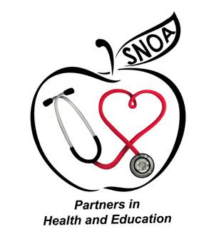

___________**School Nurses Organization of Arizona_______________**

**Position Statement**

POSITION

The School Nurses Organization of Arizona (SNOA) as a professional partner in supporting and caring for children and families, as well as, a public health entity recognizes it has a significant role in offering relevant, timely, and data driven information to our members. This information can be used to formulate the approach to care for students in the school setting moving forward through this Pandemic. We are tasked with, and it is our public health responsibility to collaborate with Federal, State and Local agencies in aligning overall guidance for the school setting to encompass approaches of care and safety regarding students, staff, families, and community. We recognize the various needs, demographics, resources, and personnel within each of Arizona’s multiple school districts and counties. We will be working with our partners to provide valuable sources for reference, guidelines and resources related to COVID-19, for schools, as well as specific tools and tips that our members can utilize in designing their specific district health office re-opening and functioning plan. We align our general guidelines with the Centers for Disease Control, Arizona Department of Health Services, Arizona Department of Education, and the National Association of School Nurses. As the data and information we are learning about this novel virus is ever fluid and changing, so must be our approach as well. We will make updates to our resources as new information unfolds, as needed, in the best interest of care and public health for all. We emphasize that our that our resources and guidelines are tools for schools to tilize in custom fitting their policies and procedures and they are not intended to supersede any district policies, as districts will be developing policies based on the presentation of the virus within the varying districts of our state.

RATIONALE POSITION

The School Nurses Organization of Arizona recognizes that not only are there varying needs within the counties of Arizona related to the COVID crisis but there are varying personnel planning, providing and implementing what the health delivery will manifest as for the upcoming school year. We will be working with our partners and providing general resources and guidelines to support the health and safety of all students in the educational setting. We also encourage procedures implemented within the health office, be data driven and in the best interest of all students. We will be focusing our information on tools, tips, and resources specific to the health office procedures, processes and workflows.

RATIONALE

At this time, the state of Arizona does not regulate or provide guidelines regarding the professional status or educational preparation for personnel or operating the school health office and not all schools have a health office. Arizona is a local control state, as related to education, and therefore, the SNOA recommendations or guidelines are provided to support the individual school or district policies. SNOA shares the responsibility to guide in the best interest of the safety and health of our members, students, staff, families, and communities and therefore; we are collaborating with Federal, State, Affiliate and County workgroups and task forces to have a voice in developing school plans. Our organization will continue to represent and inform through tips, links, data and resources that are relevant and up-to-date for our members, school health personnel and partners in formulating their district health plans related to COVID-19.