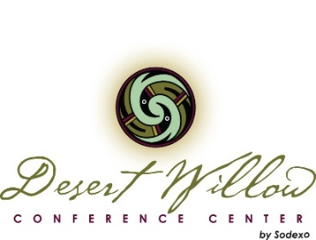
Hotels (ask for Desert Willow Rate – based on availability)
Homewood Suites by Hilton  4750 E. Cotton Center Blvd  6 blocks away  Shuttle Service | $135 night King  $170 2 Queen  Corporate Rate | 602-470-2100
Marriott Buttes Resort  2000 W. Westcourt Way  Tempe, AZ  1.18 miles away  No shuttle service | $140 Desert Willow Rate | 602-431-2386
Home2Suites  4725 E Broadway Rd  1/2 miles away  Shuttle Service | $129 King  $139 2 Queen | 602-414-0099
Courtyard by Marriott Phoenix Airport  2621 S. 47th St/Phoenix  2.25 miles away  (limited shuttle service) | $154 King  $164 2 Double  $174 2 Queen  Use this code for online booking: DZL | 480-629-1793
DoubleTree by Hilton  2100 S. Priest Drive  1 miles away  Shuttle Service | $129 Rate | 480-804-5286

Desert Willow Conference Center
4340 E. Cotton Center Boulevard / Phoenix, Arizona 85040 / tel 602.431.0001
Susan.Armentrout@Sodexo.com
www.desertwillowconferencecenter.com

