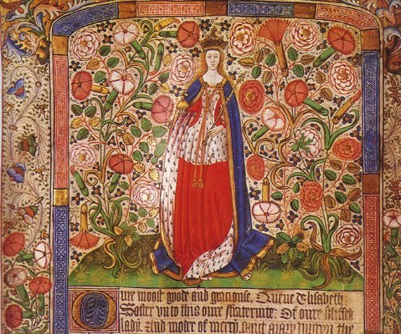
Elizabeth Woodville

In 1464 Edward secretly married the widow of a minor Lancastrian noble Elizabeth Woodville. This marriage angered Edward’s court and close advisor the Earl of Warwick as they were trying to arrange a marriage for Edward with the French King to marry his daughter. Elizabeth had also been a member of Henry VI’s wife, Margaret of Anjou’s staff. This made Edward look weak as the marriage came with no benefits for Edward, and instead it just angered his nobles.

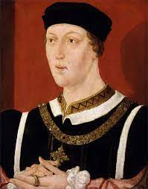
Henry VI

Edward’s throne was not fully secure as Henry VI was still alive and as long as Henry was still alive, he would still be a threat towards Edward IV’s power. Henry’s mental condition had gotten worse since he lost his throne that he was not able to rule so supporters wanted to put him back on the throne so they could rule.

Henry also had a son, Prince Edward, this meant that there were two figureheads for the Lancastrians to support against Edward IV. This made Edward look weak as he had no one to pass the throne to.

The Woodvilles
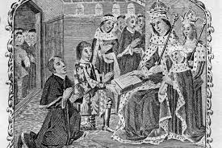
Edward, to make his new wife happy, promoted her family into very high positions at court. This made the rest of the nobles unhappy as Edward was ignoring tradition by not promoting high ranking nobles to these positions.
For example: Edward made Elizabeth’s brother the treasurer removing the Earl of Warwick’s brother. This made Edward look weak as the nobles thought his wife and her family were in charge.

The Earl of Warwick

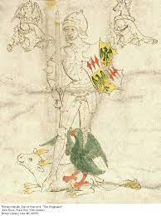
The Earl of Warwick had ruled England for Edward IV after the Battle of Towton as Edward was only 18, but as Edward got older, he wanted to rule England himself.

Warwick was the richest and most powerful noble, and some people in Europe though he was the real King. He did not want to lose his power or control so he swapped his support over to the Lancastrians so that he could remove Edward IV and rule England through Henry VI. Warwick also received support from the King of France to rebel against Edward. Warwick leaving Edward’s side left Edward looking weak and isolated as he had lost his most trusted advisor.

Edward IV
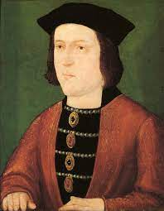

Edward IV lost his throne himself. He wanted the power all to himself but to do this he took all of Warwick’s power immediately. He took his positions off him and gave positions Warwick wanted to his friends and family making Warwick a very powerful enemy. Edward started to make decisions that went against deals that Warwick had made. Edward made a deal with Burgundy that went against Warwick’s deal with France. This made England look weak and indecisive in Europe.

Edward was also not an anointed King. He was a ‘usurper’ and he had no children to inherit his throne making his position weak.

George, Duke of Clarence

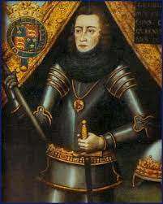
George, Duke of Clarence was Edward IV younger brother, and he was the heir to the throne. He was also a very rich and powerful noble. He was unhappy with Edward IV as he refused to let George marry the Earl of Warwick’s daughter. George married her anyway and this make Edward look weak, if he couldn’t control his own brother how could he control England?

George, Duke of Clarence resented that he was not given a lot of power by his brother so he joined Warwick to support Henry VI so he could get more power.

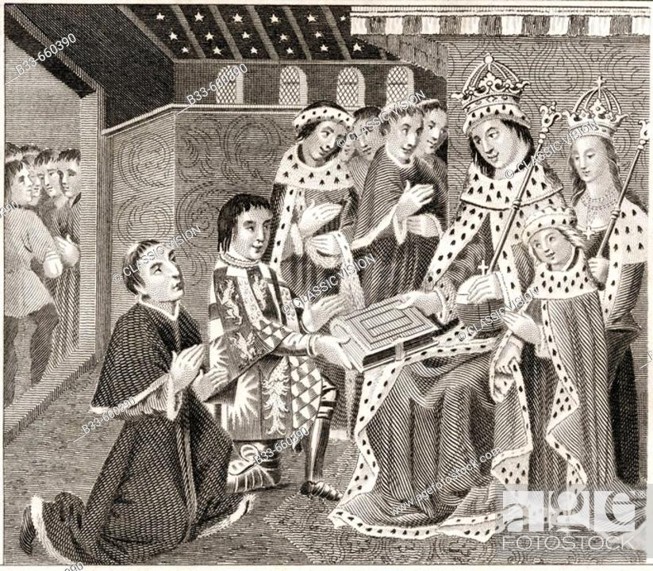
The Nobles

The nobles were unhappy with Edward as they were losing their positions at court to the Woodvilles who they hated as they used to be Lancastrians.

Edward was also asking for taxes from them so he could fight wars, but he was instead using it to buy nice clothes and food.

Edward has stopped being effective at upholding law and order and the nobles started fighting each other again and not paying rent to each other. This made Edward look weak as he couldn’t control his country.

