Understanding Your Child’s IEP
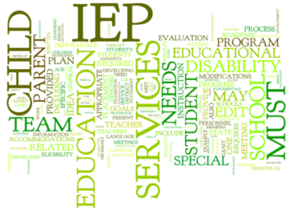 |  | Presenter:  Dr. Marva Howard  Compliance Coordinator  Exceptional Student Education  Henry County Schools
January 31, 2019
10:00 A.M. – 12:00 P.M.
Mercer University Room 141
106 Henry Parkway, McDonough Ga.
(On the same road as Sonic)

Surrogate Parent Certification will be offered from 12:00-1:00 p.m. following the IEP Training for those who are interested.

Presented by: Henry County Schools Exceptional Student Education Department
RSVP Carolyn Heard at Carolyn.heard@henry.k12.ga.us or 770-957-8086 Ext 514

